Hospital Passport

For People with Learning Disabilities

Red
Amber
Green

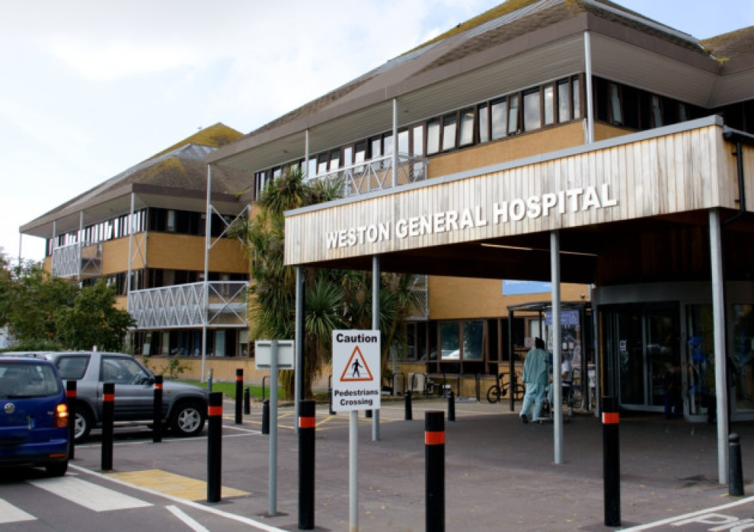

This document tells hospital staff important information about you.

Please take it with you if you go to hospital.

Ask the hospital staff to put it on the end of your bed.

Make sure that the people who look after you read this.

Things that you MUST know about me.
Name: |  |  |  |  |  |  |  |  |  |  | NHS Number:

Likes to be known as:

Address:
Date of Birth: |  |  |  |  |  |  |  | Tel No:
GP: |  |  |  |  |  |  |  | Practice:
Next of Kin: |  |  |  |  |  |  |  | Relationship: |  |  |  |  |  | Tel No:
Main carer: |  |  |  |  |  |  |  | Relationship: |  |  |  |  |  | Tel No:

Professionals involved:
Religion: |  |  |  |  |  |  |  |  | Religious Requests:

Allergies:

Medical conditions: - Cardiac, Respiratory, neurological etc.
Medical interventions: – how to take my blood, give injections, take temperature, medication, BP etc.
Risks: - Behaviours that may be challenging or cause risk etc.
Eating & Drinking instructions:

Things that you need to know about me.
Communication:
Communication passport, literacy skills, sign, etc.
Seeing/hearing:
Going to toilet:
Continence aids, prompting, constipation, etc.
Mobility:
Posture in bed, bed rails, walking aids, getting to the toilet, etc.
Taking medication:
Liquid, covert, with/without food, etc.
Pain:
How you know I am in pain, pain profile, etc.
Sleeping:
What’s usual for me, what helps me sleep, etc.
Personal care:
How I get dressed, wash etc.
Level of support: from family, paid carers, etc.
Previous bad experience:
Reasonable adjustments to consider

Things that I would like you to know about me.
Things I like: | Things I don’t like:

For an electronic version of this form: (TBC)
This form is being used with grateful acknowledgement to Kevin Elliott, Lead Health Facilitator, Gloucestershire Partnership NHS Trust, who developed this form and has given permission for us to use it.

