August 2014

**Weston Area Health NHS Trust**

**Integrated Performance Report**

# Section 1 Executive Summary

On the 10th July the Trust undertook a ‘Celebration of Success’ awards ceremony to recognise staff for their outstanding work and their positive contribution to patient care. Finalists and winners were nominated and judged by their fellow colleagues across the Trust. The calibre of the winners demonstrated the many positive changes that have happened in the Trust over the last 12 months.

Despite the significant shift in performance experienced by the Trust over the past 12 months, July proved to be a challenging month for the Trust against a number of key targets. Whilst in June the Trust achieved the four hour standard for the seventh consecutive month. In July the Trust experienced a step change in activity volumes, flows and acuity which resulted in the failure to achieve the target. This change also impacted on the Trusts ability to achieve the Stroke target in July as a result of the pressures on the Trust bed base. Both areas are being monitored closely and the necessary actions have been put in place. Despite the challenges in these areas the Trust continue to experience improvements in Cancer where in quarter one the two week wait, 31 day and 62 day targets were achieved.

The strategic focus on optimising the patient’s clinical pathway has led to improvements across a number of key quality areas including average LOS, Friends and Family Test response rate and net promoter, VTE risk assessment, Clostridium Difficile and SHMI. However, the Trust still has further improvements to make. In July there was an incidence of MRSA and the Trust has undertaken a full review and clear actions are in place to minimise the chance of reoccurrence.

In July the Trust financial position is in line with plan with a year to date deficit of £1,478,000.

# Monitor Scorecard





* 2. Summary Scorecard

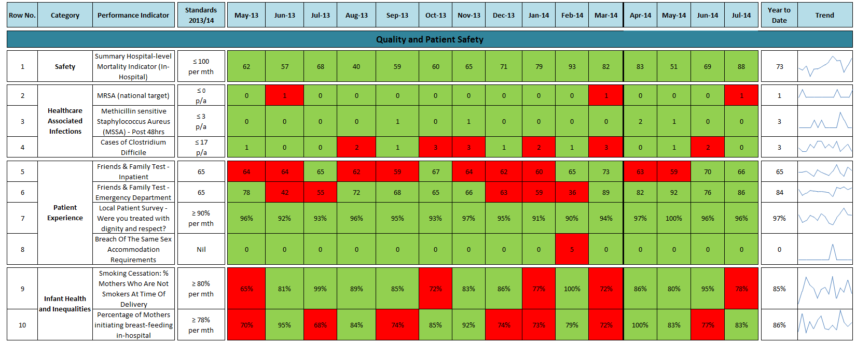

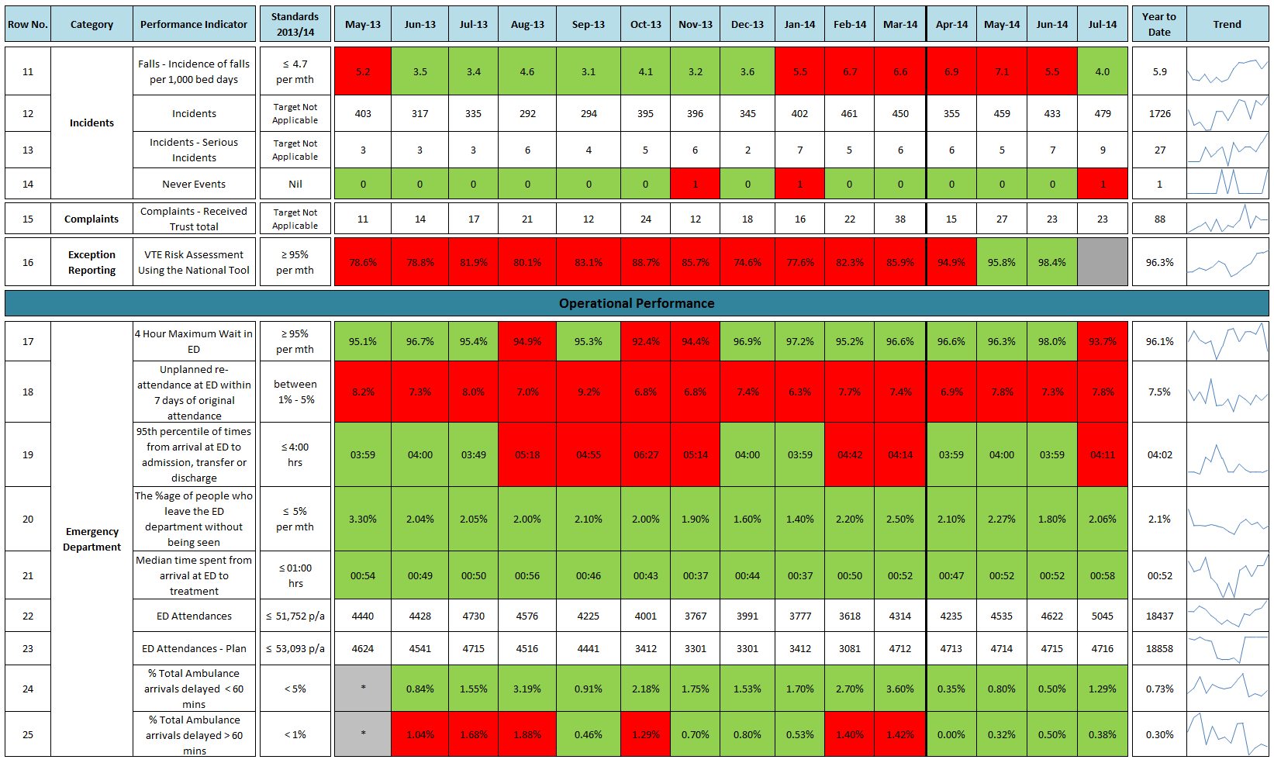

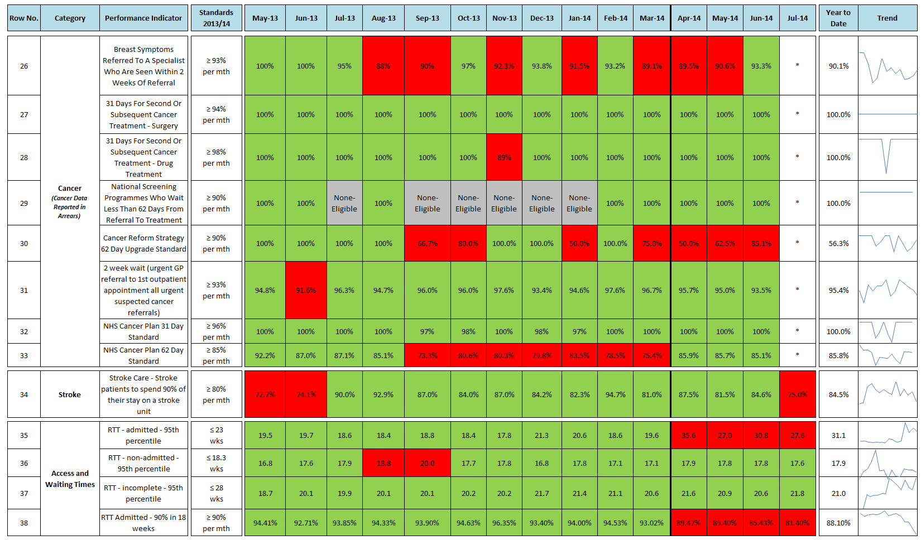**Data reported in arrears - \***

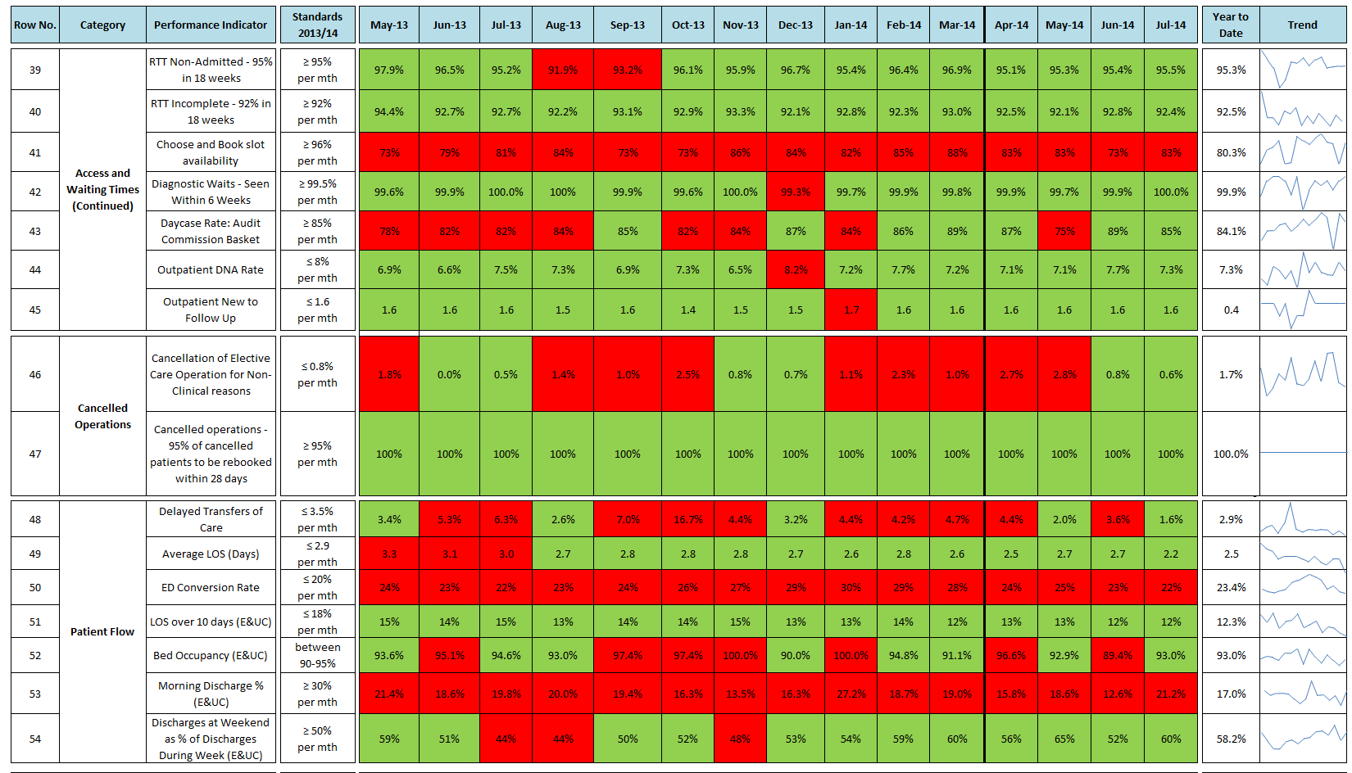

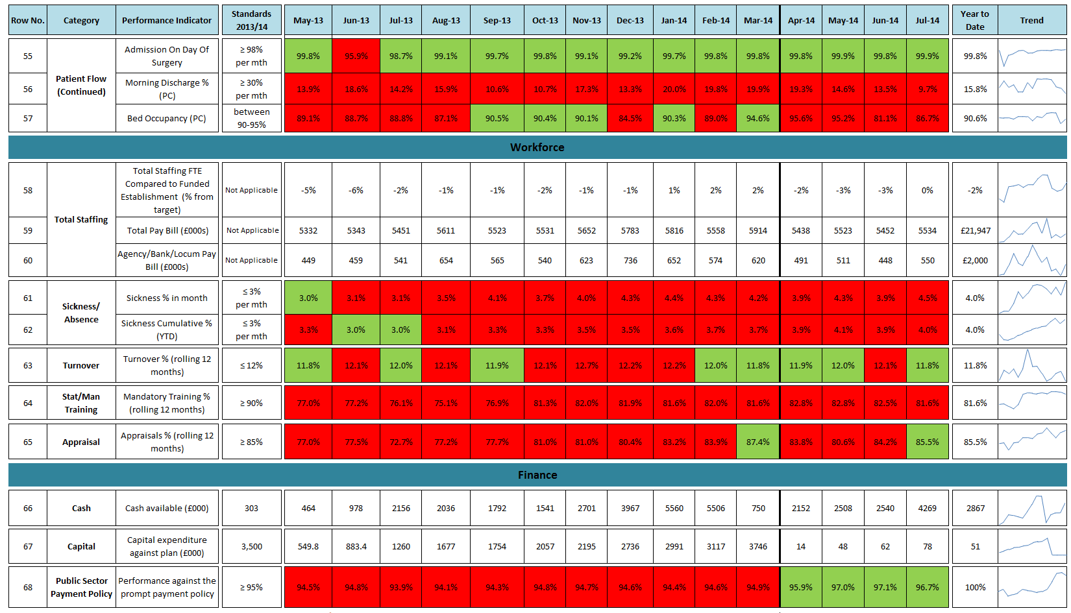

# Section 2 Quality & Patient Safety

## Quality and Patient Safety Summary Headlines

* The latest iteration of the Summary Hospital Mortality Index indicates that mortality within the Trust is as expected given the age and co-morbidities of the patients treated.
* The level of falls remains above the previous financial year however has reduced in June and July. The Trust has a number of actions in place in key clinical areas to further address the level of falls.
* Year to date the Trust remains in line with target for MSSA and Clostridium Difficile. However, a case of MRSA was identified in July and has been fully investigated.
* In June the Trust improved performance and achieved the national target of 95% with 98.4% of appropriate patients receiving a VTE risk assessment.

## 2.1. Patient Story

**Patient Story from the Radiology department**

The story relates to a patient who had a Magnetic Resonance Imaging (MRI) scan with a pre-existing condition unrelated to the reason for the scan. The patient had a very poor experience at the time of their examination and this had continued to affect the symptoms of a pre existing condition, then and now.

The patient had not previously had an MRI scan and had little knowledge or understanding of what the examination entailed, and had received no information describing the examination prior to arriving. What the patient found particularly distressing was the volume of noise generated by the scanner. Had they known or been told about this they would have informed staff that they suffered with tinnitus and expressed concerns of how noise affects their condition. The scan left the patient feeling physically sick and very distressed because of how it had exacerbated the tinnitus. We received a letter from the patient and responded. The patient found the letter of response lacking in both understanding and empathy for the distress caused. When the investigator met with the patient it was very clear that the system had failed them by not providing essential information at all stages:

* omission of MRI scan leaflet or postal notification of appointment
* assessment of pre examination form information
* omission of laminated scan information on booking into the department
* incomplete face-to-face discussion with the radiographer immediately prior to the scan.

The patient did not receive any information until the face-to-face discussion, and then not enough to enable them to give full informed consent for the examination. The patient also felt “not everything that could have been done for me was”. This failure was acknowledged and as a way of learning from this patient’s experience, they were asked if they would like to be involved in the creation of new patient information leaflets and a re-evaluation of the Radiology department information, which the patient agreed to do.

The patient also felt let down by the Trust due to the length of time it took to respond to the complaint. They were originally told the complaint would be dealt with in 30 days but received two further letters advising the deadline would not be met. There was no real explanation for this and it left the patient feeling very hurt, they said ‘it was as if I didn’t matter to them’.

The wording within the response letter that the delays were caused by ‘*an* *internal failure within the planned care division’,* were consideredto be both impersonal and lacking any real meaning by the patient and surprise was expressed that the letter was signed by the Chief Executive when he did not actually write it.

It has since been explained to the patient that the Trust is currently making a number of changes to the complaints process as a response to both local and National directives and that there are some areas within this process that need to be improved; in particular how timely the responses are and also in providing better information to patients about the reasons why a complaint response has been delayed.

The ‘internal failings’ within the planned care division were due to a lack of resources and staffing pressures over that time period which meant the processing of complaints was much slower than normal. It is acknowledged that this wording does not communicate the actual nature of the problem and it is recognised that this situation needs to be addressed and resolved quickly to prevent other patients facing delays in response.

The importance of the Chief Executive signing off each complaint letter as a demonstration of his personal interest and commitment to his awareness of all complaints was discussed and upheld as due process, during the face-to-face meeting with the patient. The patient understood this, but strongly felt that the Chief Executive should have recognised that the response did not contain an apology but did contain wording about delays that would mean nothing to the patient.

**ACTIONS**

At the June MRI (Magnetic Resonance Imaging) staff meeting, an account of the patient’s experience was given and the following actions were taken:

A simple draft leaflet entitled; ‘*What Does the Scan involve*?’ has been developed for patients and sent to the patient to review and give feedback on.

A check list for MRI Radiographers to work from has been developed to standardise the information given out by them immediately prior to the scan with greater emphasis placed on describing the noise levels within the scanner. The patient has been sent this as evidence of the department implementing change directly as a result of their feedback.

The patient has also been asked to comment on the recently produced MRI leaflet given to patients once they have arrived which describes how MRI works and what they can expect from their examination. The MRI department are awaiting feedback from the patient as to whether this is the correct level of information to give to patients.

This particular case is being reviewed with a view to identifying ways of improving the efficiency and timeliness of dealing with complaints within the Planned Care Division. The quality of response letters are also being reviewed by the Complaints Team.

**ACTIONS FROM PREVIOUS PATIENT STORY**

In May 2014 the Trust Board heard a family’s experience of Child and Adolescent Mental Health Services (CAMHS). In addressing the issues raised by this experience, the CAHMS team has established an autism strategy group and implemented a new Social Communication and Autism Multi-professional Pathway (SCAMP). The strategy group which designed this pathway is multi-agency and also includes a parent representative.

After initial assessments and interventions have been completed, one member of the team, acting as a case manager, collates all relevant information and presents the case to a panel of multi-disciplinary team members. This may result in an opinion that autism is not indicated or further information gathering. Once all the required information is available, a professional outcome meeting is held, at which the ongoing case holder is identified and feedback given to the family. Parents also receive written details of any other appointments made as a result of the case discussion with this letter giving explanations of what these assessments are for and what they entail. This changed pathway has streamlined the process for parents, giving one key point of contact and has improved both verbal and written information.

The team continue to address the remaining patients who were on the previous pathway as well as processing new referrals through the new system which became operational in April 2014. An audit on the outcome of the new system is to be undertaken later this year.

## 2.2 Registration with Care Quality Commission (CQC)

The Trust is compliant with all five of the CQC’s essential core standards of:

1. Treating people with respect and involving them in their care
2. Providing care, treatment and support the meets people’s needs
3. Caring for people safely and protecting them from harm
4. Staffing
5. Quality & suitability of management

The July 2014 Intelligent Monitoring Report, produced by the Care Quality Commission, places the Trust in priority banding 6 for inspection, with a banding of 1 being high priority for inspection and 6 being low priority for inspection, based on analysis of a number of quality and safety measures.

Quarterly monitoring of our compliance with CQC standards occurs via reporting to our Quality & Governance Committee.

## 2.3 Nursing Metrics

Providing a safe and caring environment for patients is a key aim for the Trust. To support this, the following section brings together nurse staffing metrics with high level care sensitive outcome indicators. This enables triangulation of the available data to ensure the Trust board is aware of nurse staffing issues and the impact on patients, and receives assurance over actions to address nurse staffing matters. Recruitment of staff into Surgical Assessment and Clinical Decision Unit and reallocation of former Cheddar Ward staff have supported a reduction in nurse vacancies (WTE) across the Trust to 23.8 in July from a high of 54.98 in April. This is the first month that training compliance and the percentage of new harm free care (measured by the patient safety thermometer monthly prevalence survey) are reported. The level of new harm free care is consistent with the national benchmark and the training compliance for ward nurses reflects the cross Trust compliance level. Both Hutton and Kewstoke wards are receiving intensive support from the Senior Nursing Team.

**Figure 1:**

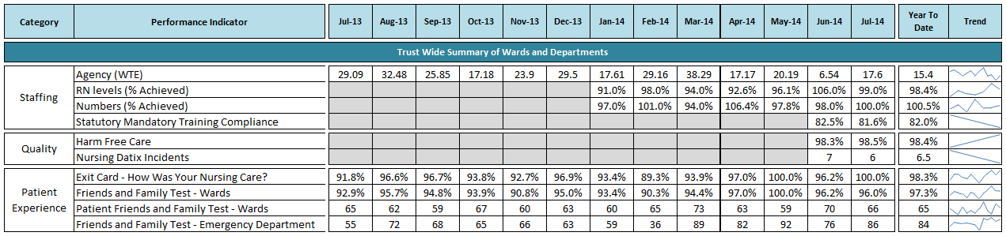

**Figure 2:**

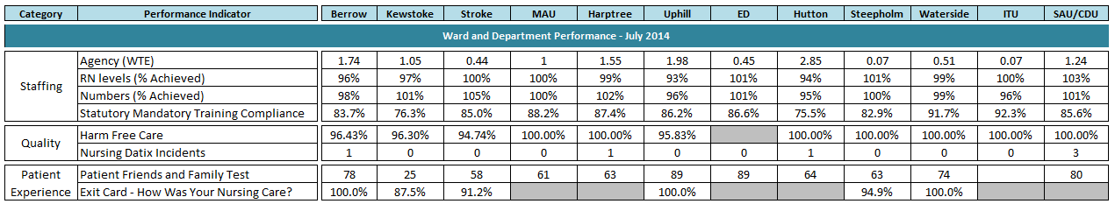

**Figure 3:**

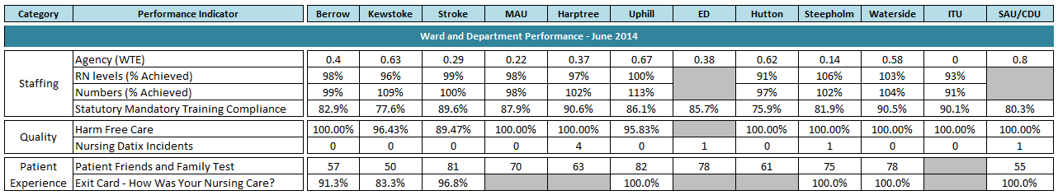

## 2.4 Incident Reporting

Incident reporting systems and policies are integral to patient safety and enable the Trust to analyse the type, frequency and severity of incidents that occur. The Trust’s open and honest reporting demonstrates a commitment to our patients and their safety. The information arising from these reports is used to make active changes to improve our provision of quality care and to safeguard the wellbeing of our staff and patients.

*Figure 4* depicts the number of patient incidents reported each month, compared to previous years.

**Figure 4:**

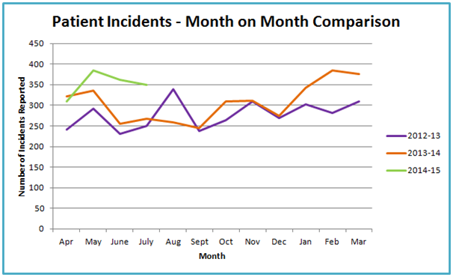

Since February 2014 the reporting of incidents within the Trust has remained fairly stable, with the number of reported incidents fluctuating between 350 to 400 per month, apart from April when there was a slight dip in numbers (312). There were a total of 711 patient incidents reported in June/July, 361 in June and 350 in July and the top 3 themes of incidents were pressure ulcers, falls and medication. On closer inspection there is a rise for June/July around incidents reported under the categories of: a) clinical assessments, 39 compared to 16 for April/May, b) Consent, Confidentiality or Communication, 33 compared to 20 for April/May. Further analysis shows the following:

* With regards to clinical assessment – There was in an increase in incidents reported under Laboratory investigations and other assessments (17 compared to 9 in April/May). Further review of incidents revealed no identified theme.
* With regards to consent/confidentiality or communication – There has been an increase in incidents reported under communication between staff, teams and departments (25 compared to 14 in April/May). Further review of incidents revealed no overall theme.

A total of 202 pressure sores were reported in June and July (total number of community and hospital acquired), accounting for 28% of all patient incidents. The Trust reported 34 hospital acquired pressure sores, which is down from 44 reported the previous 2 months. There has been an increase in hospital reported grade 3 and 4 pressure ulcers, with 5 being reported (previous 2 months 3 ulcers were reported). On closer inspection 2 of these pressure ulcers were previously attributed to community acquired and were originally reported in February and May 2014, but further investigation deemed them to be hospital acquired. All relevant external organisations were notified in June/July and a full investigation was commenced. The Trust commissioned a Peer Review of pressure ulcer management which was undertaken by local organisations in July. Preliminary feedback is encouraging however a draft report is expected in August.

110 slips, trips, falls & collisions were reported in June and July, which is slightly down on the numbers reported in April and May (122). Of the 110 reported incidents, 3 warranted a full investigation and have been reported as a serious incident.

76 medication incidents were reported in June/July, slightly up from 73 in April/May. These errors included administration (meaning medication administered orally or intravenously) from a clinical area (such as ward areas), medication error during the prescription process and preparation of medicines/dispensing in pharmacy. Further review shows that the Emergency department reporting of medication incidents has decreased from 11 in April/May to 4 in June/July and Harptree ward has increased from 5 to 12. On further review no trend can be identified but there were 2 incidents reported around a drug being used on the ward that fell outside of normal protocol.

### 2.4.1 Daily Situation Report

The daily situation report (SitRep) continues to be circulated by the Quality Improvement Team on a daily basis. Data is presented to help operational leads focus on any areas of concern.

Since March 2014 the Quality Improvement Team (QIT) has implemented a Safety News Flash bulletin, which is an urgent email communication to all staff to highlight a particular trend or concern on the day that it is noted by the Quality Improvement Team from the SitRep. During June/July 3 safety news flashes were issued:

* Number to call for the crash team (2222)
* Importance of incident reporting
* Patients receiving air not oxygen

**2.4.2 Staff Incidents**

The Trust Health and Safety Committee reviews incident trends and receives reports on incidents reported under the Reporting of Injuries, Diseases and Dangerous Occurrences Regulations (RIDDOR) 1995. *Figure 5* depicts the number of staff incidents reported each month, compared to previous years.

**Figure 5:**

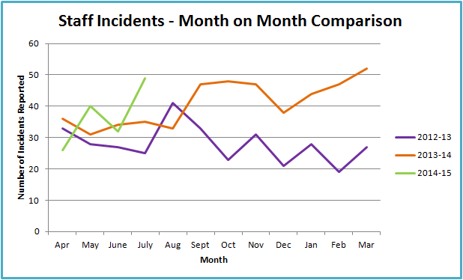

There were 32 staff incidents reported in June and 49 incidents reported in July, a total of 81 compared to 66 reported in April/May. Incidents reported involving abuse of staff has decreased from 27 incidents in April/May to 22 in June/July. There has been an increase in staff incidents reported under a) Accident that may result in personal injury, up from 27 to 35 b) Medical equipment/devices, up from 0 to 6. Further analysis shows the following:

* Accident that may result in personal injury – There was an increase incidents around staff falls, from 8 to 12 and accidents caused by other means, from 6 to 9. Further review of incidents revealed no identified theme.
* Medical equipment/devices - Further review of incidents revealed no identified theme.

### 2.4.3 Serious Incidents (SIRIs)

A Serious Incident is defined in the <http://www.england.nhs.uk/ourwork/patientsafety/> (2013) as an incident that occurred in relation to NHS-funded services and care resulting in:

* Unexpected or avoidable death of one or more patients, staff, visitors, or members of the public.
* Serious harm to one or more patients, staff, visitors, or members of the public or when the outcome requires life saving intervention, major surgical/medical intervention, permanent harm or will shorten life expectancy or result in prolonged pain or psychological harm (this includes incidents graded under the NPSA definition of severe harm)
* A scenario that prevents or threatens to prevent a provider organisations ability to continue to deliver healthcare services, for example, acute or potential loss of personal/organisational information, damage to property, reputation or the environment, IT failure or incidents in population programmes like screening and immunisation where harm potentially may extend to a large population.
* Allegations of abuse
* Adverse media coverage or public concern about the organisation or the wider NHS.
* One of the core set of Never Events

*Figure 6* depicts the number of serious incidents reported to the Trust

**Figure 6:**

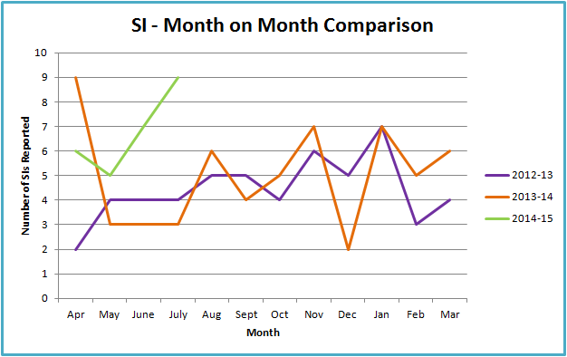

Resultant investigation reports are reviewed by the local Clinical Commissioning Group and, for the most serious cases, also reviewed by the NHS Trust Development Authority. Between the 1st June and 31st July 16 serious incidents (June 7 and July 9) were reported and an investigation commissioned.

The 17 investigations are classified as follows:

|  |  |  |
| --- | --- | --- |
| Category | Grade 1 | Grade 2 |
| Operational (e.g. unit closure) | 1 | 0 |
| Adverse media attention | 0 | 0 |
| Information Governance (e.g. loss of data) | 0 | 0 |
| Clinical Care of patient (e.g. pressure ulcer, delayed diagnosis, avoidable severe harm) | 13 | 0 |
| Safeguarding (e.g. allegation of abuse) | 1 | 0 |
| Avoidable severe harm to staff | 1 | 0 |

The Trust reported 1 never event (wrong site surgery) in July.  On return to the ward patient realised that the wrong site surgery had taken place and was returned to theatre immediately.

## 2.5 Inpatient Falls Data

Patients fall in hospital for a variety of reasons. These reasons can encompass the following factors:

* Chronic health conditions, such as [heart disease](http://www.nhs.uk/conditions/Coronary-heart-disease/Pages/Introduction.aspx), [dementia](http://www.nhs.uk/conditions/Dementia/Pages/Introduction.aspx) and [low blood pressure (hypotension)](http://www.nhs.uk/conditions/Blood-pressure-(low)/Pages/Introduction.aspx), which can cause [dizziness](http://www.nhs.uk/conditions/Vertigo/Pages/Introduction.aspx);
* Impairments, such as poor vision or muscle weakness;
* Disabilities that can affect balance.

Through June and July 2014 the Trust has seen a reduction in the number of patient falls from 57 in May to 44 in June and 34 in July. In July, Kewstoke ward and the Medical Admission Unit experienced the highest number of patient falls, with a rise also reported for Hutton ward. The proportion of patients who fell who were admitted to hospital due to a fall sustained at home remained constant throughout June and July, with the figure averaging 22.5%.

During June and July there were two incidents of falls where significant harm resulted. One of these incidents is currently being reviewed to establish if the significant harm was caused by a fall or a collapse. The second incident resulted in a patient suffering a fractured neck of femur and has been fully investigated. Learning from this incident has been taken back to the relevant area.

The percentage of patients who fell who had been assessed for risk of falls was 91.2%; the three patients that were not assessed were in the Emergency Department and Assessment Units and therefore fell before a full assessment of their falls risk could be undertaken.

56% of patients who fell, had been admitted with a history of falls. Five patients during this period fell more than once.

**Figure 7:**



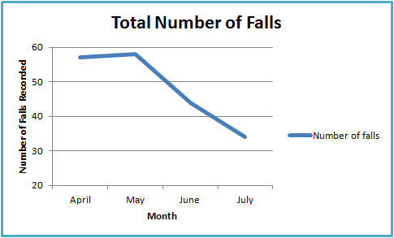

**Trust Actions:**

Staff education regarding falls prevention remains an ongoing commitment. Medical Admission Unit staff have been appraised of falls within their area and training has been implemented regarding preventative measures and what could have been implemented.

All nursing staff on wards where significant harm is a result of a fall will receive a letter of recommendations to follow, to reduce falls incidents.

All untrained staff on the Medical Admission Unit will attend an offsite training day on falls prevention.

The Lead Nurse for Falls Prevention is assessing aids and equipment that may be used across all areas to further protect patients who have been assessed as at risk of falling. Several have been introduced into use on wards with some success to date.

## 2.6 Pressure Ulcers

A pressure ulcer is a localised injury to the skin and/or underlying tissue usually over a bony prominence, as a result of pressure or pressure in combination with shearing. A number of contributing or compounding factors are also associated with pressure ulcers: the significance of all these factors is yet to be elucidated (European Pressure Ulcer Advisory Panel, 2009). Pressure ulcers are graded in severity from grade 1 which is early signs of skin damage, i.e. localised redness of the area, to grade 4, where damage extends beyond the skin to underlying tissue e.g. muscle.

In July the Trust has recorded a 29% reduction in hospital acquired pressure ulcers. There have been no recorded Grade 3 pressure ulcers but one recorded Grade 4 ulcer. *Figure 8* shows the year to date hospital acquired pressure ulcer, and their severity.

**Figure 8:**

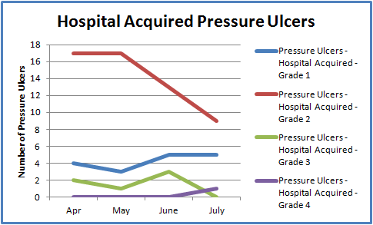

The split of community and hospital acquired pressure ulcers in June and July is illustrated in *Figure 9*.

**Figure 9:**

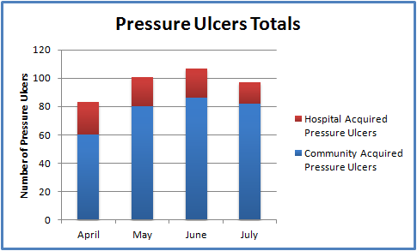

A Peer Review, led by Somerset Clinical Commissioning Group, was undertaken on 28th July 2014; the report from this is awaited. Highlighted areas of concern however were narrowed down to training, induction and risk assessment. Good practice was identified in Board engagement, investment in equipment and use of wound photography in admission areas. A full action plan will be developed once the Peer Review report is available.

## 

## 2.7 Patient Feedback

### 2.7.1 Complaints

Complaints management is critical to ensuring the Trust not only responds to the complainant in a timely manner, but to ensure the learning from complaints is translated into action. Complaints data enables the Trust to determine if there are any trends in subject matter, location or personnel.

*Table 10* portrays that the total number of complaints received in June and July was 23 and 23 respectively. The number of complaints received equate to 0.93% of all activity over this period. This is against inpatient activity of 3,221; Emergency Department attendance of 9,667; Outpatient Department attendance of 15,035 and Day Case activity of 2,576.

All complainants are offered the opportunity to meet with relevant staff should they wish. Four complaint resolution meetings were held in June and July, resulting in satisfactory resolution for the complainant. Should complainants remain unsatisfied with the final response from the Trust, and all options for internal resolution have been exhausted, complainants are advised of the option to refer their complaint to the Complaints Ombudsman. One new complaint was referred to the Complaints Ombudsman in July. A decision not to uphold a complaint previously referred to them was received from the Ombudsman in July.

**Figure 10:**

|  |  |  |  |  |  |  |  |  |  |  |  |  |
| --- | --- | --- | --- | --- | --- | --- | --- | --- | --- | --- | --- | --- |
|  | Jan | Feb | Mar | Apr | May | Jun | Jul | Aug | Sept | Oct | Nov | Dec |
| 2013 | 17 | 22 | 21 | 19 | 11 | 14 | 17 | 21 | 12 | 24 | 12 | 18 |
| 2014 | 16 | 22 | 38 | 15 | 27 | 23 | 23 |  |  |  |  |  |

The Trust aims to provide a full response to all complainants within 30 working days. The response time to complaints in *Figure 10* demonstrates the commitment of the Trust to resolve complaints in a timely manner. 48% of complaints were responded to within the target date; the Trust target response rate of 80% was not achieved. Planned Care Division is being supported to improve their complaints response times. This includes further complaints training for staff and development of a more robust system that avoids single points of failure due to staff absence.

**Figure 11:**

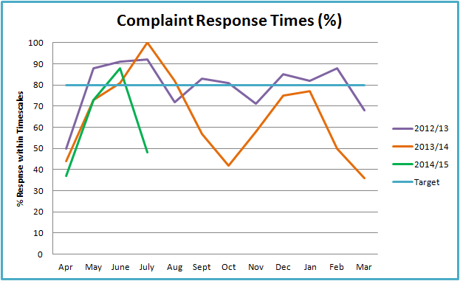

Communication remains a theme for complaints in June and July. The communication issues raised range from patients feeling that they have not been listened to, pain not being taken seriously and families not feeling supported to make decisions to communication on discharge.

To promote effective communication a pilot is being run on the wards in the Emergency Division which is offering different communication cards to patients and their families.

In the Planned Care Division options are being considered to redesign the workforce in order to deliver patient pathways which will facilitate patients being provided with the right information at the right time.

The emerging theme of complaints relating to discharge in June decreased in July with 4 complaints received. Concerns however were raised relating to the appropriateness of a discharge plan for a patient with dementia. Three complaints highlighted that the family had not been kept informed of the discharge plan when it was changed. Further concerns were raised relating to appropriate assessment and the clothing a patient was sent home in. A new discharge policy has been developed and is now being followed. There is great focus on safe and appropriate discharge.

There was an increase in the number of complaints highlighting dignity as a concern, 4 complaints were received. The complaints were received in 4 different areas and related to a range of staff: Clinicians, Nursing staff, Cardiology Specialist. The Trust Lead for dignity has been made aware of each complaint and will review any emerging themes with the Dignity Champions across the Trust. The patient feedback received through the exit card continues to be positive; in May 99% and in June 96.2% patients felt that they had been treated with dignity and respect.

The number of complaints linked to the attitude of staff was the highest since March 2014. In each case the staff member was perceived as being abrupt and insensitive by either the patient or a member of their family. Complaints were received over four different areas; Clinicians were mentioned in two complaints, other staff mentioned were a secretary, a physiotherapist and a ward sister. Each of these complaints related to individual’s behaviour has been address with the individuals concerned by their line manager.

*Figure 12* depicts the key themes identified from complaints in June and July.

**Figure 12:**



**Figure 13:**

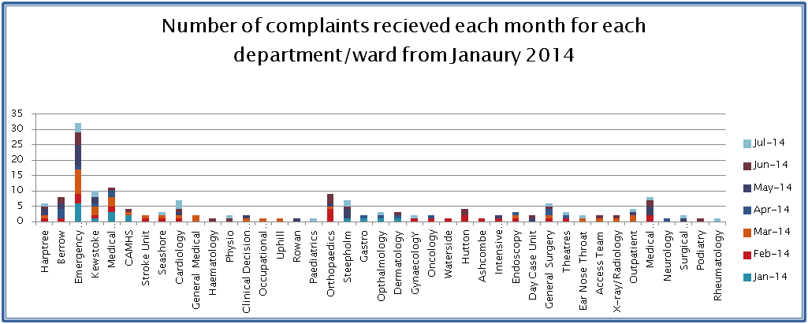

**2.7.2 Compliments**

The number of compliments received in July was 89. A new system of reporting and recording this information has now been introduced.

The Compliments formally recorded are received via email or letter. *Figure 14* depicts three examples of compliments received by the Trust in June. Where appropriate each compliment receives a letter to thank the individual for taking time to comment.

**Figure 14:**

|  |  |
| --- | --- |
| COMPLIMENTS | |
| A thank you from the wife of a patient who died whilst in Hospital | I am writing to say what excellent care was given to my late husband over the weekend 13 June 2014. From the paramedics to casualty, to MAU where the staff were wonderful. A special mention for the doctor and nurse who were with my husband when he passed away.  The care continued for me and my family right through to the bereavement services.  I would also like to mention the Oncology Unit where my husband has received treatment over the past few years. A fantastic team, we have felt among friends and in very safe hands. |
| A thank you from the family of a patient with severe dementia | I am writing to thank staff for their very impressive and effective help to my father at the hospital this year. He has severe dementia and needed urgent attention to reinsert a catheter. He became agitated at reception and would not cooperate with the triage process. I walked him around the grounds; staff understood the difficulty, kept in touch with me on my mobile and admitted him to a booth and inserted a catheter. It was not immediate but I recognise how many pressures are on the Unit. However once in the department a new catheter was quickly inserted. This could have been very problematic and risky. If there had been a significant delay to the bay he could have become aggressive due to his extreme anxiety, but the team quickly gathered and got the job done.  He was also an inpatient for nearly a week just prior to Easter and I thought I should also include my thanks for the support that he and the family received then. Staff were attentive to his needs, and very good at communicating the key messages regarding his treatment to us. They didn’t just wait to be asked and were sensitive to our concerns and anxieties. They were also very good with him. |
| A thank you from a patient who has been an inpatient on two occasions | I recently spent two spells of four weeks and three weeks in Weston General Hospital. The first was under the care of a Consultant on Hutton ward and the second under the care of a different Consultant on West Harptree ward.  May I say in both instances the care, compassion and attention I received was exemplary. Not only that but the efficiency demonstrated throughout my stay was excellent. These statements encompass not only the Consultants and their respective teams but the nursing and cleaning staff which I found attentive and good humoured.  I can only speak for a small number of your staff but I am confident this is reflected throughout your organisation. I believe we are very fortunate to have Weston General Hospital as our local hospital. |

## 2.8 Patient Feedback

As a national requirement Weston Area Health NHS Trust is engaging in the delivery of the Friends and Family Test (FFT). This test has been implemented successfully across all areas. The Friends and Family Test is a single question survey which asks patients whether they would recommend the NHS service they have received to friends and family who need similar treatment or care.

The Friends and Family Test is offered to all patients at the point of discharge and when patients attend the Emergency Department.

Each Division and all wards receive a breakdown of the outcome of their survey results to ensure they can take relevant action to sustain improvements already made and proactively develop actions to deliver further improvement. *Figure 15* provides a detailed report of July’s Friends & Family Test results.

**Figure 15:**

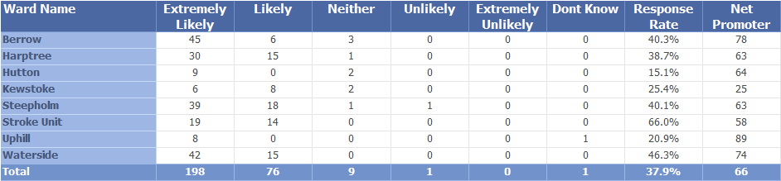

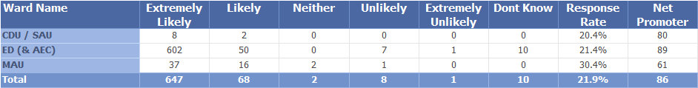

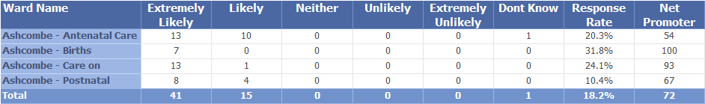

The Commissioning for Quality & Innovation (CQUIN) targets attached to Family & Friends have all been achieved for Quarter One, and the test has been rolled out to all Outpatient Departments, including Oncology and Endoscopy units over the month of July.

The CQUIN targets for 2014/15 are:

1. Implementation of the Test in Outpatient and Day Case Departments.
2. Increase or maintained response rate for Quarter one.
3. Increased Response Rate for Inpatients of a minimum of 40% in March 2015.

### 2.8.1 Inpatients

The response rate for Inpatients is in line with the National Targets, but an increase to 40% is expected in order to meet the CQUIN target for March 2015. To achieve this monthly response rates are being highlighted by ward on notice boards, and creating a positive ‘word cloud’ – an amalgamation of the positive comments left on the questionnaire card with the intention of boosting staff morale to encourage patient participation in the Test.

A Friends & Family champion has been identified on each ward. This is a member of staff whom understands the process and will promote to all, patients and staff in their area.

**Figure 16:**

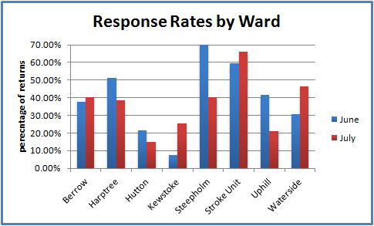

**Figure 17:**



The newly appointed lead for Friends & Family is a well established member of Trust staff, and will be working closely with Harptree, Hutton, Steepholm and Uphill wards to discover why their response rates declined in July and the best ways to increase this score. There is also a plan for capturing the Friends & Family Test information through the Discharge Lounge, and making the test a part of discharge process in this area.

Whilst Net Promoter scores are not related to the CQUIN schedule, they remain an important indicator of patient experience to the Trust and the lead will be spending a period of time on the wards whose Net Promoter scores reduced in July. Any quality issues will be discussed with Sisters, Matrons, Heads of Nursing and Consultant teams to identify actions for improvement. NHS England issued updated guidance on the Friends and Family Test in July 2014 and the implications of this updated guidance for the Trust are currently being assessed.

### 2.8.2 Emergency

Emergency care areas have achieved the required target of 20% response rate whilst maintaining an excellent Net Promoter score and have been congratulated on this. They continue to promote the filling in of the test to patients and are prompt with collection and submission of results. As a result of the latest guidance released by the Department of Health there is now a significant focus on patient’s comments. As a result the Emergency teams will actively encourage patients to write any comments relevant to their experience. Comments will be collated and electronically logged each month for use in the Performance and Patient Experience teams.

### 2.8.3 Maternity

Maternity response rates remain low, with difficulties in obtaining feedback for all points that patients are asked the question (both antenatally and postnatally).

The new lead for the Family & Friends Test is working with the Maternity Department to discover how best to increase the response rates. The Maternity Touch Points have been evaluated and for patients in the community, it has been agreed that a text messaging service may be the best way to capture the responses and boost overall Maternity response rate. A quote for this service has been submitted, based on historical activity figures for the Trust and the lead is fine tuning this information before creating a business plan for review.

To continue, the Midwifery Matron has highlighted the importance of continuing with the post card method with her teams.

## 2.9 Mortality Data

The latest iteration of the Summary Hospital Mortality Index covers the year to December 2013 and has a value of 1. This indicates that mortality within the Trust for the period covered is exactly as expected given the age and co morbidities of the patients treated, shown in *Figure 18*.

**Figure 18:**

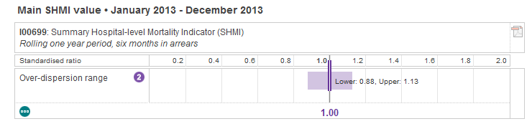

Whilst the SHMI describes the overall picture for hospital and community deaths *Figure 19* illustrates the Trust’s position (red dot) relative to the national picture for those deaths which occurred only in the hospital setting for the period April 2013 to July 2014. Again the Trust’s performance is better than anticipated.

**Figure 19:**

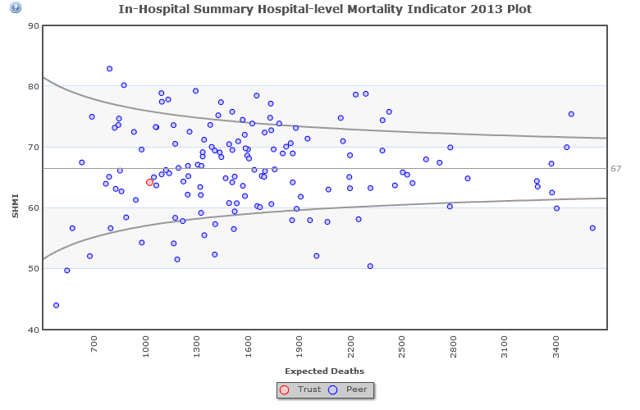

**2.10 Infection Prevention & Control Performance**

**2.10.1 Clostridium Difficile**

The Trust has a set trajectory for Clostridium Difficile for the year 2014/15 of no more than 17 cases. In June there were two Hospital attributed cases; there were no cases in July.

The antimicrobial stewardship strategy and programme for the Trust was approved at the July Infection Prevention and Control Committee. The programme of audit is now well established and an antimicrobial stewardship committee met for the first time in July 2014.

**2.10.2 MRSA/MSSA bacteraemia**

There has been one incidence of MRSA bacteraemia in July against a null target. An investigation of this has been completed which demonstrated learning related to ongoing screening programmes and general clinical management of the patient. The investigation did not identify issues with specimen collection as were found in previous MRSA and MSSA bacteraemia investigations.

There were no Hospital attributed MSSA bacteraemia during June and July.

**2.10.3 Hand Hygiene Audits**

In June the wards reported hand hygiene compliance at the point of need of 98%, and in July 95%.

**2.10.4 Carbepenemase Producing Enterobacteriaceae CPE**

National guidance requires that the Trust Board is made aware of all cases of CPE that occur in the Trust. There have been no patients identified with CPE in June or July 2014.

**2.10.5 Outbreaks**

There have been no outbreaks in June and July 2014.

**2.10.6 Training**

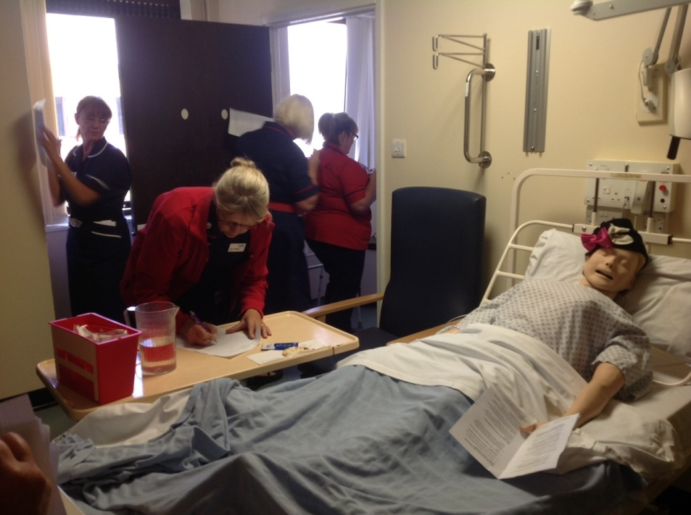The availability of a side room on Cheddar ward has enabled the Infection Prevention and Control Team to use a novel method to train staff. Using a concept adapted from the West Midlands Infection Prevention Society the team have set a scenario whereby a side room is mocked up to show infection control infractions. All staff members are invited to visit the sideroom and identify risks and mistakes which include control of transmission of infection, patient safety and holistic care. This activity supports compliance to statutory and mandatory training figures.

**2.11 Maternity**

The maternity team achieved variable results both its national targets for initiating breastfeeding in-hospital and mothers not smoking at the time of delivery in June and July.

All midwives and maternity support staff now have access to the online Quit Manager referral service. The Matron is receiving reports from SmokeFree North Somerset on the number of referrals.

The Infant Feeding Specialist Midwife is currently undertaking the annual audit of breastfeeding standards as required by UNICEF UK Baby Friendly to maintain full Baby Friendly Status.

Two initiatives have been implemented to increase the number of women choosing to give birth at Ashcombe Birth Centre:

* 1. Provision of an overnight stay for the birth partner in a single room with the new mother and baby on the first night after birth. Sleeper chairs have been purchased and a pathway and service-user information developed.
  2. A midwife-led clinic on Ashcombe Birth Centre for women who are 36 weeks pregnant and suitable for midwife-led care in labour. This takes the place of the routine community appointment with the named-midwife, and includes a tour of Ashcombe Birth Centre and information on the services provided.

## 2.12 Venous Thrombo-Embolism (VTE)

The completion of the VTE risk assessment and the necessary actions as a result of the assessment is vital for patient safety to ensure that patients are not at risk of unnecessary harm from avoidable DVT or pulmonary embolism.

The Trust is aiming to achieve 100% of inpatients receiving a VTE risk assessment according to NICE guidance in 2014/15. In June the Trust improved performance and achieved the national target of 95% with 98.4% of appropriate patients receiving a VTE risk assessment. The proactive monitoring of compliance to assessment within 24 hours will continue until at least March 2015 to ensure this assessment is well embedded in practice.

# Section 3 Operational Performance

## 3.1 Executive Summary Headlines

* In Quarter one the Trust achieved seven of the eight national cancer targets.
* The Trust continues to reduce the number of patients waiting over 16 weeks in line with the national requirement set by NHS England.
* The Emergency Department Four Hour target was achieved for the seventh consecutive month in June but an unexpected and significant change in activity volumes, flows and acuity meant that the target was not achieved in July. A robust action plan and daily monitoring is in place.
* The focus on optimising the patient pathway has lead to continued reduction in the average length of stay and the number of patients in the hospital with a length of stay over 10 days.

## 

## 3.2 Operational Performance

The following sections detail the Trust performance against a number of key indicators. The report is divided into:

* *Clinical Indicators*
* *Clinical Pathways*
* *Emergency Access*
* *Elective Access*
* *Patient Flow*

## 3.3 Clinical Indicators

*This section analyses the clinical indicators which directly influence operational performance.*

### 3.3.1 Emergency Readmissions

An emergency readmission is defined as an unplanned readmission within an identified time of leaving the hospital. The ideal readmission rate is zero however this is not always possible as patients can have multiple co-morbidities or long-term conditions which require frequent medical attention. Monitoring emergency readmission rates is important to the Trust as it can help to prevent or reduce unplanned readmissions to hospital.

The Trust monitors emergency readmissions within 14 days and 30 days. As illustrated in *Figure 20* performance continued to improve across June & July.

**Figure 20:**

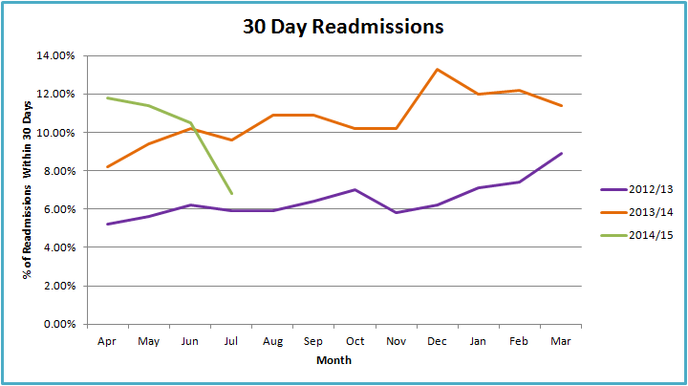

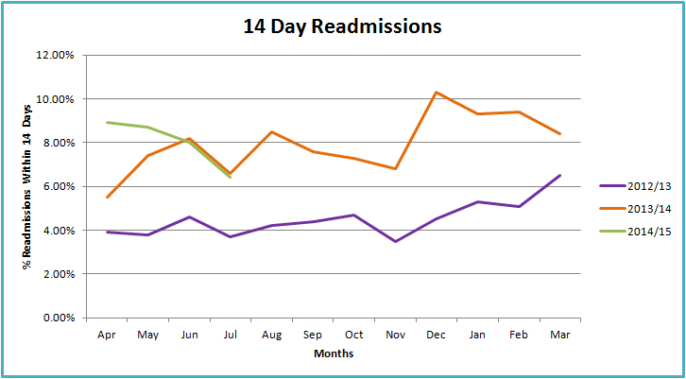

**Trust Action:**

To provide additional assurance that emergency readmissions are not related to the original episode of care, the Emergency & Urgent Care Division are undertaking regular audits of the readmissions to provide assurance that patients are not being readmitted as a result of the Trusts treatment and care.

### 3.3.2 Average Length of Stay

The average length of stay (ALOS) refers to the average number of days that patients spend in hospital. The Trust strives to have a length of stay below the Trust target as it demonstrates proactive planning of the whole process of care, as well as active discharge planning. In July the average LOS reduced further to 2.2 days which demonstrates the significant work put into streamlining and optimising the patient’s journey.

**Figure 21:**

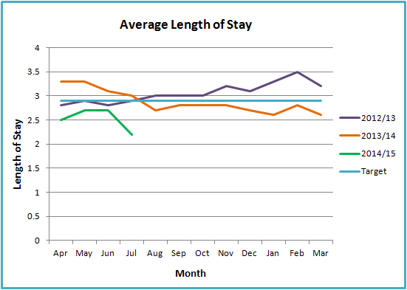

The Trust also monitors the percentage of patients with a length of stay (LOS) over 10 days. The programme of work to improve patient pathways and the level of care alongside the focus on the Green to Go list has enabled the Trust to continue to experience a reduction in the percentage of patients with a LOS over 10 days.

**Figure 22:**

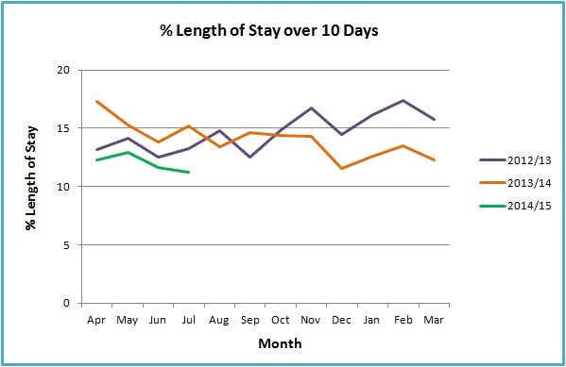

**Trust Action:**

In addition to the work streams already underway as part of the Trusts business plan, the operational teams are focussing on optimising the ward board rounds. A ward board round takes place twice during the day and is where the multi-disciplinary clinical teams review each of the patient in detail using the rounding tool. This will ensure that throughout the patients stay all necessary actions are undertaken on time and in line with the clinical pathway for the patient. Each ward has also been allocated a senior manager to support the teams to deliver and unblock any difficulties that arise.

## 3.4 Clinical Pathways

*This section sets out performance indicators related to key clinical pathways, including cancer and stroke.*

## 3.4.1 Cancer Services

The Trust strives to achieve the national cancer waiting times as they are important to patients clinical outcomes, are a measure of how the Trust is responding to demands for services, and highlights where there are delays in the system. In June the Trust achieved all eight of the national cancer targets.

#### 3.4.2 Cancer Two Week Wait

The two week wait target was achieved in both May and June with a score of 95% and 97.9% respectively. Unfortunately the Trust was unable to achieve the two week wait target for referrals with breast symptoms for quarter one but is on track to be achieved in July in line with the recovery plan.

**Trust Action:**

A number of actions are being undertaken to improve performance against the Breast Symptomatic target:

* There was a 15% increase in referrals from 2012/13 to 2013/14. The Cancer manager is undertaking a capacity and demand analysis alongside the Breast Multi-Disciplinary Team. The results of this analysis will inform a redesign of the service to meet the increasing demand.
* The main cause of breaches was patient choice, where patients were not made aware of the need to attend their appointment within two weeks. To support GP's and other health care professionals to inform patients of the need to attend within two weeks, the Cancer team have developed a patient fast track leaflet which will explain the process to patients. This has been approved by Somerset CCG. North Somerset CCG is currently reviewing the leaflet with their membership.
* A review is being undertaken into how the Trust processes the breast symptomatic referrals to ensure that it is streamlined and does not delay patients from receiving an appointment.

#### 3.4.3 Day Target

The Trust achieved all three of the 31 day targets in May, June and for Quarter one demonstrating the Trusts ability to effectively treat patients once diagnosed with cancer.

**Trust Action:**

Daily monitoring of performance by the MDT Coordinator and cancer team leader.

Weekly monitoring at the Waiting List Forward Planning meeting.

3.4.4 Day Target

The Trust achieved the 62 days standard for quarter one and the months of May and June which is a significant improvement for the Trust. Unfortunately the Trust did not achieve the 62day upgrade standards a result of the single figure number of patients treated within the month and the effect of patient choice.

**Trust Action:**

Daily monitoring of performance by the MDT Coordinator and cancer team leader.

Weekly monitoring at the Waiting List Forward Planning meeting.

## 3.4.5 Stroke

Whilst the Trust achieved the stroke target of patients diagnosed with a stroke spending 90% of their time on the Stroke Unit for 80% of patients in quarter one, unfortunately as a result of the pressure on patient flow in July the Trust did not achieve the target with a score of 75% (*Figure 23*).

**Figure 23:**

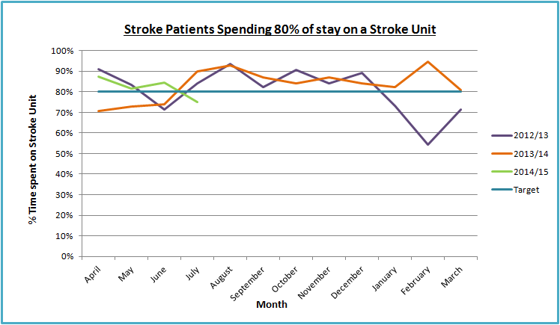

**Trust Action:**

The patient flow team have been instructed to create and keep a stroke hot bed for both sex’s available at all times. This will ensure that patients diagnosed with a Stroke or TIA in the Emergency Department can be transferred straight to the unit to start their care and treatment.

## 3.5 Emergency Access

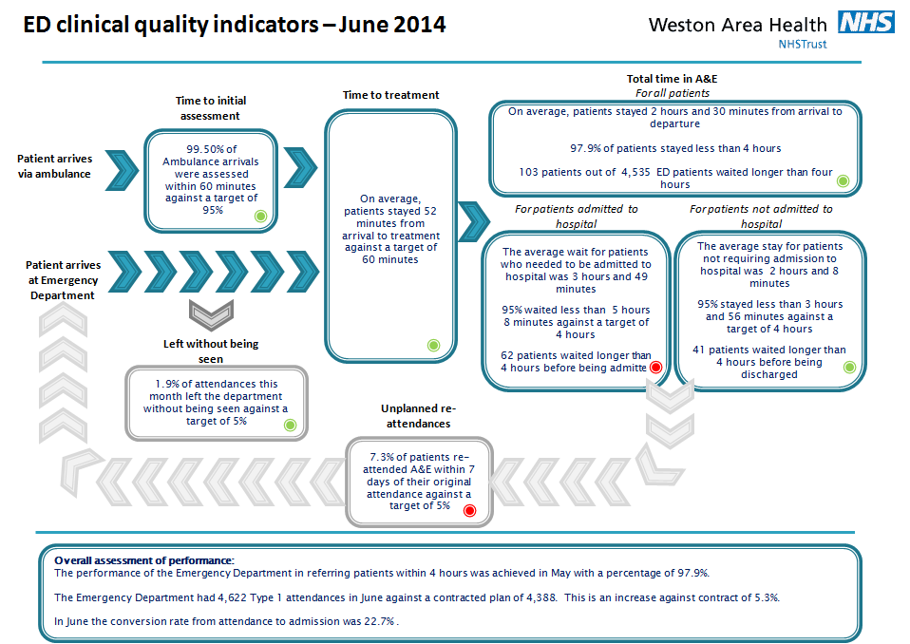

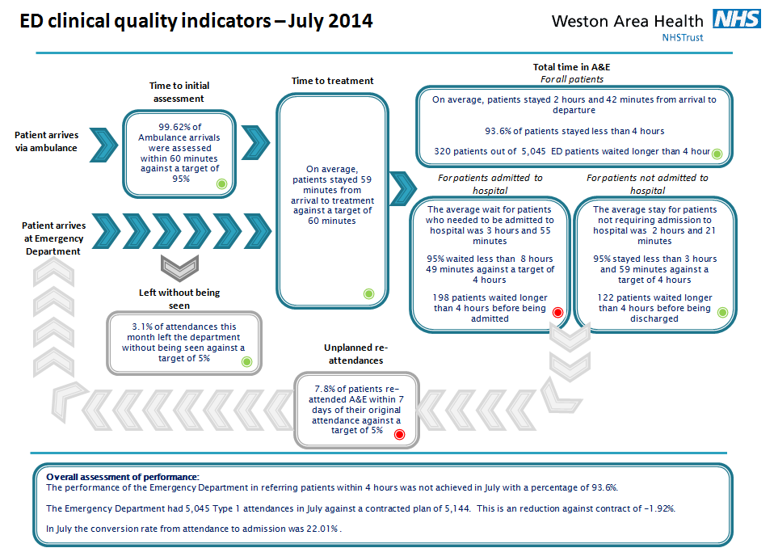

### 3.5.1 Emergency Department (ED) Performance

The NHS constitution set the national standard wherein 95% of all patients attending NHS Emergency Department’s spend a maximum of four hours in the department before being discharged, referred/transferred to other services or admitted to the hospital and transferred to an inpatient bed. The target was achieved in June (97.96%) but was not achieved in July (93.66%) as illustrated in *Figure 25*. This as a result of two key factors:

1. The increase in demand for beds (emergency and elective) has outstripped capacity despite the continued reduction in the length of stay.
2. In July the Trust experienced a sudden spike in activity between 17:00 and 19:00 which put significant pressure on the Emergency Department. This activity is a mixture of both an increase in walk-in patients and ambulance arrivals.

**Figure 24:**

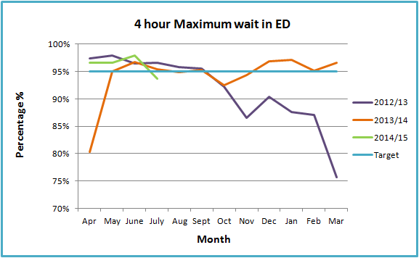

**Trust Action:**

* The Trust has undertaken a detailed review of internal and external performance and activity data to understand the causes behind the sudden drop in performance. The review has been shared with key staff internal and external to the Trust to support the development and implementation of the necessary actions to bring about positive change.
* North Somerset CCG has increased the daily calls from three to five days per week to ensure that performance across the health and social care system is reviewed in detail to ensure all capacity is maximised to manage patients the most effective and caring manner.
* Trust has increased the number of site meetings throughout the day and increased the seniority of attendance to ensure appropriate actions are taken and barriers escalated both internally and externally.
* Daily review meetings are held each morning with ward representation, matrons and senior management where all breaches and any issues highlighted are reviewed in detail with clear actions.

# 3.6 Elective Access

*This section reviews the key elective access targets to understand the effectiveness and the quality of care throughout the elective care pathways.*

### 3.6.1 Referral to Treatment (RTT)

The NHS constitution states that patients have the legal right to start their NHS consultant-led treatment within a maximum of 18 weeks from referral, unless the patient chooses to wait longer or it is clinically appropriate to wait longer. For the months of June and July the following sub-sections will review the Trust performance against the three national 18 week targets.

### 3.6.2 Referral to Treatment (RTT) Admitted

The Trust did not achieve the admitted 18 week target in June and July in line with a plan agreed with the Clinical Commissioning Group and the Trust Development Authority to enable the Trust to treat all patients over 18 weeks for Urology and Trauma & Orthopaedics.

**Figure 25:**

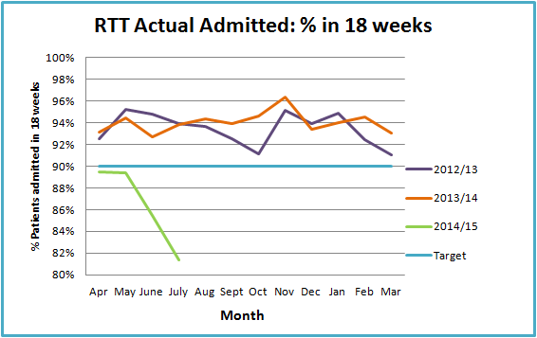

**Trust Action:**

The Trust continues to reduce the numbers of patients over 18 weeks for Trauma and Orthopaedics and Urology in line with the agreed trajectory. There are now no patients waiting over 18 weeks within the speciality of Urology.

The Trust continues to undertake weekly waiting list forward planning meetings where the waiting list for each specialty and the theatre timetable is reviewed by the Assistant Divisional Manager of Planned Care, Access Manager and Theatre Manager. From the new financial year this has been strengthened with the Director of Operations in attendance. The Trust aim to bring patients in within 16 weeks and additional finances have been agreed to assist with this.

### 3.6.3 Referral to Treatment (RTT) Non-Admitted

The Trust continued to achieve the non-admitted target in June as illustrated in *Figure 26.*

**Figure 26:**

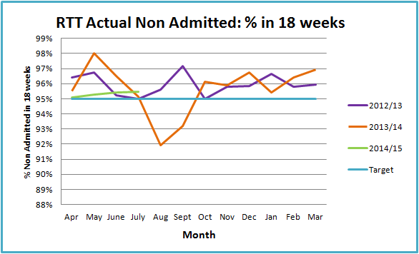

**Trust Action:**

The Trust will continue to undertake waiting list forward planning meetings where the waiting list for each specialty and the theatre timetable is reviewed on a weekly basis with the Assistant Divisional Manager of Planned Care, Access Manager and Theatre Manager. This has been strengthened with attendance of the Director of Operations to ensure improvement trajectories are delivered moving forward.

### 3.6.4 Referral to Treatment (RTT) Incomplete

The 92% target was achieved for June 2014 as illustrated in *Figure 27*.

**Figure 27:**

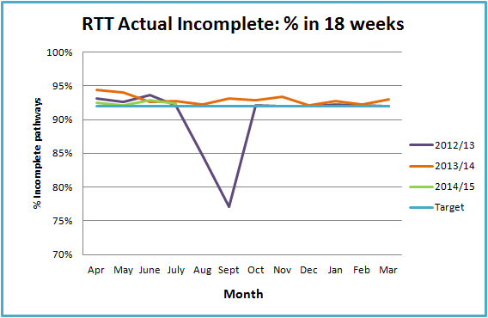

**Trust Action:**

The Trust will continue to undertake waiting list forward planning meetings where the waiting list for each specialty and the theatre timetable is reviewed on a weekly basis with the Assistant Divisional Manager of Planned Care, Access Manager and Theatre Manager, attendance has now been strengthened with the Director of Operations in attendance.

Towards the end of June 2014, The Trust received notification that the planned fail of the RTT was extended throughout July and August. Therefore there will be not be reporting information available for this period.

### 3.6.5 Choose and Book

In June and July the Trust did not achieve the 96% National target for Choose and Book slot availability target as depicted in *Figure 28.* Current performance is caused by a number of factors:

* The planned closure and transfer of two clinical services to specialist providers has impacted on the ability to provide slots ahead of the move.
* The Trust has experienced a continued increase in two week wait referrals resulting in choose and book slots being used to provide additional urgent appointments
* Capacity provided by visiting Trusts has not been enough to match demand leading to no slots being available for patients.

**Figure 28:**

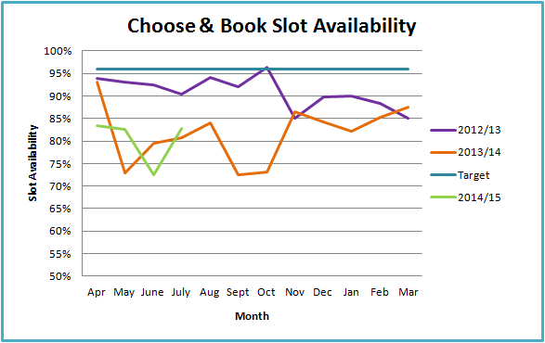

**Trust Action:**

A plan is being developed to redesign the entire Planned Care pathway from referral to treatment as it forms a key part of the Trust's Business Plan. As part of this work demand and capacity and the process of referral is being reviewed which will significantly improve performance against the Choose & Book target in the long-term.

In the short-term the Trust is working closely with the provider Trusts of the visiting services of ENT and Ophthalmology to ensure that the Trust receives the capacity required. Also, work is ongoing to increase internal capacity trough additional waiting list initiatives and changes to job plans to facilitate increased capacity.

### 3.6.6 Cancelled Operations

Minimising the number of last minute cancelled operations for non clinical reasons is a key target for the Trust. Elective surgery can be cancelled for a number of reasons including:

* Hospital Beds unavailable
* Surgeon or Anaesthetist unavailable
* Emergency case needing theatre
* Theatre list over-ran
* Equipment failure
* Administrative error

In April and May the Trust did not achieve the internal Trust target for the cancellation of elective care operations for non-clinical reasons.

**Trust Action:**

To reduce the level of non-clinical cancellations a Theatre Scheduling meeting has been introduced where the theatre team, access team and operational managers will meet to review all theatre lists to ensure that all the theatre kit is ordered, the patient mix and order is optimised and to provide an opportunity to learn from past mistakes through reviewing cancellations and putting in place actions to stop reoccurrence.

## 3.7 Patient Flow

*To support the delivery of key operational targets, it is vital that the Trust has good patient flow. An important aspect of ensuring good patient flow is the level of discharges throughout the day and at the weekend.*

### 3.7.1 Delayed Transfer of Care

A delayed transfer of care is defined as when a patient is ready for transfer from acute care, but is still occupying an acute bed. Patients can be delayed for the following reasons:

* Further assessment required before their discharge destination can be decided
* Lack of capacity in local nursing/residential homes
* They may require a specialist placement
* Patient or their family/carer needs more time to make a decision about a long-term placement

The Trust monitors performance daily against delayed transfers of care as high levels can have a big impact on the daily numbers of discharges, causing delays in allocating beds for emergency admissions or planned operations. Performance in April fell slightly compared to the previous month, but significant reduced in May to 1.96% (*Figure 29*). This demonstrates that the introduction of the new case manager team and the use of the **‘Green to Go’** list is having the desired impact.

**Figure 29:**

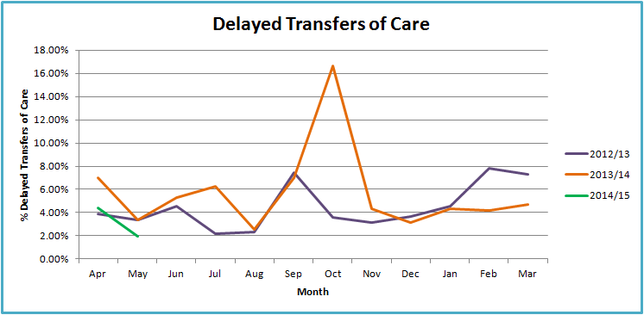

**Trust Action:**

The site manager and senior case manager are visiting both Clevedon community hospital and Burnham community hospital to further strengthen relationships and facilitate a streamlined process for the referral and acceptance of patients.

The Trust continues to work with health and social care partners in North Somerset to manage the **‘Green to Go’** list, and where gaps in services are discovered, work with the Clinical Commissioning Group to identify how future commissioning can be organised to close these gaps, providing higher quality joined up care between all partners. The numbers on the list are monitored daily on the system operational calls which include all partner organisations.

# Section 4 Workforce

## 4.1 Executive Summary Headlines

* The temporary staffing cost in June was 8.1% of the total pay bill compared to 9.9% in July.
* Sickness rates were 3.88% in June and 4.53% in July.
* The appraisal rate was 84.22% in June and 85.54% in July.
* The training compliance rate was 82.74% in June and decreased to 81.61% in July

## 

## 4.2 Workforce

*Figure 30* below shows the pay expenditure for contracted staff, for agency staff.

## Figure 30:

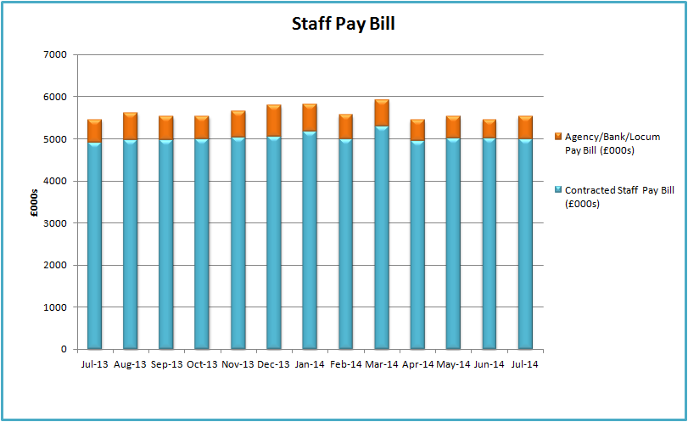

*Figure 31*, shows the temporary staffing usage as a month on month comparator. There is a significant decrease in June in the nurse agency usage. This is mainly attributed to the closure of Cheddar Ward which reduced temporary staffing requirements and enabled the Trust to use permanent staff more effectively. At the end of July there were 8.73 vacancies across the core ward areas.

The nurse agency usage in July has increased; reports generated from the e-rostering system identify an increased level of annual leave being granted during July and August, which has an adverse impact on our temporary staffing usage. Sickness across nursing (registered and unregistered) has remained consistent between months and will not have resulted in an increased requirement for temporary staffing.

Recruitment to the medical workforce remains a challenge across all areas; however we continue to work hard to attract high calibre candidates. In the last two months we have successfully recruited to the Emergency Department, Radiology department and surgery. Gastroenterology and community paediatrics remain a challenge and we are working on a number of initiatives in an attempt to fill these gaps.

**Figure 31:**

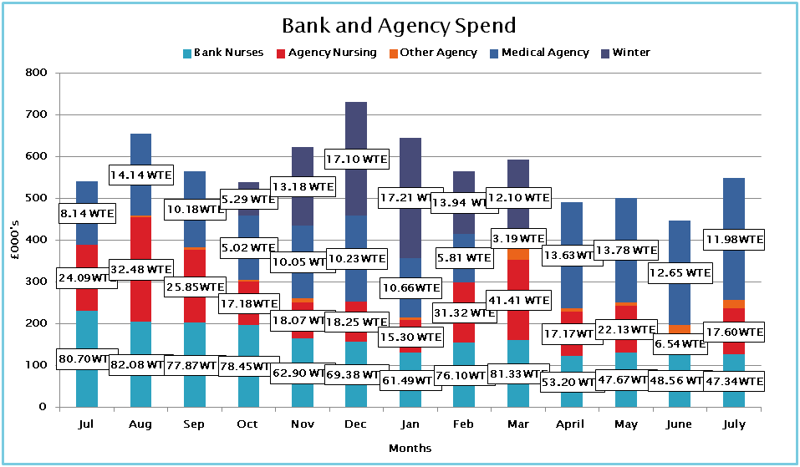

### 

### 4.2.1 Sickness

Sickness reduced in June to 3.88% but increased again in July to 4.53%, with the current run rate significantly higher compared to the same period last year. Sickness rate in the Planned Care Division is high at 5% and is having a significant impact on the Trusts overall sickness rate. Audits of the worst performing areas across each division have been completed to identify those areas that are managing sickness absence in accordance with Trust policy. Managers will be provided with guidance, support and direction on the correct application of the policy.

**Figure 32:**

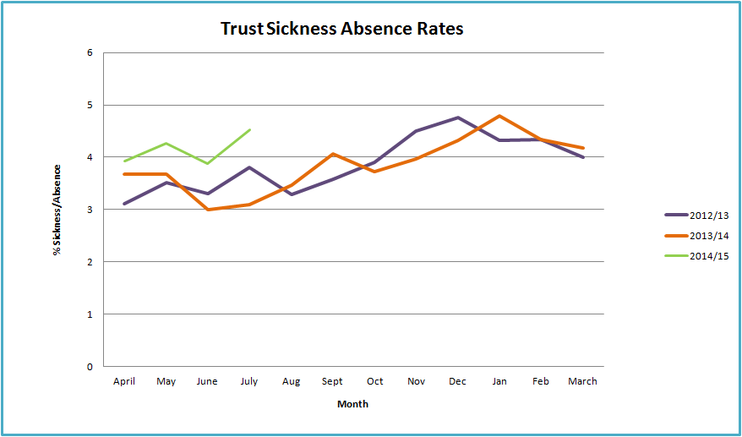

* Trust standard is ≤ 3.0%

### 4.2.2 Statutory/Mandatory Training

The statutory/mandatory training compliance rate was 82.74% in June and decreased slightly to 81.61% in July. A new and robust approach is being taken by the Trust against staff who continually fail to meet their contractual requirements for training.

### 4.2.3 Appraisal

The appraisal compliance rate for June 84.22% and increased to 85.54% in July to reach the Trust target. Achieving and maintaining the Trust compliance rate is a priority, but it is also important that we ensure appraisals are carried out to a high standard and that they are meaningful.

### 4.2.4 Celebration of Success

The Trust held its inaugural celebration of success awards ceremony in July, which was well received by all that attended, with winners from a range of departments and specialities. Awards were presented to employees and volunteers for the following categories:

* PRIDE of PRIDE Award - Cancer Office Team
* Patients’ Ally Award - Helen Anderson, Tissue Viability Nurse
* Gold Award - Lynne Lane, Dispensary Manager
* Nurse of the Year Award - Sue Bebber, Collaborative Care Team
* Nursing Assistant of the Year Award - Janet Feeney, Stroke Unit
* Clinician of the Year Award - Dr Eilidh Gunn, F1 Doctor
* Team Spirit Award - Collaborative Care Team
* Newcomer of the Year Award - Samira Halila, Modern Apprentice
* Volunteers Award - Anne Clarke, X-Ray

### 4.2.5 Staff Friends and Family Test

From April 2014, all acute, community, ambulance and mental health services were required to survey all of their staff at least once a year and ask them the following questions:

1. How likely are you to recommend this organisation to friends and family if they needed care or treatment?
2. How likely are you to recommend this organisation to friends and family as a place to work?

In May of this year, a third of our staff, received postcards attached to their payslips which they were asked to complete and return in post boxes located around the hospital site.

Results from Quarter 1 (April-June) indicate that 65% of staff who responded were either likely or extremely likely to recommend the organisation as a place to receive treatment whilst 62% of staff are either likely or extremely likely to recommend as a place to work.

National results for Quarter 1 will be published in September this year.

A further third of our staff will be surveyed in August and these results (Quarter 2) will be available to the Trust at the beginning of October.

# Section 5 Finance

## 4.1 Executive Summary Headlines

* The financial position at Month 4 is that the Trust is reporting a year to-date deficit of £1,478k which is in line with the plan.
* Overall income is £178k over plan at the end of July.
* Overall expenditure is £178k over plan at the end of July.
* The Trusts plan for the year is a deficit budget of £4.95m.

### 

### **5.1.1 Statement of Comprehensive Income Position to Date**

The financial position at Month 4 is that the Trust is reporting a £1,478k deficit which is in line with the annual plan.

Revenue from patient activity is £166k over plan for the 4 months to the end of July 2014. Other sources of income are £12k over plan.

Overall expenditure for pay, non pay and depreciation is £185k over plan for the 4 months to the end of July.

The Trust’s Service Improvement Programme (SIP) is below target by £14k with a year to date achievement of £1,179k against the target of £1,192k.

The adjusted run rate for expenditure has increased by £251k in July when compared with the June level.

### **5.1.2 Statement of Comprehensive Income Position In Month**

Income from patient care activity is £209k more than plan whilst other sources of income generated £72k more than plan.

Pay and non pay expenditure, including savings delivery, is £282k over plan for the month of July.

The Trust’s Service Improvement Programme (SIP) delivered £338k in July against a plan of £370k and is now £14k below target for the year to date.

### **5.1.3 Cash**

The cash plan for 2014/15 is to hold a balance of £532k at 31st March 2015 and this will be delivered through the in year management of cash and working balances. The cash balance of £4,269k, as at 31st July, is £2,908k higher than the planned position of £1,361k.

The Trust has submitted an application in June 2014 for £4,950k permanent Public Dividend Capital (PDC) Revenue, similar to last financial year. The application was via the NHS Trust Development Authority and to the Independent Trust Financing Facility Committee. We are waiting formal confirmation of approval and this will ensure that there is sufficient cash to pay all commitments in this year.

### **5.1.4** External Financing Limit

The Trust’s External Financing Limit will be achieved through the management of cash and working balances along with the planned level of Public Dividend Capital.

### **5.1.5 Capital Resource Limit**

The capital resource limit is £3,858k an in addition to this the Trust is due to receive £124k matched funding from the NHS Safer Hospital, Safer Wards Technology Fund for the implementation of a new Order Communications system. Therefore the Trust’s anticipated forecast capital resource and spend on capital projects is £3,982k at 31st March 2015.

As at the 31st July the programme has delivered capital expenditure of £78k. The Trust will operate within its Capital Resource Limit and continued capital programme management will enable this to be achieved. There are two approved business cases which will commit the majority of the funding for the year, dependant on the timing of implementation.

### **5.1.6 Capital Cost Absorption rate**

The Trust’s Capital Cost Absorption (CCA) rate is fixed at 3.5% and this will be calculated based on 3.5% of actual balance sheet values at the end of the financial year.

### **5.1.7 Better Payment Practice Code (BPPC)**

The Trust’s overall performance as at 31st July is 96.7% on the BPPC.

### **5.1.8 Forecast outturn**

The Trust is forecasting to deliver the plan for the year although this will require delivery of the Trusts savings plans and the continued management of the Trusts services within the available budgets.

### **5.1.9 Risk to delivery of financial plan**

The major financial risks are the delivery of the £4.5m savings programme, the management of Medical staffing to minimise locum agency expenditure and the delivery of NHS service income in line with plan.

Financial Dashboards 2014/15: Month 4



## 5.2 The Income and Expenditure Position of the Trust

**5.2.1** The financial position at Month 4 is a deficit of £1,478k, which is in line with the plan.

## 5.3 Expenditure

**5.3.1** The main points are:

* The position is that overall the Trust has overspent the expenditure budgets by £185k which includes under delivery of Savings (SIP) of £14k.
* Pay expenditure is higher than budgeted with an overspend of £128k. The staff category with the highest overspend at the end of July was Nursing (£152k), this was due to an increase in annual leave plus a small increase in vacancies resulting in a significant increase in agency expenditure. This overspend was offset by an underspend in the following categories AHP’s (£153k), Admin and Clerical (£83k) and Biomedical Scientists (£50k).
* Non pay expenditure is £57k over budget at the end of July, including the underachievement of savings. There are underspends on Training (£52k), Office Equipment (£39k), Rent & Rates (£24k) and Blood Products (£33k), offset by overspends on Internal recharges (£41k), Linen & Laundry (£40k), Management Consultants (£38k) and Utilities (£34k).
* Bank and agency expenditure on Nursing increased in July. In month the nurse agency expenditure increased significantly, despite the reduction in bed capacity as part of the savings programme, to £110k (up from £45k in June) and nursing bank reduced slightly to £127k (down from £130k).
* In recent months the Trust has an increasing number of Medical staff vacancies which has led to an increase in the use of Agency locums to cover the Trusts regular bed base. In July £294k was spent, up from £250k in June, the highest level required to cover the regular bed base during the last 2 years. Some of this locum expenditure is offset by the medical staff vacancy savings particularly in ED where there are a total of 9 vacant posts (a £95k under spend in month) and Medicine where there are a further 11 vacancies (£75k under spend in July).

**5.3.2** At Month 4 the main points for the Divisional and Corporate performance are as follows:

* The Emergency Division has underspent by £51k year to date. Of this, Pay expenditure is overspent by £119k whilst Non Pay is underspent by £110k. There is SIP over delivery of £59k. The Pay overspend is mainly due to Medical Staffing (£59k), Uphill (£55k), Kewstoke (£40k) and ED (£39k), offset by an underspend on Pathology (£39k). The Non Pay underspend is mainly due to a saving on drugs (£90k).
* The Planned care Division has overspent by £214k year to date. The pay overspend is £34k whilst non pay is overspent by £149k. The divisional income is £18k above the planned level. The SIP underachievement is £49k. The non pay overspend is mainly on drugs (£88k) and Theatres (£52k) offset by savings on Radiography (£32k), PPU (£30k) and Blood (£10k)
* The Estates and Facilities Division has overspent by £94k at the end of month 4, mainly due to savings non-delivery of £47k, a Pay overspend of £30k and a Non pay overspend of £23k. The Divisional income is £7k above plan. The Pay overspend is due to Housekeeping additional hours (£26k) and Property Services having to employ agency cover for a vacancy (£11k). The non pay overspend is mainly on Utilities (£30k) and Property Services (£5k) offset by an underspend on Rates (£14k).
* The Corporate Departments have underspent by £119k year to date.

Reserves have been deployed to cover spend where there are agreed allocations such as the cover of Medical agency premiums and agreed waiting list initiatives.

**5.3.3** The Trusts expenditure run-rate information has been rebased to neutralise the affect on both expenditure and budgets for variations in monthly NICE funded drugs expenditure which has no overall impact on the Trusts net financial position. There have also been some amendments for one-off exceptional items. The Trust’s expenditure run rate is shown in the table below compared to the adjusted expenditure level for each month of 2013/14.

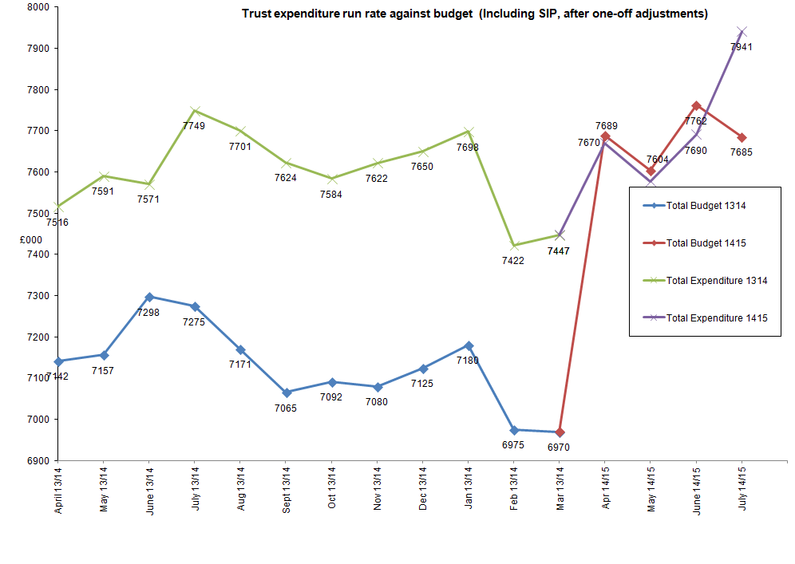 The budgeted adjusted run rate for July is £7.685m. The adjusted expenditure run rate has increased in July by £251k, from £7.690m in June to £7.941m in July.

The main increases were against the following categories –Drugs £143k, Medical staffing £53k, Nursing £34k.

## 5. 4 Savings Plans (SIP)

**5.4.1** The Trusthas a savings requirement of £4,500k for the year which represents 4.45% of expenditure budgets. Savings plans have delivered £1,179k against the profiled plan of £1,192k for the four months, an under-delivery of £14k. Of the SIP savings delivered £729k is from recurrent schemes and £450k from non-recurrent schemes. In month the Trust delivered £338k against the £370k required. The Trusts performance against its monthly SIP savings requirement is shown below along with the monthly phased plan.

The Trust will take actions to ensure that the savings plans are implemented and milestones are met, with mitigating action taken where needed, to maximise the delivery of savings. Progress of individual schemes will be reviewed at the monthly Business plan delivery meetings.

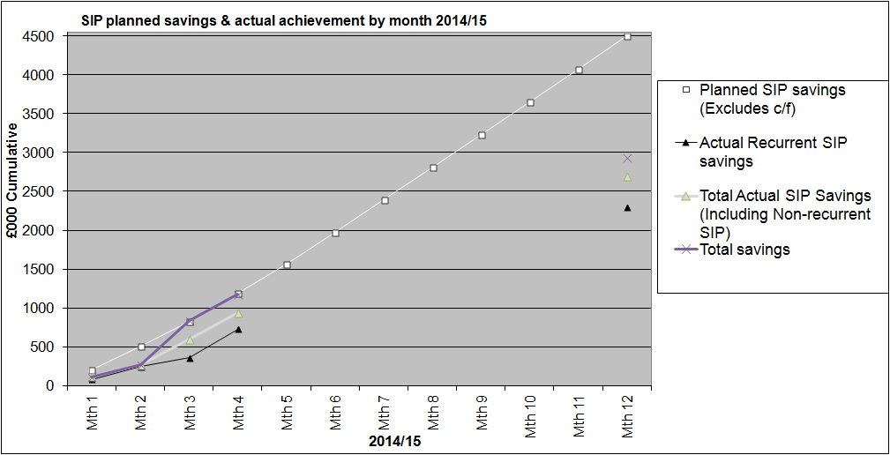

## 5. 5 Activity and Income

* + 1. Overall patient activity income is assessed at £166k above plan at the end of July 2014. This will include the impact of the RTT additional work that has been commissioned by the CCG and which will be separately identified as we conclude the work.
* Income related to North Somerset CCG contract is £224k under plan and private patients is £57k under plan.
* Income related to the NHS Somerset contract is £147k over plan, other CCG patient care activities is £88k over plan, Specialist services contract is £183k over plan and Local authorities is £29k over plan.



Significant volume variations in performance are shown in the table below:



**5.5.2** The following table shows the overall activity for the period ended 31st July 2014:



## 5.6 CQUINS

**5.6.1** A provision of £100k (16.0%) for CQUIN’s has been included in month 4 as a potential income underachievement and it will be reviewed during the year.

## 5.7 Penalties

**5.7.1** A provision of £44,000 for fines has been included as an estimate of the potential penalties for the period ending 31st July 2014 for Referral to Treatment, Cancer access, Emergency Department 4 & 12 hour waits and Ambulance handovers. The detailed assessment is shown in the table below. This will be updated as the validation of performance in these areas is finalised.



**Referral to Treatment penalty by specialty**



## 5.8 Statement of Financial Position

**5.8.1** The Trust’s main accounting statements are shown in the appendices of this report and see Appendix B for the Statement of Financial Position as at 31st July 2014.

#### Cash

**5.8.2** The External Financing Limit will be achieved by in year management of cash and working balances. The cash balance of £4,269k, as at 31st July, is £2,908k higher than the planned position of £1,361k.

The difference between actual cash balance held £4,269k and the reported £4,554k relates to un-presented cheques and cash in transit as at 31st July 2014.

The forecast balance as at 31st March 2015 is £532k which will ensure that the Trust meets its requirement to remain within its External Financing Limit.

#### Debtors

**5.8.3**. The figures from the debtors system represent invoices raised for which cash has yet to be received. The total outstanding debt as at 31st July is £709k, which is divided between NHS £467k, Private Patients £41k and non NHS £201k. Debts over 250 days represent £74k which is 10.4% of the total debt.

#### Creditors

**5.8.4** The measure for the better payment practice code is to pay all NHS and non-NHS trade creditors within 30 calendar days of receipt of goods or a valid invoice (whichever is later), unless other payment terms have been agreed. The compliance is for at least 95% of invoices to be paid (by the bank automated credit system or date and issue of a cheque) within thirty days, or within agreed contract terms. For July the performance against the target is:



## 5.9 Capital Programme and Performance against Capital Resource Limit

**5.9.1** The Trust will operate within its Capital Resource Limit and detailed capital programme management will enable the capital expenditure to be delivered within resources and the Trust’s cash plans for the year.

**5.9.2** As at 31st July 2014 there has been £78k capital expenditure.

**5.9.3** The Capital Planning Committee continues to monitor the capital priorities and projects and the detail is included on Appendix D.

## 5.10 Foundation Trust Indicative Risk Rating

**5.10.1** The Financial risk rating for the Trust, if operating as a Foundation Trust, as at the 31st July 2014 is a level 1, and the liquidity ratio is 8.9 days which also achieves a level 1.

**5.10.2** The Continuity of Services risk metrics, if operating as a Foundation Trust, as at the 31st July 2014 is a level 1.

**5.10.3** The calculation for the Financial risk rating, after applying the over-riding rules, and for the Continuity of Services risk metrics, for the annual plan, year to date and forecast outturn for the Trust is a 1, which is a result of the Trust’s overall financial sustainability issues.



## 5.11 Recommendation

The Board is asked to note the Trust’s Month 4 financial performance for 2014/15 regarding the revenue, capital and cash positions.

### Appendix A – Statement of Comprehensive Income – Accumulated Variances as at Month 4 – July 2014



### Appendix B – Statement of Financial Position as at 31st July 2014



### Appendix C - 12 Month statement of rolling cash flow



### Appendix D - Capital Programme 31st July 2014

