October 2014

**Weston Area Health NHS Trust**

**Integrated Performance Report**

# Section 1 Executive Summary

Delivery of the Emergency Department four hour target has been challenging due to an ongoing increase in demand coupled with higher numbers of delayed discharges. The Trust continues to work with the Urgent Care Network, which includes partner organisations from the Local Authority, Community Partnership, Ambulance Trust and Mental Health Services to bring about the required level of improvement. Plans to deliver sustained recovery coupled with resilience through the winter period are being implemented internally and across the health community.

Performance against the eight cancer targets has improved as a result of work undertaken by the Trust with primary care to address issues of data completeness and patient availability on referral. This target however remains fragile given the number of complex pathways to neighbouring tertiary centres for a proportion of our patients but we continue to work with these centres to ensure a seamless transfer of care where this is necessary.

The Trust made excellent progress towards delivery of its RTT Recovery Plan during August and September. Whilst the Trust did not have a significant number of patients waiting longer than 18 weeks for treatment to the extent of the majority of Acute Trusts nationally, it was felt that this opportunity should be pursued to enable us to reduce our waiting lists and provide a better service for the local population. At the end of September the Trust was in line with its trajectory and had admitted an additional 248 elective patients and seen almost 700 additional outpatients over the summer months as planned.

The Trust has faced a challenging two months in respect of infection control and prevention, particularly Clostridium difficile with two cases reported in August and three in September. We saw an outbreak of Norovirus across two wards during September.

The Trust continues to remain on target to deliver the financial plan with actions in place to mitigate the risk of not fully delivering the efficiency programme.

# Monitor Scorecard

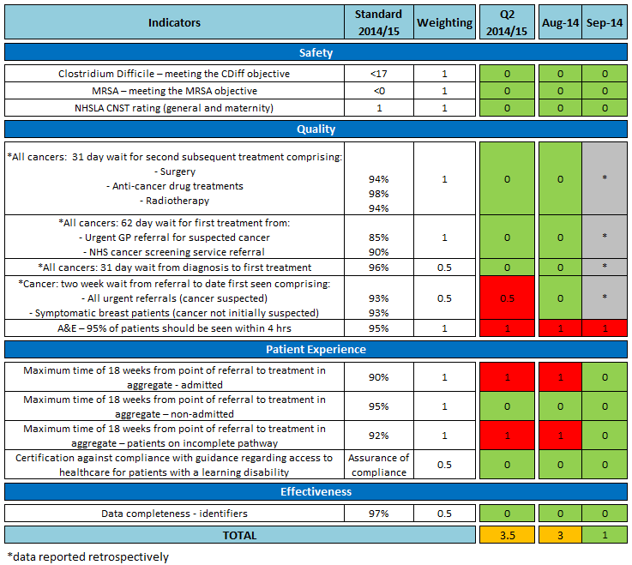



* 2. Summary Scorecard

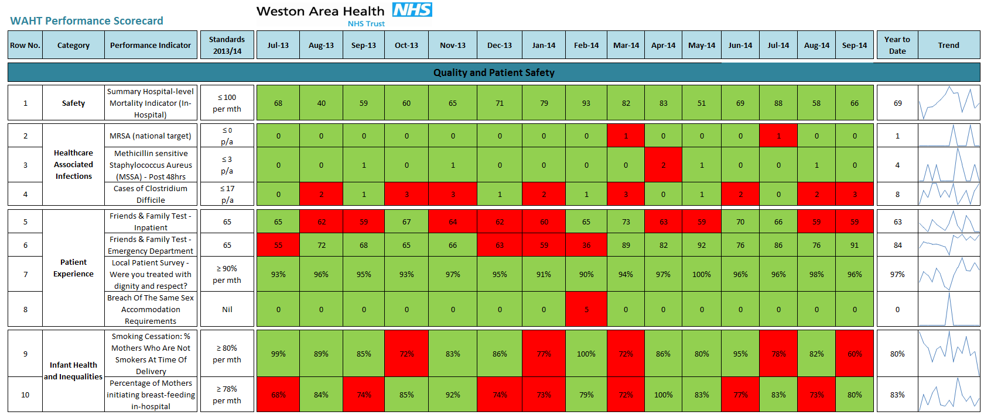

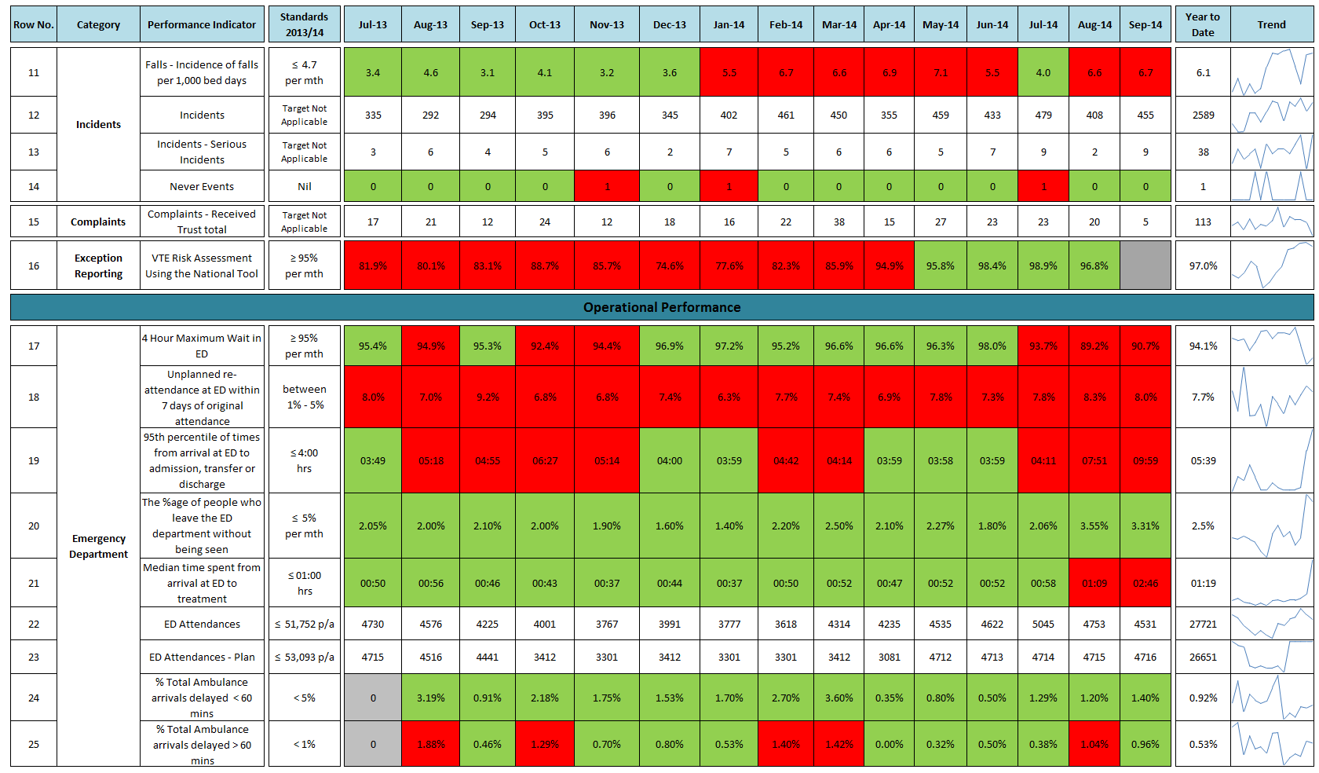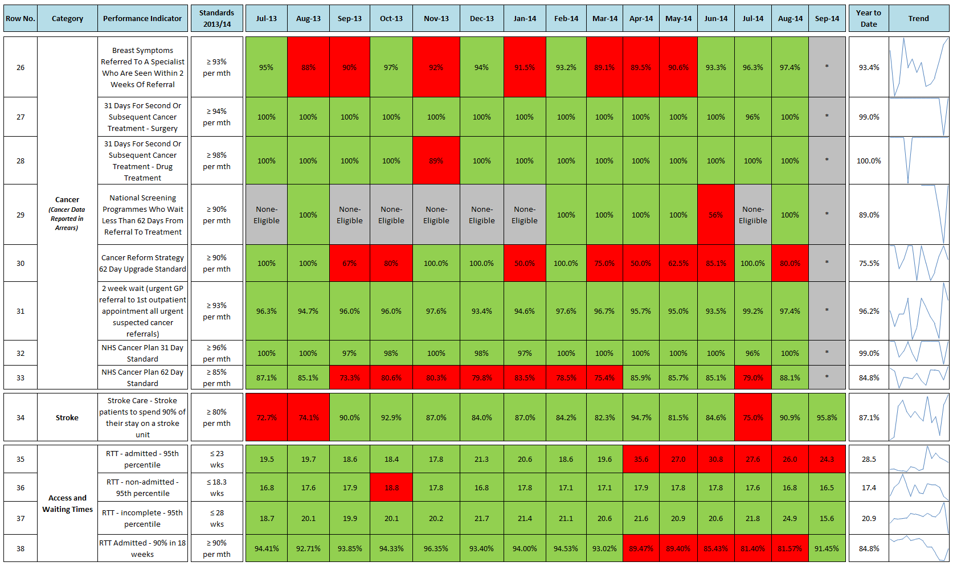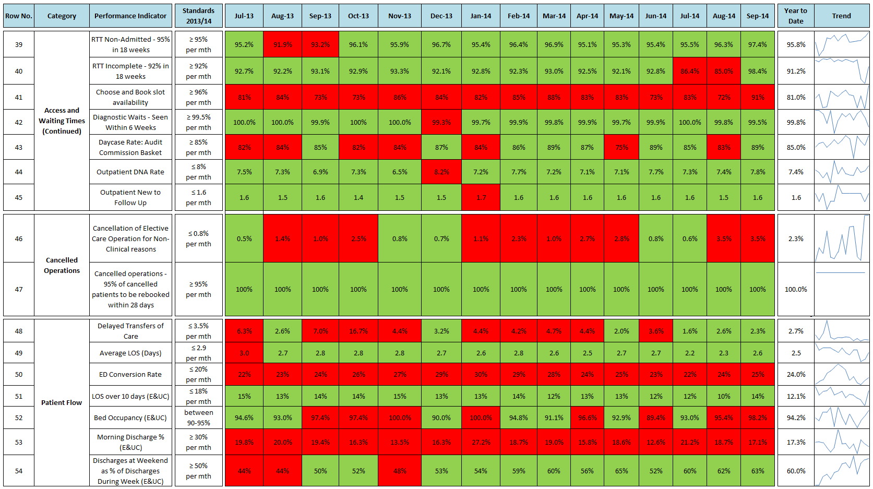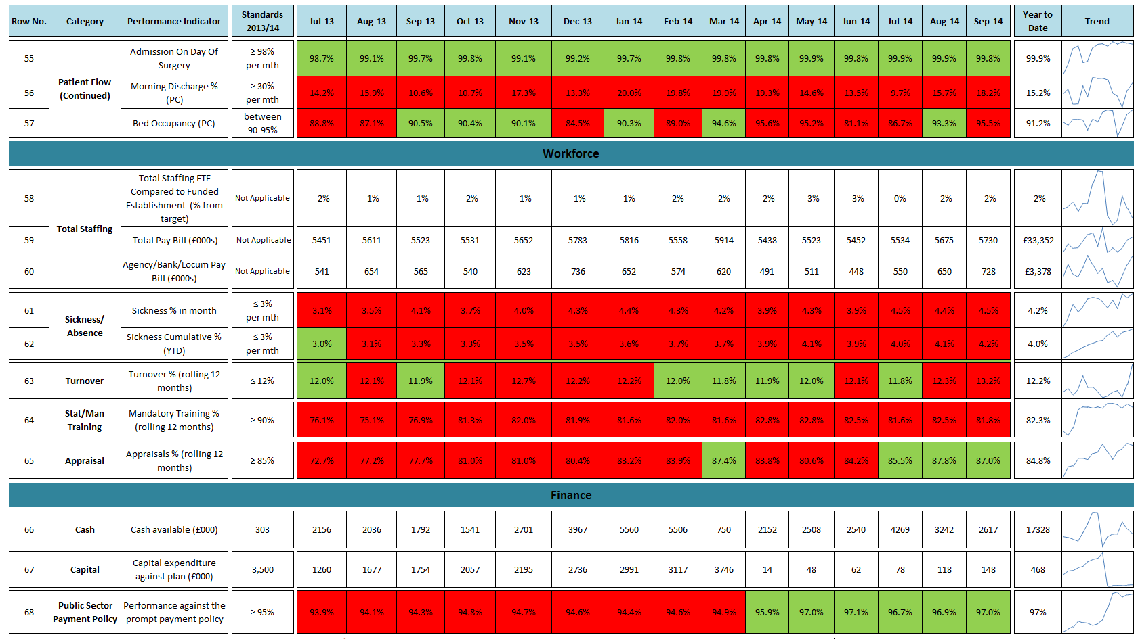

**Data reported in arrears - \***

# Section 2 Quality & Patient Safety

The Board receives the first Harm Free Care Report in November 2014. As these reports are regularly scheduled and include detail on some metrics of the performance scorecard these elements are not duplicated unless by exception.

Both response rate and Net Promoter scores for the Friends and Family Test decreased in August and September. Work continues with key ward and department areas to address this with the Trust Lead also undertaking work with frequent suppliers of agency staff.

In September the Trust improved performance and achieved the national target of 95% with 97.2% of appropriate patients receiving a VTE risk assessment.

The management of complaints across the Trust has recently undergone a period of change brought into effect by the Director of Nursing to improve patient experience. The Trust is currently trialling a process where concerns are sent to the relevant area with a 48 hour resolution with the aim of responding and resolving at the earliest opportunity. The target for response times was achieved in both months and will continue to be a focus on improvement activity.

## continues on falls prevention with an increase noted in August and September. Staff education regarding falls prevention remains an ongoing commitment and all nursing staff on wards where significant harm is a result of a fall will receive a letter of recommendations to follow. SWARM has been reinvigorated on Kewstoke ward, and the outcome is reflected in the reduction of patient falls in that area. As a result, Hutton and Uphill wards have been invited to complete SWARM documents

In September the Trust improved performance and achieved the national target of 95% with 97.2% of appropriate patients receiving a VTE risk assessment.

The management of complaints across the Trust has recently undergone a period of change brought into effect by the Director of Nursing to improve patient experience. The Trust is currently trialling a process where concerns are sent to the relevant area with a 48 hour resolution time.

## 2.1. Patient Story

The patient story presented to the Board is one of the stories captured by the Patients’ Council as part of their work supporting Trust improvements. The Council Members visit patients and their family at home and, using prompts based on the bold headings, capture a narrative of the patient experience. The patient whose story is presented today was an inpatient between December 2013 and February 2014.

**Feeling unwell at home and coming into hospital**

We had an accident in Bristol. I was helped back off the floor so we came back home. The next day I walked to the bathroom and was in great pain up my leg. We couldn’t see anything. The District Nurse was coming so we asked her about it. She said she thought it was alright but she phoned the hospital to see if we could come in and we went down in the afternoon to be seen in A&E.

I was treated very well there; the only thing was that the Nurse Practitioner said ‘we’d like you in for one night’ – but that one night turned out to be ten weeks! I was then admitted to Steepholm. I had a back slab put on.

**Being on the ward**

I was treated very well on Steepholm. Staff were extremely helpful. Everything went fine with my personal needs looked after all the time. Obviously I had to be hoisted – so you sometimes had to wait – but that was ok. They were good on Steepholm. I’ve got a catheter so they dealt with that. They were a delight really. I was in over Christmas and everyone was very nice. They came to see me and everything.

After Christmas I was moved to Uphill. Again the nursing care was terrific. When I was there one night I was violently sick and I brought up some blood. The treatment I received was second to none. I had doctors and drips and x-rays and everything. I was completely sorted out.

I take 20 tablets in the morning, 6 at lunchtime, 11 at teatime and 6 at bedtime. Yet there were no problems at all with this. I also have nebulisers. One day I tried to get out of bed with the OTs help – which was a dreadful thing to do – because I hadn’t had my nebuliser, but this was soon sorted out by the OT who called a staff nurse from another bay.

There was a bad time on Uphill. Everyone else had Alzheimer’s in the bay. They were all older than my mother. We didn’t think that there was enough staff because one of the patients needed one to one care. The nurses used to say to me ‘could you give us a ring if someone goes wandering or something’. The nursing care was good there but there wasn’t enough staff for people who were getting violent etc. That was the place we felt that there wasn’t enough staff. Nobody should be made to work like that. They were stretched too much.

We overheard a nurse saying that another couldn’t go for tea break because a nurse hadn’t turned up for the shift.

A side room became available but I refused it because I was used to being in the bay.

The one thing that did upset me was that they told me that I was going to Rowan – at about 8pm. I cried because I was settled on Uphill. In the end I was transferred at about 11pm. When I got to Rowan, they were very nice but I was very tired.

I went to Rowan, had physiotherapy and occupational therapy every day and they helped me get walking again. It’s nice in there when you get sorted. I had my own room there as well.

**My personal needs**

The food was good. I would have liked a bit more variety at teatime because I can’t eat cheese & fish. Cheese seemed to figure in everything.

**Outcome**

The Trust has an alternative menu which should be offered to the patient if the choices on the main menu are unsuitable.  This was a long term patient and the staff should have picked up on the patient’s diet and alternative food could have been arranged through the catering department. The Facilities Manager will liaise with the Housekeeping Manager to remind staff to communicate any patient’s nutrition requirements to the catering department.

Nurse staffing on Uphill Ward has been increased since this patient’s time on the ward. Where wards are not working to their planned nurse numbers, there is a process in place for the Matron of the Hospital out of Hours Coordinator to review the ward at regular intervals to ensure that matters such as missed staff breaks are picked up and addressed.

Transfers between wards at night are avoided unless there is an absolute clinical need for this to occur.

## 2.2 Registration with Care Quality Commission (CQC)

The Trust is compliant with all five of the CQC’s essential core standards of:

1. Treating people with respect and involving them in their care
2. Providing care, treatment and support the meets people’s needs
3. Caring for people safely and protecting them from harm
4. Staffing
5. Quality & suitability of management

The essential standards of quality and safety set by the CQC government body are central to our work as a Trust.

The July 2014 Intelligent Monitoring Report, produced by the Care Quality Commission, places the Trust in priority banding 6 for inspection, with a banding of 1 being high priority for inspection and 6 being low priority for inspection, based on analysis of a number of quality and safety measures.

Quarterly monitoring of Trust compliance with CQC standards occurs via reporting to our Quality & Governance Committee.

The Trust has been informed that the CQC will be undertaking an inspection of the Trust commencing 6th January 2015.

## 2.3 Nursing Metrics

The agency usage for the ward and department areas included in the nursing metrics report for August and September was 19.68 and 18.82 respectively. Escalation beds were open in Cheddar Ward during this time period to manage the additional activity for Referral to Treatment improvements and for emergency activity which led to an additional increase in agency staff usage. Further detail is provided in the Human Resources section in relation to agency usage.

A number of the wards with higher agency use showed lower scores for the Friends and Family Test Net Promoter and for the exit card survey on nursing care. The only ward with higher agency use and lower harm free care scores was Harptree. The low score for harm free care on SAU/CDU in August 2014 was due to a number of patients admitted with a fractured neck of femur prior to admission as the NHS Safety Thermometer includes these patients in the new harm category. An intensive national and international recruitment programme has been undertaken in September and October with a total of 43 permanent and 25 bank nurses recruited.

Hartpree ward reported five instances of staffing issues during September. These related to shortness of staff for various reasons that were unavoidable as opposed to poor planning and need for additional staff due to the acuity of patients’ conditions. Where a ward is working below staffing numbers, the Matron or Hospital out of Hours Coordinator are expected to review the ward regularly (at least two hourly) to ensure safety of care is maintained.

Additional support from Matrons and Heads of Nursing continues on Kewstoke, Uphill and Hutton Wards.

**Figure 1:** 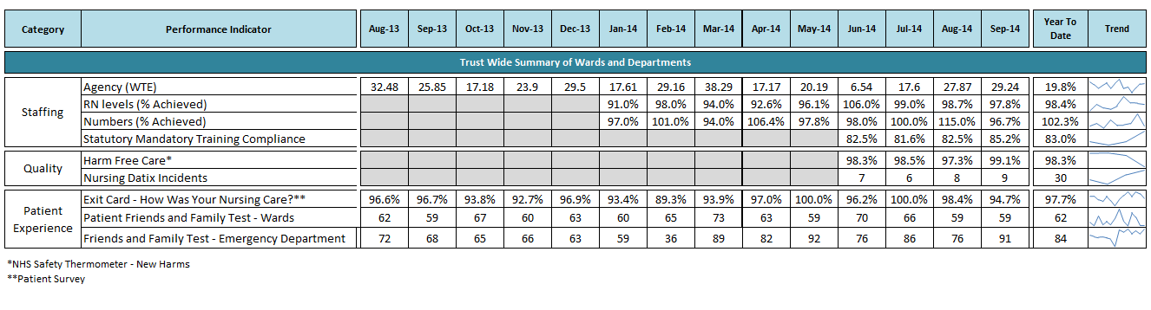

**Figure 2:** August 2014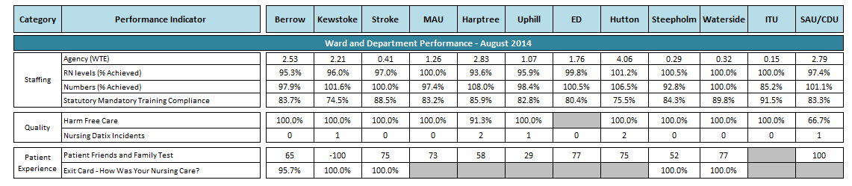

**Figure 3:** September 2014

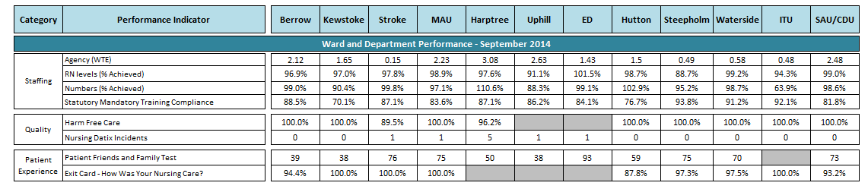

## 2.4 Incident Reporting

Incident reporting systems and policies are integral to patient safety and enable the Trust to analyse the type, frequency and severity of incidents that occur. The Trust’s open and honest reporting demonstrates a commitment to our patients and their safety. The information arising from these reports is used to make active changes to improve our provision of quality care and to safeguard the wellbeing of our staff and patients.

*Figure 4* depicts the number of patient incidents reported each month, compared to previous years.

**Figure 4:**

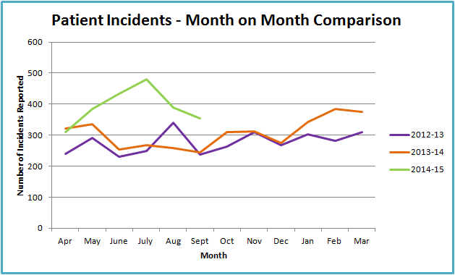

Since February 2014 the reporting of incidents within the Trust has remained fairly stable, with the number of reported incidents fluctuating between 350 to 400 per month, apart from April when there was a slight dip in numbers (312). There were a total of 742 patient incidents reported in August/September, 388 in August and 354 in September and the top 3 themes of incidents were pressure ulcers, falls and medication. On closer inspection there is a rise for August/September around incidents reported under the categories of: a) Laboratory investigations, 17 compared to 11 for June/July, b) Assessment - other, 11 compared to 2 for June/July and c) Patient Transfer, 45 compared to 14 for June/July. Further analysis shows the following:

* With regards to laboratory investigations – Further review of incidents revealed no identified theme.
* With regards to Assessment (other) – Further review of incidents revealed no identified theme.
* With regards to Transfer – Further review of incidents revealed there was a considerable increase in incidents around delays in transfer of patients (22 in August/September compared to 0 in June/July). ITU reported 15 incidents around delays of transfer as beds were not available on the wards when a decision was made that a patient could be stepped down from ITU care. It is important to note that this was for 8 patients as the same incident was reported for a patient each day they could not be transferred.

A total of 170 pressure sores were reported in August and September (total number of community and hospital acquired), accounting for 23% of all patient incidents. The Trust reported 35 hospital acquired pressure sores, which is an increase of 1 from June/July. The Trust reported 6 hospital reported grade 3 and 4 pressure ulcers. All relevant external organisations were notified in August/September and a full investigation was commenced.

Ninety eight slips, trips, falls & collisions were reported in August and September, which is slightly down on the numbers reported in June and July (110).

Sixty six medication incidents were reported in August/September, slightly down from 76 in June/July. These errors included administration (meaning medication administered orally or intravenously) from a clinical area (such as ward areas), medication error during the prescription process and preparation of medicines/dispensing in pharmacy. Further review of incidents revealed no identified theme.

The harm free care report to Board, introduced from November 2014, on a four-monthly schedule, includes detail on falls and pressure ulcer prevention actions. Therefore these matters will only be reported on by exception in the performance report.

### 2.4.1 Daily Situation Report

The daily situation report (SitRep) continues to be circulated by the Quality Improvement Team on a daily basis. Data is presented to help operational leads focus on any areas of concern.

**2.4.2 Staff Incidents**

The Trust Health and Safety Committee reviews incident trends and receives reports on incidents reported under the Reporting of Injuries, Diseases and Dangerous Occurrences Regulations (RIDDOR) 1995. *Figure 5* depicts the number of staff incidents reported each month, compared to previous years.

**Figure 5:**

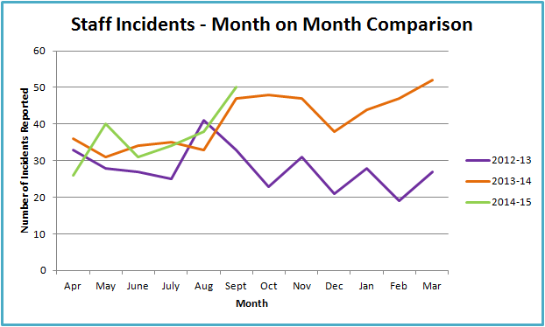

There were 38 staff incidents reported in August and 50 incidents reported in September, a total of 88 compared to 81 reported in June/July. Incidents reported involving abuse of staff has increased from 22 incidents in June/July to 43 in August/September. In response the Trust has instigated a Violence and Aggression group with the first meeting scheduled to take place in October 2014 and the Trust has just ratified the Violence and Aggression policy which has been updated on the Trust’s Document Management System.

### 2.4.3 Serious Incidents (SIRIs)

A Serious Incident is defined as an incident that occurred in relation to NHS-funded services and care resulting in:

* Unexpected or avoidable death of one or more patients, staff, visitors, or members of the public.
* Serious harm to one or more patients, staff, visitors, or members of the public or when the outcome requires life saving intervention, major surgical/medical intervention, permanent harm or will shorten life expectancy or result in prolonged pain or psychological harm (this includes incidents graded under the NPSA definition of severe harm)
* A scenario that prevents or threatens to prevent a provider organisations ability to continue to deliver healthcare services, for example, acute or potential loss of personal/organisational information, damage to property, reputation or the environment, IT failure or incidents in population programmes like screening and immunisation where harm potentially may extend to a large population.
* Allegations of abuse
* Adverse media coverage or public concern about the organisation or the wider NHS.
* One of the core set of Never Events

Resultant investigation reports are reviewed by the local Clinical Commissioning Group and, for the most serious cases, also reviewed by the NHS Trust Development Authority.

*Figure 6* depicts the number of serious incidents reported to the Trust

**Figure 6:**

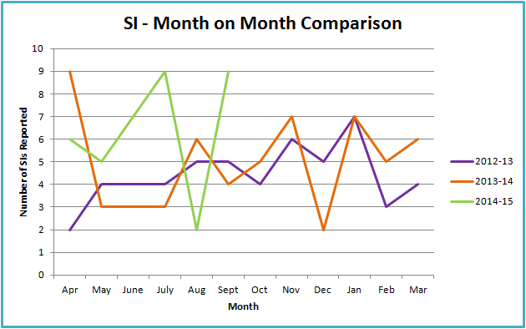

Between the 1st August and 30th September 11 serious incidents (August 2 and September 9) were reported and an investigation commissioned.

The 17 investigations are classified as follows:

**Figure 7:**

|  |  |  |
| --- | --- | --- |
| **Category** | **Grade 1** | **Grade 2** |
| Operational (e.g. unit closure) | 1 | 0 |
| Adverse media attention | 1 | 0 |
| Information Governance (e.g. loss of data) | 0 | 0 |
| Clinical Care of patient (e.g. pressure ulcer, delayed diagnosis, avoidable severe harm) | 7 | 0 |
| Safeguarding (e.g. allegation of abuse) | 2 | 0 |
| Avoidable severe harm to staff | 0 | 0 |

**2.7 Patient Feedback**

### 2.7.1 Complaints

Complaints management is critical to ensuring the Trust not only responds to the complainant in a timely manner, but to ensure the learning from complaints is translated into action. Complaints data enables the Trust to determine if there are any trends in subject matter, location or personnel.

*Figure 8* portrays that the total number of complaints received in August and September was 25. The number of complaints received equate to 1.2% of all inpatients in over this period. This is against inpatient activity of 1,379, Emergency Department attendance of 4,730, Outpatient Department attendance of 8,864 and Day case activity of 1,140. The number of compliment letters during August and September was 187.

All complainants are offered the opportunity to meet with relevant staff should they wish. Eight complaint resolution meetings were held in August and September resulting in satisfactory resolution for the complainant. Should complainants remain unsatisfied with the final response from the Trust, and all options for internal resolution have been exhausted, complainants are advised of the option to refer their complaint to the Complaints Ombudsman. No new complaints were referred to the Complaints Ombudsman in August or September.

**Figure 8:**

|  |  |  |  |  |  |  |  |  |  |  |  |  |
| --- | --- | --- | --- | --- | --- | --- | --- | --- | --- | --- | --- | --- |
|  | Jan | Feb | Mar | Apr | May | Jun | Jul | Aug | Sept | Oct | Nov | Dec |
| 2013 | 17 | 22 | 21 | 19 | 11 | 14 | 17 | 21 | 12 | 24 | 12 | 18 |
| 2014 | 16 | 22 | 38 | 15 | 27 | 23 | 23 | 20 | 5 |  |  |  |

**Figure 9:**

The Trust aims to provide a full response to all complainants within 30 working days. The response time to complaints as demonstrated in *Figure 10* demonstrates the commitment of the Trust to resolve complaints in a timely manner. The response rate of 82% in July and 90% August achieved by the Trust, met the 80% standard required. The Divisions are continuing to make improvements in this area.

Training sessions have been delivered in October for Cancer Services staff and a further session has been scheduled as part of the Sisters Development Day in the Planned Care Division which will help achieve an improvement in the management of complaints.

**Figure 10:**

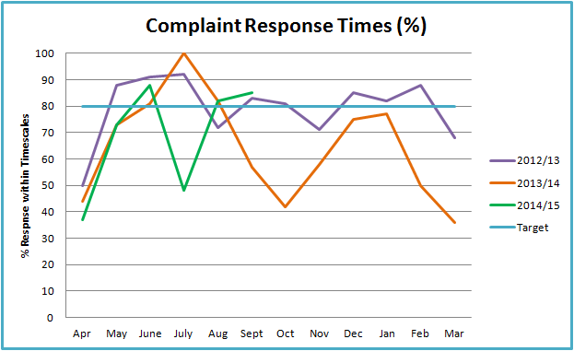

The management of complaints across the Trust has recently undergone a period of change brought into effect by the Director of Nursing to improve the patient experience.   With the effect from the 8th September the Trust has been trialling a process where concerns raised by members of the public are logged by the Patient Advice and Liaison Service and sent to the local area for immediate resolution.  The intention is that the concerns raised are resolved in a much speedier manner and addressed to the patient’s satisfaction.  If this cannot be achieved the expectation is that the Senior Sister escalates to the Matron/Head of Nursing/Departmental Manager for resolution within a 48 hour timescale.  If resolution is still not achievable the concerns are escalated to the Director of Nursing for a decision on how the complaint will be monitored and resolved.

There were no complaints linked to safety incidents. Following receipt of their response 6 complainants have contacted the Trust to ask further questions or seek further information relating to the questions already raised. It should be noted that the complainants who have contacted the Trust received their initial response in varying months from May through to September 2014. Eight local resolution meetings took place; two for Planned Care Division six for the Emergency Division.

**Figure 11:** Key themes identified from the 25 Complaints received in August and September 2014:

*\* -The pie chart depicts the number of themes expressed in each of the complaints.*

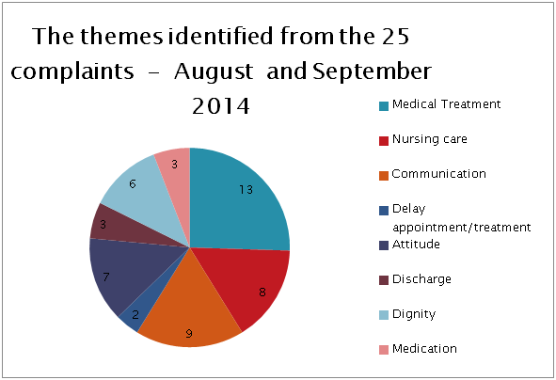

*Medical Treatment – 11 = 44%*

Medical treatment was a significant theme for complaints this month. 11 out of the 25 complaints mentioned medical treatment. 5 of the complaints related to concern that the clinician had not given appropriate treatment. 2 related to concerns about the treatment given to a patient that subsequently died. Further themes identified from complaints relate to; missed diagnosis of fracture, delay in treatment.

The current use of locum doctors in the Emergency Department is contributing to the level of complaints related to medical treatment. The details of any complaints are shared with the appropriate agency to promote learning. There is also an active campaign to recruit more permanent doctors to the Department.

**The Divisional Director for Planned Care is reviewing all complaints received with the Divisional Management Team and making** teams aware of the findings from the reviews to focus change on improving the treatment of patients.

A teaching session for Doctors has been planned for February 2015 to share the themes of complaints and encourage doctors to identify what went wrong and how they can work differently to reduce complaints.

*Communication – 9 = 36%*

The number of complaints linked to communication was a main theme this month: 9 out of the 25 complaints mentioned communication. Hutton ward received two complaints related to communication. No other area received more than one complaint related to communication.

Patients have raised concerns with lack of clear information about patient treatment for family members in 2 complaints. The lack of information provided by the medical team was a concern in 2 complaints. One patient felt the doctor did not listen to them.

The number of concerns raised linked to communication has fallen for three consecutive months. In July the number was 50% less than in June 2014 and in September the number has continued to fall.

*Discharge – 3 = 12%*

The theme of complaints relating to discharge has decreased over the past two months. Concerns however were raised relating to the appropriateness of a discharge plan for a patient with dementia. Two complaints highlighted that there was no communication with carers when the discharge plan was changed.

The new discharge policy including a detailed checklist is being followed with the focus on safe and appropriate discharge.

*Dignity - 6 = 24%*

There has been an increase in the number of complaints highlighting dignity as a concern for the last three months.

Three complaints were received in Hutton ward. The Trust Lead for dignity is working with the ward Sister and the Dignity Champion to improve the way patients and their family members feel about the way they are being treated.

Two complaints related to the way patients were made to feel by the doctor, they did not feel that they had been treated in a respectful way. The Trust Lead for dignity has been made aware of these complaints and has asked the Executive Medical Director to nominate a person to join the group and also to join in with the Dignity Day that is being planned for 2nd February 2015.

The patient feedback received by the Trust through the exit cards for August and September demonstrates that those patients who gave feedback feel they are being treated with dignity and respect across the Trust. (August 95.3% of 121 patients and September 96.3% of 308 patients)

*Nursing Care – 3 = 12%*

The number of complaints linked to nursing care increased slightly in August but remains low.

Hutton ward received 2 complaints linked to the nursing care of a dementia patient and a further complaint related to a patient with limited hearing. The Complex Needs Sister has commenced training for staff on the ward specifically aimed at patients with dementia or a learning disability such as pain relief and end of life care. The Complex Needs Sister is also offering one to one support to ward staff on a daily basis.

There is a new ward Sister in post on Hutton who has introduced a number of initiatives such as a new hand over system, a safety brief at the beginning of each shift to highlight the dependency of each patient which includes if a patient has dementia, or communication problem. The safety brief is displayed on a white board for all staff to inform multi professions of the needs of each patient, alarmed cushions for patients have also been introduced. Training incentives are being offered to staff to ensure that they are up to date with training including dignity training.

*Attitude – 7 = 28%*

The number of complaints linked to the attitude of staff was the highest in August since March 2014. It has been highlighted that the Emergency Department has received the most complaints linked to this theme during 2014. The Emergency Department Matron and a Consultant in Emergency Medicine will make this theme the focus at the next Department meeting and through discussion with staff explore what changes could be made to improve the patient experience.

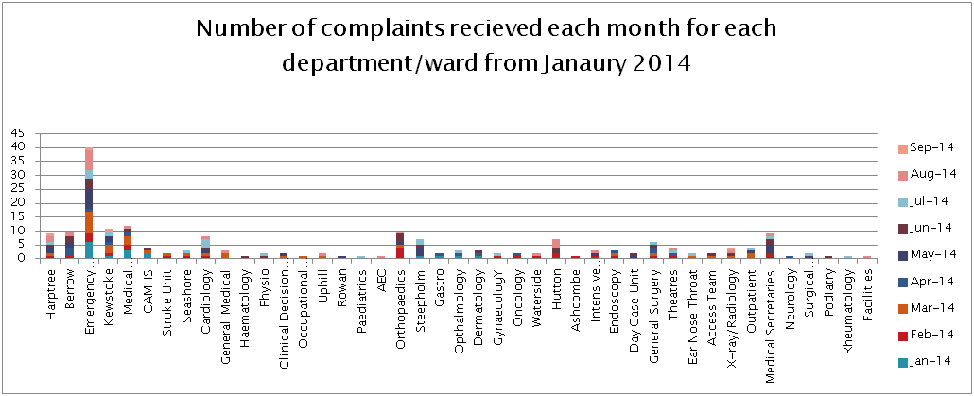

**2.7.2 Compliments**

The number of compliments received in August and September was 187.

Wards are continuing to focus on gathering patient feedback and it is hoped that reviewing the exit cards weekly will encourage staff to make sure patients are given the opportunity to provide feedback before leaving the hospital. The Compliments formally recorded are received via email or letter. *Figure 12* depicts three examples of compliments received by the Trust in August and September. Where appropriate each compliment receives a letter to thank the individual for taking time to comment.

**Figure 12:**

|  |  |
| --- | --- |
| COMPLIMENTS | |
| A thank you from the daughter of a patient cared for on Uphill ward | I wanted to write and tell you what an amazing ward Uphill is. The nurses there were really cheerful and really helpful to my mother and myself as her carer.  I also wanted to say that the doctor sat down with me and discussed what he was going to do for my mother. He then asked for my input and actually listened to what I said and said it was helpful to him. I have never had a doctor sit with me and let me know what is going on. He is a credit to the hospital and deserved acknowledgment for what he has done. |
| A thank you from a Medical Assessment Unit patient | I would like to say a big thank you for the brilliant professional care given to me in September. After a heart scare during a race along Weston Prom it was reassuring to know I was in very good hands. |
| For the Midwives and Team on Ashcombe | We can’t express how thankful we both are for your amazing care and for the support you have given us in bringing our little angel into the world. You really have been amazing. A special thanks to one member of the management team for the fantastic support in the delivery of our son. |

## 

## 2.8 Patient Feedback

As a national requirement Weston Area Health NHS Trust is engaging in the delivery of the Friends and Family Test (FFT). This test has been implemented successfully across all areas. The Friends and Family Test is a single question survey which asks patients whether they would recommend the NHS service they have received to friends and family who need similar treatment or care.

The FFT is offered to all patients at the point of discharge and when patients attend the Emergency Department.

Each Division and all wards receive a breakdown of the outcome of their survey results to ensure they can take relevant action to sustain improvements already made and proactively develop actions to deliver further improvement. *Figure 13* provides a detailed report of September’s Friends & Family Test results.

**Figure 13:**

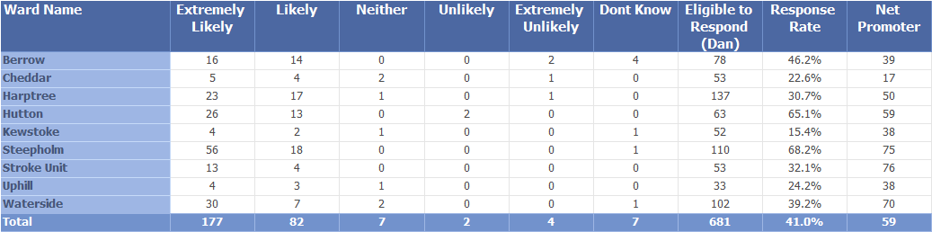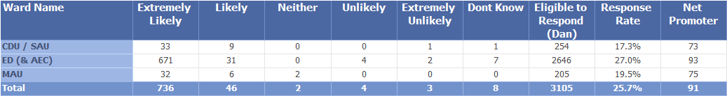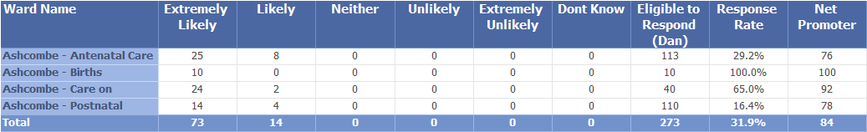

The FFT yielded a disappointingly low response rate across the Trust for the month of August with an average reduction in response rate of 8.35% across all areas from the previous month.

Break down of decrease in response rates from July to August:

* Acute Wards response rate was down by 9.3%
* Emergency Care response rate was down by 9.4%
* Maternity response rate was down by 6.3%

The increased use of temporary nursing staff is likely to have contributed to the lower scores as a mini audit suggests that temporary staff have a lower awareness of FFT, so would be unlikely to seek patient feedback in this way and offer cards to appropriate patients.

The Trust Lead for FFT will work with the Temporary Staff Bank Office to address this issue and offer awareness sessions for this group of staff.

Part of this will be a training session offered called “Friends and Family FAQ’s”. A recovery plan for all areas has been drafted, as well as individual action plans for those areas where performance has been particularly low.

Analysis shows that the poorest performing areas for response rate in each section were:

* Acute Wards- Kewstoke Ward (2.4%);
* Cheddar was opened as a temporary ward and also yielded a low response rate of 4.5%
* Emergency Care-CDU /SAU (1%);
* Maternity – Ashcombe Antenatal Care (4.5%)

Following raised awareness, action planning and presenting results to senior nursing staff, the picture for response rates from August - September has improved as follows:

* Acute Wards response rate has increased by 12.4%
* Emergency Care response rate has increased by 12.6%
* Maternity Care response rate has increase by 10.6%

***Net Promoter August – September***

Acute Wards net promoter remained static at 59

In August, one patient across the acute wards (on Harptree) indicated that it was “extremely unlikely” that they would recommend the hospital to friends and family. No other wards reported an “extremely unlikely” in August. In September, four patients indicated that they were “extremely unlikely” to recommend the hospital to friends and family (one patient on Harptree, one patient on Cheddar, two patients on Berrow). Staff are being encouraged to scrutinise these cards to address any themes, around the free text that these patients may have offered. In October, the “Exit card” containing the FFT question will be slightly amended to encourage patients to write free text at the beginning of the card. This is in line with suggestions made by NHS England who visited the Trust on October 8th to meet with the new Trust Lead for FFT.

***Next Steps***

Individual action plans for areas of poor performance will indicate the number of cards needed to distributed and returned to reach their target.

Day Case, Out Patients and Endoscopy have all engaged with the process for submitting data for FFT, in readiness for their “Go Live “date at the end of October.

Monthly meetings are being set up to allow leads for Exit Cards from all areas to network and share ideas and best practice.

“Mobile boxes” exist in some areas but are being standardised to give a recognisable “brand” and greater visibility for FFT. Trust volunteers are helping with this.

**Figure 14:**

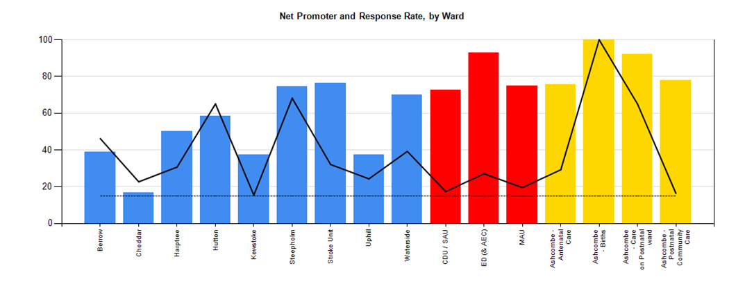

## 

## 2.9 Mortality Data

The latest iteration of the Summary Hospital Mortality Index covers the year to December 2013 and has a value of 1. This indicates that mortality within the Trust for the period covered is exactly as expected given the age and co morbidities of the patients treated, shown in *Figure 15*.

**Figure 15:**

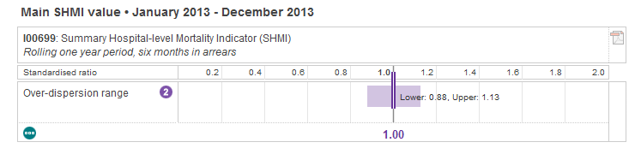

Whilst the SHMI describes the overall picture for hospital and community deaths *Figure* *16* illustrates the Trust’s position (red dot) relative to the national picture for those deaths which occurred only in the hospital setting for the period April 2013 to September 2014. Again the Trust’s performance is better than anticipated.

**Figure 16:**

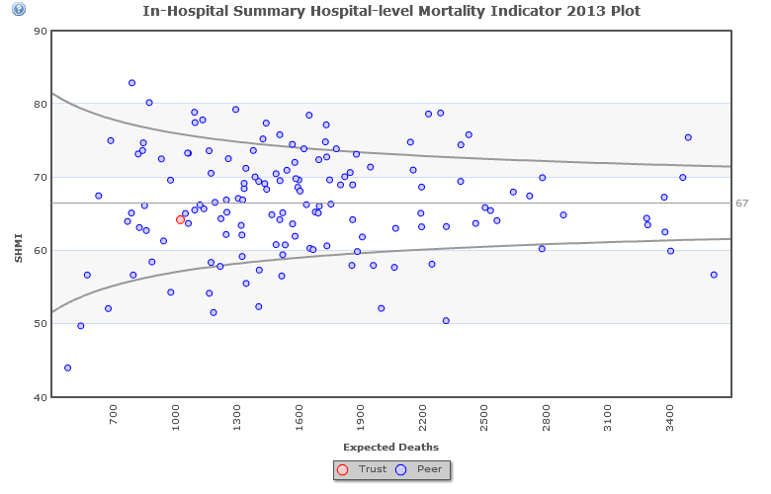

**2.10 Infection Prevention and Control Performance**

**2.10.1 Clostridium Difficile**

Weston Area Health NHS Trust has a local threshold of 12 hospital attributable cases of Clostridium *difficile* for the financial year 2014/15. Prevention of avoidable hospital attributed cases continues to remain a priority for the Infection Prevention and Control Team and a robust recovery and action plan has been implemented to give assurance that all preventable measures are in place.

Two cases of hospital attributable Clostridium *difficile* were reported in August and three in September; the total number of reportable cases is now eight. A review of all cases has been undertaken by the Consultant Microbiologist and Infection Prevention and Control Nurses. Criteria determined nationally have been applied to assess whether there have been any lapses in care and whether that case could have been avoided. This review will now be scrutinised by the Commissioners to confirm the allocation of avoidable or unavoidable cases; the outcome of this will be in future Board reports. Those cases allocated as unavoidable are excluded from trajectory numbers for the purpose of apportioning fines.

The antimicrobial stewardship programme continues apace and involves both the Consultant Microbiologist and Antimicrobial Pharmacist. Issues with inappropriate prescribing are being addressed in a timely fashion and this feedback is leading to a reduction in the amount of inappropriate prescriptions. The inaugural meeting of the Antibiotic Stewardship Group has now been held. There is a continued focus on the use of co-amoxiclav and how to reduce this. The Trust has launched an antimicrobial app which can be downloaded for free onto individuals’ i-phones. This will enable the medical staff instant access to our current antimicrobial guidelines with the aim of improving compliance even further.

**2.10.2 MRSA/MSSA bacteraemia**

The Trust has a zero trajectory for MRSA bacteraemia and has reported one case in the financial year 2014/15.

There were no cases of MRSA bacteraemia reported in August or September.

One case of MSSA bacteraemia was reported in August, taking the total to four for 2014/2015 against our trajectory of three cases. A recovery plan is in place and being monitored closely to ensure that every avenue for prevention is in place.

**2.10.3 Hand Hygiene Audits**

Monthly internal audits are undertaken by Infection Prevention and Control Link Practitioners. The audits look at three areas of hand hygiene – environment, observation and technique. The Director of Infection Prevention and Control is supporting the completion of these audits by releasing time for the link practitioners to undertake and submit these audits. Overall Trust wide compliance was reported at 99% in August and 95% in September. The Infection Prevention and Control Team have an action plan in place and are working with the Link Practitioners to address compliance.

**2.10.4 Carbepenemase Producing Enterobacteriaceae CPE**

No cases have been acquired in or admitted to the hospital in August or September 2014.

**2.10.5 Outbreaks**

There was one confirmed outbreak of Norovirus on Kewstoke ward in August and during September Kewstoke ward had two subsequent Norovirus outbreaks. Deep cleaning of Kewstoke’s environment was undertaken after every outbreak in line with the Trust outbreak policy. Initial reports following these outbreaks have identified lapses in communication and documentation. An in depth environmental audit has identified problems with the physical environment and has recommended this ward for refurbishment/remedial actions to address these issues.

A business case was submitted to replace the current washer disinfector with a macerator due to the increased number of outbreaks on this ward and this has been successful. This should be fitted within the next two weeks. Maceratable products and their contents are then able to be disposed of instantly and this negates the risk of substandard cleaning with reusable products.

**2.10.6 Viral Haemorrhagic Fever (VHF)**

In response to the major outbreaks of Ebola in West Africa, a policy for VHF is now available on the Trust Intranet. Flow charts and current algorithms to follow can be found within this policy. Pertinent questions around VHF have been added to the new Infection Prevention and Control risk assessment. The Trust’s Emergency Planning Officer has led the internal planning process for VHF with the Trust having the appropriate policies, processes and equipment in place in full preparation for any potential cases.

**2.11 Maternity**

The maternity team achieved variable results in both its national targets for initiating breastfeeding in-hospital and mothers not smoking at the time of delivery in August and September.

All midwives and maternity support staff now have access to the online Quit Manager referral service. The Matron is receiving reports from SmokeFree North Somerset on the number of referrals.

The number of women who gave birth in Ashcombe Unit in August and September was lower than hoped. A plan has since been actioned to invite all women who would be safe to give birth in the unit to have their 36 week midwifery check up in the unit. This offers the opportunity for mothers-to-be to look round the unit and be assured of the safety of midwife-led units.

During August and September, the department have been submitting data as part of the NHS Safety Thermometer Maternity Pilot. This pilot scheme ends in October and results will be analysed shortly afterward.

## 2.12 Venous Thrombo-Embolism (VTE)

The completion of the VTE risk assessment and the necessary actions as a result of the assessment is vital for patient safety to ensure that patients are not at risk of unnecessary harm from avoidable DVT or pulmonary embolism.

The Trust is aiming to achieve 100% of inpatients receiving a VTE risk assessment according to NICE guidance in 2014/15. In September the Trust improved performance and achieved the national target of 95% with 97.2% of appropriate patients receiving a VTE risk assessment.

# Section 3 Operational Performance

## 

## 3.1 Executive Summary Headlines

* In August the Trust achieved seven of the eight National cancer targets.
* The Trust has significantly reduced the number of patients waiting over 18 weeks in line with the national requirement set by NHS England and achieved rhe plans laid out in July for full achievement of admitted and non admitted targets by September 2014.
* The Emergency Department Four Hour target was not achieved in Quarter Two. Unexpected volume of attendances and higher acuity levels saw an increase in admitted patients. A robust action plan and daily monitoring is in place.
* The focus on optimising the discharge procedure has lead to continued reduction in delayed transfers of care and the number of patients awaiting therapies assessment and input.

## 

## 3.2 Operational Performance

The following sections detail the Trust performance against a number of key indicators. The report is divided into:

* *Clinical Indicators*
* *Clinical Pathways*
* *Emergency Access*
* *Elective Access*
* *Patient Flow*

## 3.3 Clinical Indicators

*This section analyses the clinical indicators which directly influence operational performance.*

### 3.3.1 Emergency Readmissions

An emergency readmission is defined as an unplanned readmission within an identified time of leaving the hospital. The ideal readmission rate is zero however this is not always possible as patients can have multiple co-morbidities or long-term conditions which require frequent medical attention. Monitoring emergency readmission rates is important to the Trust as it can help to prevent or reduce unplanned readmissions to hospital.

The Trust monitors emergency readmissions within 14 days and 30 days. As illustrated in *Figure 18,* performance of readmissions within 14 days continued to improve in September.

**Figure 18:**

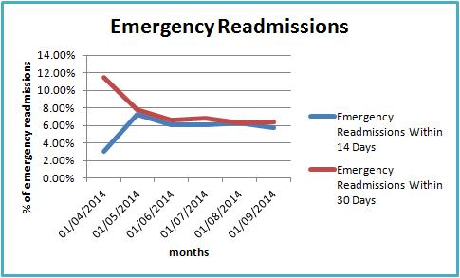

**Trust Action:**

To provide additional assurance that emergency readmissions are not related to the original episode of care, the Emergency & Urgent Care Division are undertaking regular audits of the readmissions to provide assurance that patients are not being readmitted as a result of the Trusts treatment and care.

### 3.3.2 Average Length of Stay

The average length of stay (ALOS) refers to the average number of days that patients spend in hospital. The Trust strives to have a length of stay below the Trust target as it demonstrates proactive planning of the whole process of care, as well as active discharge planning. In September the average LOS increased slightly to to 2.6 days which reflects the higher acuity levels and admissions of patients.

**Figure 19:**

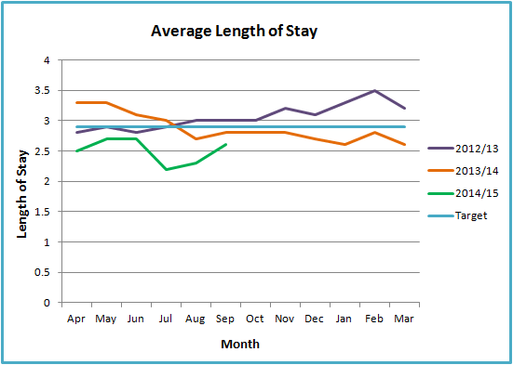

The Trust also monitors the percentage of patients with a length of stay (LOS) over 10 days. The programme of work to improve patient pathways and the level of care alongside the focus on the Green to Go list has enabled the Trust to work to a reduction plan in the percentage of patients with a LOS over 10 days.

**Figure 20:**

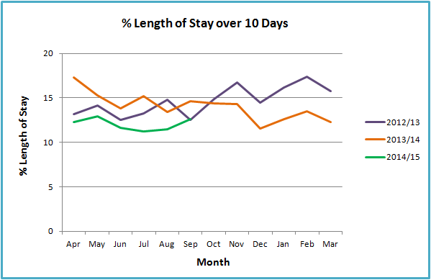

**Trust Action:**

In addition to the work streams already underway as part of the Trusts business plan, the operational teams are focussing on optimising the ward board rounds. A ward board round takes place twice during the day and is where the multi-disciplinary clinical teams review each of the patient in detail using the rounding tool. This will ensure that throughout the patients stay all necessary actions are undertaken on time and in line with the clinical pathway for the patient. Each ward has also been allocated a senior manager to support the teams to deliver and unblock any difficulties that arise.

## 3.4 Clinical Pathways

*This section sets out performance indicators related to key clinical pathways, including cancer and stroke.*

## 3.4.1 Cancer Services

The Trust strives to achieve the national cancer waiting times as they are important to patients clinical outcomes, are a measure of how the Trust is responding to demands for services, and highlights where there are delays in the system. In August the Trust achieved seven of the eight national cancer targets.

#### 3.4.2 Cancer Two Week Wait

The two week wait target was achieved in both July and August with a score of 99.2% and 97.4% respectively. This was matched by the Breast Symptomatic two week wait target, which also achieved above 93% for July and August and is on track to meet the quarterly target.

#### 3.4.3 Day Target

The Trust achieved all three of the 31 day targets in July and August and is on track for for Quarter Two demonstrating the Trusts ability to effectively treat patients once diagnosed with cancer.

3.4.4 Day Target

The Trust did not achieve the 62 days standard for July but did meet the target in August, which is a significant improvement for the Trust. The Trust met the 62 Day Upgrade standard in July, but not in August.

**Trust Action:**

Daily monitoring of performance by the MDT Coordinator and cancer team leader.

Weekly monitoring at the Waiting List Forward Planning meeting.

## 3.4.5 Stroke

Whilst the Trust achieved the stroke target of patients diagnosed with a stroke spending 90% of their time on the Stroke Unit for 80% of patients in quarter one, unfortunately as a result of the pressure on patient flow in July the Trust did not achieve the target with a score of 75%. With improved focus on this requirement on a daily basis from the operational teams, the Trust improved significantly throughout August and September and achieved scores of 90.9% and 95.8% respectively (*Figure 21*). This is a demonstration of the hard work staff put in to maintain flow and bedding patients in the right place.

**Figure 21:**

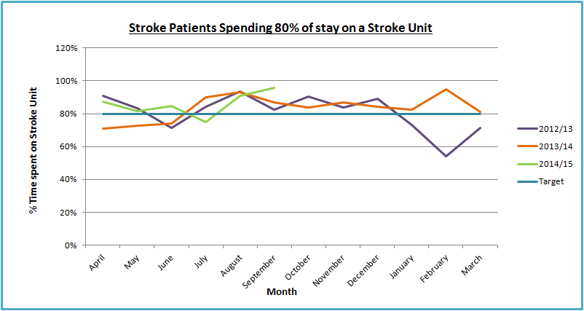

**Trust Action:**

The patient flow team have been instructed to create and keep a stroke hot bed for both sex’s available at all times. This will ensure that patients diagnosed with a Stroke or TIA in the Emergency Department can be transferred straight to the unit to start their care and treatment.

## 3.5 Emergency Access

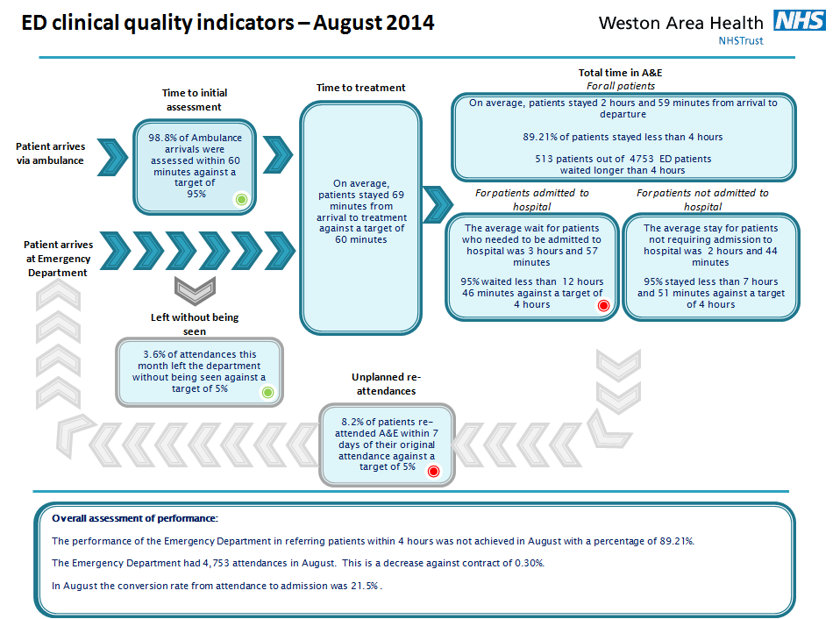

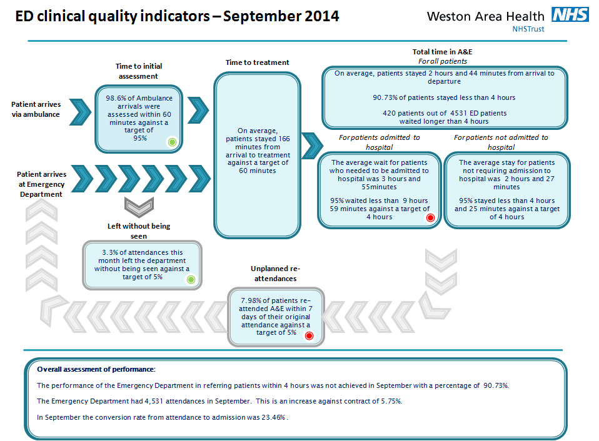

### 3.5.1 Emergency Department (ED) Performance

The NHS constitution set the national standard wherein 95% of all patients attending NHS Emergency Department’s spend a maximum of four hours in the department before being discharged, referred/transferred to other services or admitted to the hospital and transferred to an inpatient bed. The target was not achieved in August (89.02%) or in September (90.70%) as illustrated in *Figure 22*. This as a result of two key factors:

1. The increase in demand for beds (emergency and elective) has outstripped capacity reflected in the small increase of the length of stay.
2. Throughout August and September the Trust has been experiencing a an increase in activity out of hours, which put significant pressure on the Emergency Department. This activity is a mixture of both an increase in walk-in patients and ambulance arrivals.

**Figure 22:**

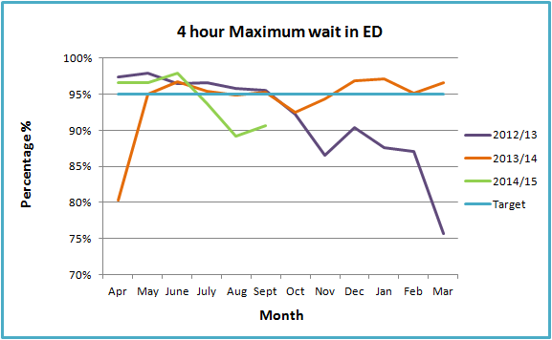

**Trust Action:**

* The Trust has undertaken a detailed review of internal and external performance and activity data to understand the causes behind the sudden drop in performance. The review has been shared with key staff internal and external to the Trust to support the development and implementation of the necessary actions to bring about positive change.
* North Somerset CCG has increased the daily calls from three to five days per week to ensure that performance across the health and social care system is reviewed in detail to ensure all capacity is maximised to manage patients the most effective and caring manner.
* Trust has increased the number of site meetings throughout the day and increased the seniority of attendance, particularly when the Trust is in red escalation to ensure appropriate actions are taken and barriers escalated both internally and externally.
* Daily review meetings are held each morning with ward representation, matrons and senior management where all breaches and any issues highlighted are reviewed in detail with clear actions. An action plan is sent out to attendees of the review meeting so that each day, it is clear to see which areas need additional attention.
* A ‘system reset’ week is under development for mid November, this will focus on discharge from day of admission and will involve North Somerset Community Partnership, the Local Authority and North Somerset Clinical Commissioning Group as well as a number of key operational staff from within the Trust.

# 3.6 Elective Access

*This section reviews the key elective access targets to understand the effectiveness and the quality of care throughout the elective care pathways.*

### 3.6.1 Referral to Treatment (RTT)

The NHS constitution states that patients have the legal right to start their NHS consultant-led treatment within a maximum of 18 weeks from referral, unless the patient chooses to wait longer or it is clinically appropriate to wait longer. For the months of August and September the following sub-sections will review the Trust performance against the three national 18 week targets.

Towards the end of June 2014, The Trust received notification that a planned fail of the RTT was permitted throughout July and August with the target of achieving all RTT targets by September, therefore reporting information available for this period should be viewed with this in mind.

### 3.6.2 Referral to Treatment (RTT) Admitted

The Trust achieved the admitted 18 week target in September at 91.45% in line with the plan agreed with the Clinical Commissioning Group and the Trust Development Authority.

**Figure 23:**

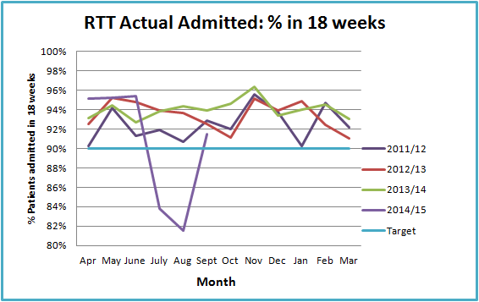

**Trust Action:**

The Trust continues to undertake weekly waiting list forward planning meetings where the waiting list for each specialty and the theatre timetable is reviewed by the Divisional Manager of Planned Care, Access Manager and Theatre Manager. From the new financial year this has been strengthened with the Director of Operations in attendance. The Trust aim to bring patients in within 16 weeks and additional finances have been agreed to assist with this.

### 

### 3.6.3 Referral to Treatment (RTT) Non-Admitted

The Trust continued to achieve the non-admitted target in August and September as illustrated in *Figure 24.*

**Figure 24:**

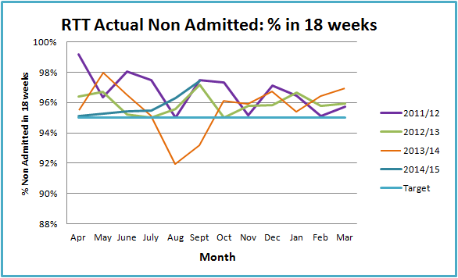

**Trust Action:**

The Trust will continue to undertake waiting list forward planning meetings where the waiting list for each specialty and the theatre timetable is reviewed on a weekly basis with the Divisional Manager of Planned Care, Access Manager and Theatre Manager. This has been strengthened with attendance of the Director of Operations to ensure improvement trajectories are delivered moving forward.

### 

### 3.6.4 Referral to Treatment (RTT) Incomplete

The 92% target was achieved for September 2014 as illustrated in *Figure 25*. This was expected according to plan. The Trust has undertaken a rigorous validation of its waiting list supported by a team from the Trust Development Authority, this has driven new algorithms to be put in place to ensure the current validated waiting list position maintains at a manageable level on an ongoing basis.

**Figure 25:**

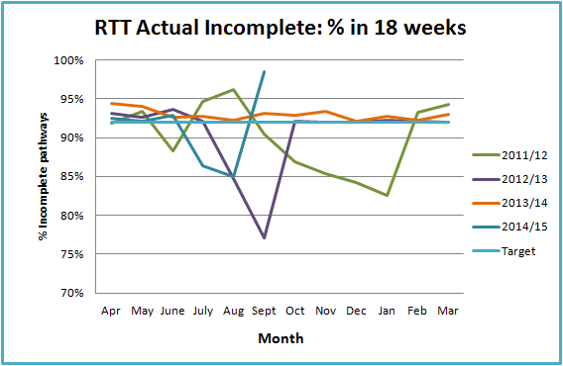

**Trust Action:**

The Trust will continue to undertake waiting list forward planning meetings where the waiting list for each specialty and the theatre timetable is reviewed on a weekly basis with the Divisional Manager of Planned Care, Access Manager and Theatre Manager, attendance has now been strengthened with the Director of Operations in attendance.

**3.6.5 Choose and Book**

Whilst in August and September the Trust did not achieve the 96% National target for Choose and Book slot availability the September performance at 91% is the result of increased capacity in some previously over-stretched specialities and the move of two specialities which had experienced significant service problems to neighbouring providers. This improvement is depicted in *Figure 26.*

**Figure 26:**

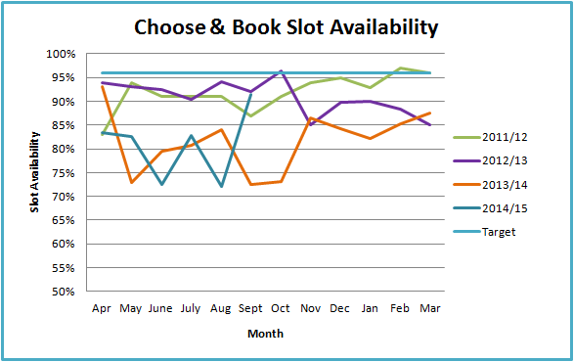

**Trust Action:**

Work is ongoing to continue to improve this performance and meet the 96% requirement by:

Review of capacity and demand required, particularly as we have experienced a continued increase in two week wait referrals resulting in choose and book slots being used to provide additional urgent appointments

Work with neighbouring Trusts who provide some visiting services where capacity fails to match demand leading to no slots being available for patients.

### 3.6.6 Cancelled Operations

Minimising the number of last minute cancelled operations for non clinical reasons is a key target for the Trust. Elective surgery can be cancelled for a number of reasons including:

* Hospital Beds unavailable
* Surgeon or Anaesthetist unavailable
* Emergency case needing theatre
* Theatre list over-ran
* Equipment failure
* Administrative error

In August and September the Trust did not achieve the internal Trust target for the cancellation of elective care operations for non-clinical reasons.

**Trust Action:**

To reduce the level of non-clinical cancellations a Theatre Scheduling meeting has been introduced where the theatre team, access team and operational managers will meet to review all theatre lists to ensure that all the theatre kit is ordered, the patient mix and order is optimised and to provide an opportunity to learn from past mistakes through reviewing cancellations and putting in place actions to stop reoccurrence.

## 3.7 Patient Flow

*To support the delivery of key operational targets, it is vital that the Trust has good patient flow. An important aspect of ensuring good patient flow is the level of discharges throughout the day and at the weekend.*

### 3.7.1 Delayed Transfer of Care

A delayed transfer of care is defined as when a patient is ready for transfer from acute care, but is still occupying an acute bed. Patients can be delayed for the following reasons:

* Further assessment required before their discharge destination can be decided
* Lack of capacity in local nursing/residential homes
* They may require a specialist placement
* Patient or their family/carer needs more time to make a decision about a long-term placement

The Trust monitors performance daily against delayed transfers of care as high levels can have a big impact on the daily numbers of discharges, causing delays in allocating beds for emergency admissions or planned operations. Performance in September increased slightly compared to the previous month (*Figure 27*). However there is still considerable work to undertaken with partner organisations and the use of the **‘Green to Go’** list.

**Figure 27:**

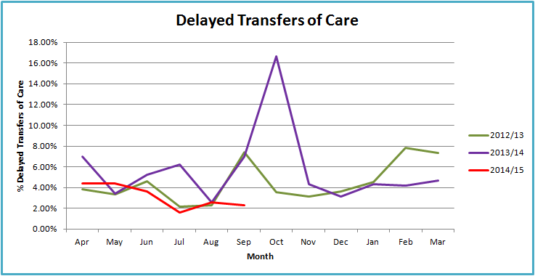

**Trust Action:**

The Trust continues to work with health and social care partners in North Somerset to manage the **‘Green to Go’** list, and where gaps in services are discovered, work with the Clinical Commissioning Group to identify how future commissioning can be organised to close these gaps, providing higher quality joined up care between all partners. The numbers on the list are monitored daily on the system operational calls which include all partner organisations.

Agencies and other care providers are invited in regularly to assess patients, particularly those who may have complex needs with a view to discharging as soon as possible.

# Section 4 Workforce

## 4.1 Executive Summary Headlines

* The temporary staffing cost in August was 11.45% of the total pay bill compared to 12.70% in September.
* Sickness rates were decreased to 4.36% in August and increased to 4.52% in September.
* The appraisal rate was 87.84% in August and 86.95% in September.
* The training compliance rate was 82.54% in August and 81.84% in September.

## 

## 4.2 Workforce

*Figure 28* below shows the pay expenditure for contracted staff, for agency staff.

## Figure 28:

*Figure 29* shows the temporary staffing usage as a month on month comparator. Whilst it was previously reported of a significant decrease in the number of nurse agency staff, this decrease has not been sustained. An increase in nurse agency usage has been particularly high during August and September. This is relating to a number of factors which include opening of Cheddar requiring additional staffing for a whole ward, increased number of vacancies, in June there were 4 WTE vacancies compared to 11 WTE in September, high levels of annual leave granted during the school holidays, and high sickness is some areas of nursing. All of which have contributed to an increased agency usage.

Ongoing recruitment has been taking place, including overseas recruitment in Italy and through Skype interviews. These activities have yielded some success but not to the level previously experienced in 2013 which is due in some to the competition with other NHS Trusts also recruiting from within Europe and the length of the NMC process which delay the start dates of successful candidates.

A separate paper outlined the current position and a projection of nursing numbers is included within the board papers.

The level of temporary staffing usage in the medical workforce has remained high; recruitment activity has been taking place with some success recruiting within the Emergency Department where four Staff Grade Doctors have been appointed into permanent posts and two NHS locums have been appointed into Consultant posts. At the time of preparing the board paper, a conditional offer has been made to a Consultant Gastroenterologist who will be visiting the Trust in early November.

Unfortunately we have not made any appointments to the difficult to recruit positions within acute medicine, , and community paediatrics.

### 

### 4.2.1 Sickness

Sickness has continued to remain higher than in previous years and is higher than at this time last year. The current level of sickness is disappointing, and whilst improvements have been made in some areas the overall Trust position requires urgent improvement. Sickness audits have been completed which have identified some issues that are currently being worked on to help reduce sickness.

### Figure 30:

* Trust standard is ≤ 3.0%

### 4.2.2 Statutory/Mandatory Training

The statutory/mandatory training compliance rate was 82.54 in August and decreased to 81.84% in September. As previously outlined the Trust has been taking a more robust approach towards staff that are non compliant, the first phase of this has been completed and the second phase is currently being implemented.

### 4.2.3 Appraisal

The appraisal compliance rate for August was 87.84% and decreased to 86.95% on September, with the Trust continuing to maintain a high appraisal rate.

### 4.2.5 Staff Friends and Family Test

The quarter one results for the friends and family test for staff have been received and show that:

* 62% of staff would recommend the Trust as a place to work
* 60% of staff would recommend the Trust as a place to receive treatment

These results have been shared with staff through a number of listening events, where members of the executive have met with staff, discussed the results to help identify actions to help improve the outcomes of these two questions.

The quarter two friends and family test have been completed and comments made by staff have been received, with a full report to be provided to the Trust by the end of November. At the time of preparing this update, the results have not yet been issued to be within the public domain.

**Section 5 - Finance Report**

## 

## 5.1 Executive Summary Headlines

## 

* The financial position at Month 6 is that the Trust is reporting a year to-date deficit of £2,508k which is in line with the plan.
* Overall income is £256k over plan at the end of September.
* Overall expenditure is £298k over plan at the end of September.
* The Trusts plan for the year is a deficit budget of £4.95m.

### 

### 5.1.1 Statement of Comprehensive Income Position to Date

The financial position at Month 6 is that the Trust is reporting a £2,508k deficit which is in line with the annual plan.

Revenue from patient activity is £6k over plan for the 6 months to the end of September 2014. Other sources of income are £250k over plan.

Overall expenditure for pay, non pay and depreciation is £587k over plan for the 6 months to the end of September. Pay and non pay expenditure is £622k over plan and this is offset by £324k of reserves.

The Trust’s Service Improvement Programme (SIP) is below target by £118k with a year to date achievement of £1,858k against the target of £1,976k.

The adjusted run rate for expenditure has increased by £215k in September when compared with the August level.

### 5.1.2 Statement of Comprehensive Income Position in Month

Income from patient care activity is £130k greater than plan whilst other sources of income generated £55k more than plan.

Pay and non pay expenditure, including savings delivery, is £220k over plan for the month of September.

The Trust’s Service Improvement Programme (SIP) delivered £410k in September against a plan of £413k and is now only £118k below target for the year to date.

### 5.1.3 Cash

The cash plan for 2014/15 is to hold a balance of £532k at 31st March 2015 and this will be delivered through the in year management of cash and working balances. The cash balance of £2,617k, as at 30th September, is £1,111k higher than the planned position of £1,506k.

The Trust will drawdown £2,475k permanent Public Dividend Capital (PDC) Revenue in October and repay the advance of cash received by the North Somerset CCG.

### 5.1.4 External Financing Limit

The Trust’s External Financing Limit will be achieved through the management of cash and working balances along with the planned level of Public Dividend Capital.

### 5.1.5 Capital Resource Limit

The capital resource limit is £3,858k and in addition to this the Trust is due to receive £124k matched funding from the NHS Safer Hospital, Safer Wards Technology Fund for the implementation of a new Order Communications system. Therefore the Trust’s anticipated forecast capital resource and spend on capital projects is £3,982k at 31st March 2015.

As at the 30th September the programme has delivered capital expenditure of £148k. The Trust will operate within its Capital Resource Limit and continued capital programme management will enable this to be achieved.

### 5.1.6 Capital Cost Absorption Rate

The Trust’s Capital Cost Absorption (CCA) rate is fixed at 3.5% and this will be calculated based on 3.5% of actual balance sheet values at the end of the financial year.

### 5.1.7 Better Payment Practice Code (BPPC)

The Trust’s overall performance as at 30th September is 97.0% on the BPPC.

### 5.1.8 Forecast Outturn

The Trust is forecasting to deliver the plan for the year although this will require delivery of the Trusts savings plans and the continued management of the Trusts services within the available budgets.

The financial forecast outturn includes an overspend against pay budgets for the Medical and Nursing categories, a non pay overspend on drugs and a shortfall in the savings programme. The income has been forecast based on current referral patterns and activity levels which would result in a shortfall from Patient care activities against the plan.

### 5.1.9 Risk to Delivery of Financial Plan

The major financial risks are the delivery of the £4.5m savings programme, the management of Medical staffing to minimise locum agency expenditure, the higher than planned use of agency nursing staff, and the delivery of NHS service income in line with plan and with minimal contract penalties.

Financial Dashboards 2014/15: Month 6



## 5.2 The Income and Expenditure Position of the Trust

**5.2.1** The financial position at Month 6 is a deficit of £2,508k, which is in line with the plan.

## 5.3 Expenditure

**5.3.1** The main points are:

* The position is that overall the Trust has overspent the expenditure budgets by £622k which includes under delivery of Savings (SIP) of £117k. This has been offset with £324k from reserves.
* Pay expenditure is higher than budgeted with an overspend of £348k. The staff category with the highest overspend at the end of September was Nursing (£407k), this was due to additional capacity, the closure of some beds due to infection control outbreaks and an increase in vacancies resulting in a significant increase in agency staff and expenditure. This overspend was offset by an underspend in the following categories AHP’s (£219k), Admin and Clerical (£138k) and Biomedical Scientists (£71k).
* Non pay expenditure is £274k over budget at the end of September, including the underachievement of savings. There are underspends on Training (£69k), Blood Products (£55k), Catering (£28k), Office Equipment (£21k) and Rent & Rates (£24k) offset by overspends on Management Consultants (£80k), Internal recharges (£65k), Drugs (£62k), Linen & Laundry (£61k), NHS recharges (£47k) and Utilities (£31k).
* Bank and agency expenditure on Nursing increased in September to £204k whereas it was £201k in August. Bank expenditure reduced from £141k in August to £129k in September. Of the Bank and Agency expenditure £35k agency and £5k bank was attributable to the RTT initiative work in Month 6.
* In recent months the Trust has had an increasing number of Medical staff vacancies which has led to an increase in the use of Agency locums to cover the Trusts services. In September £269k was spent, down from £305k in August which was the highest level used during the last 2 years. However £55k of this expenditure was attributable to the additional RTT initiative work. Some of this locum expenditure is offset by the medical staff vacancy savings, particularly in ED where there are a total of 8 vacant posts including a consultant vacancy and Medicine where there are a further 10 vacancies.

**5.3.2** At Month 6 the main points for the Divisional and Corporate performance are as follows:

* The Emergency Division has overspent by £264k year to date. Of this, Pay expenditure is overspent by £313k whilst Non Pay is underspent by £90k. There is SIP under delivery of £40k. The Pay overspend is mainly due to Medical Staffing (£193k), Uphill (£92k), ED (£76k), and Kewstoke (£59k), offset by an underspend on Pathology (£64k). The Non Pay underspend is due to a saving on drugs (£104k), Blood (£34k) & Pharmacy (£22k) offset by an overspend on Pathology (£94k).
* The Planned care Division has overspent by £454k year to date. The pay overspend is £76k whilst non pay is overspent by £226k. The divisional income is £38k above the planned level. The SIP underachievement is £191k. The pay overspend is Theatres (£102k), Hutton (£70k) and SAU (£66k), offset by Planned Care Management (£40k), Hospital at Night (£26k) and ITU (£15k). The non pay overspend is mainly on drugs (£180k), Radiology (£39k) and Theatres (£23k), offset by savings on Radiography (£62k), PPU (£39k) and Blood (£17k).
* The Estates and Facilities Division has overspent by £89k at the end of month 6, mainly due to savings non-delivery of £76k and a Pay overspend of £32k. The Pay overspend is due to Housekeeping additional hours (£43k) and Property Services having to employ agency cover for a vacancy (£10k), offset by savings on Portering (£9k). The non pay overspend is mainly on Utilities (£27k) offset by an underspend on Property Services (£33k).
* The Corporate Departments have underspent by £252k year to date.

Reserves have been deployed to cover spend where there are agreed allocations such as the cover of Medical agency premiums, RTT initiative work and agreed waiting list initiatives.

**5.3.3** The Trust’s expenditure run-rate information has been rebased to neutralise the affect on both expenditure and budgets for variations in monthly NICE funded drugs expenditure which has no overall impact on the Trusts net financial position. There have also been some amendments for one-off exceptional items which includes the impact of any work undertaken a part of the RTT recovery project. The Trust’s expenditure run rate is shown in the table below compared to the adjusted expenditure level for each month.

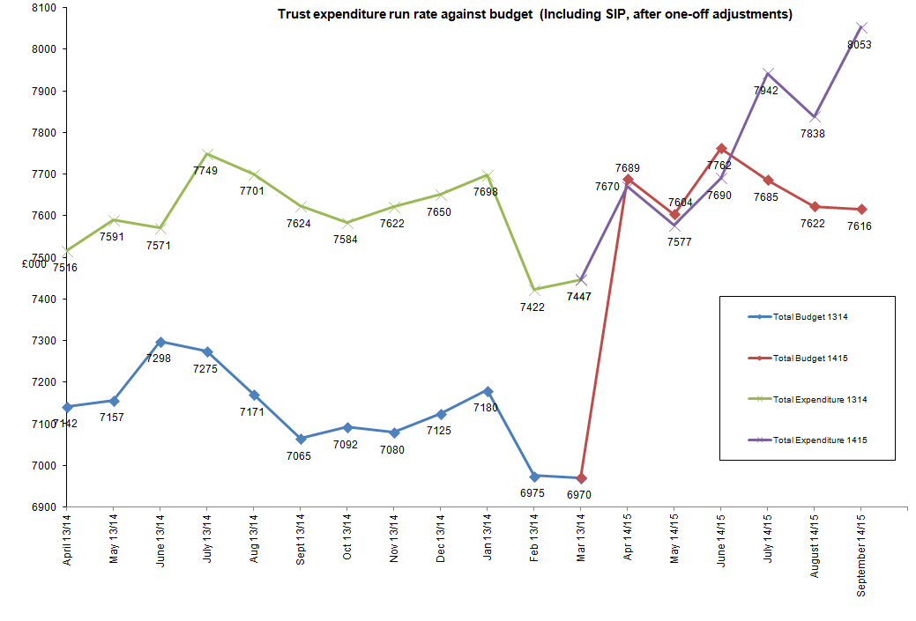

The budgeted adjusted run rate for September is £8.053m. The adjusted expenditure run rate has increased in September by £215k, from £7.838 in August to £8.053m in September.

The main increases in spend were Drugs (£207k increase), Nursing staff (£64k increase) and Medical staff (£17k increase). This was offset by in month by reduced expenditure in the Admin & Clerical (£18k reduction) and legal fees (£44k reduction) categories.

## 5.4 Savings Plans (SIP)

**5.4.1** The Trusthas a savings requirement of £4,500k for the year which represents 4.45% of expenditure budgets. Savings plans have delivered £1,859k against the profiled plan of £1,967k for the six months, an under-delivery of £118k. Of the SIP savings delivered £1,151k is from recurrent schemes and £708k from non-recurrent schemes. In month the Trust delivered £411k against the £413k required. The Trusts performance against its monthly SIP savings requirement is shown below along with the monthly phased plan.

The Trust will continue to take actions to ensure that the savings plans are implemented, with mitigating action taken where needed, to maximise the delivery of savings. Progress of individual schemes is reviewed at the monthly Business plan delivery meetings.

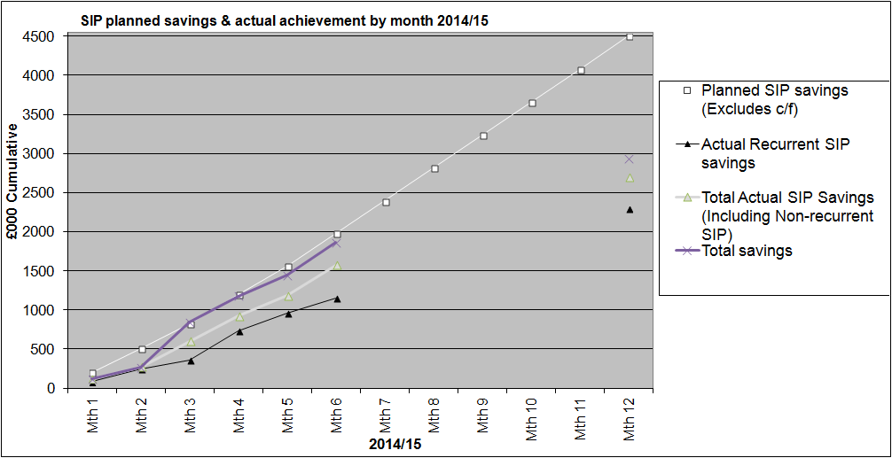

## 5. 5 Activity and Income

* + 1. Overall patient activity income is assessed at £6k over plan at the end of September 2014. This will include the impact of the RTT additional work.
* Income related to North Somerset CCG contract is £490k under plan.
* Income related to the NHS Somerset contract is £71k over plan
* Other CCG patient care activities is £139k over plan
* The Specialist services contract is £340k over plan
* Local authorities is £24k over plan
* Private patient income is £78k under plan.

|  |  |  |  |  |  |  |  |
| --- | --- | --- | --- | --- | --- | --- | --- |
| **6 Months ending September 2014 Activity and Income Report** | | | | | | | |
|  |  |  |  |  |  |  |  |
|  |  | **Annual Plan** | **YTD Plan** | **YTD Actual** | **YTD Variance** | **Variance** |  |
|  |  | **£,000** | **£,000** | **£,000** | **£,000** | **%** |  |
|  |  |  |  |  |  |  |  |
| Day cases |  | 8,087 | 3,978 | 4,438 | 460 | 11.6% |  |
| Elective Inpatients |  | 5,762 | 2,852 | 3,028 | 176 | 6.2% |  |
| Non Elective Inpatients |  | 26,946 | 13,363 | 13,333 | (30) | -0.2% |  |
| Non Elective Excess Bed days |  | 1,616 | 795 | 579 | (216) | -27.2% |  |
| Emergency pathway reconfiguration |  | 0 | 0 | 265 | 265 |  |  |
| Excess Bed Days |  | 74 | 37 | 222 | 185 | 500.0% |  |
| First Outpatients |  | 5,711 | 2,869 | 2,553 | (316) | -11.0% |  |
| Follow up Outpatients |  | 5,205 | 2,587 | 2,454 | (133) | -5.1% |  |
| Outpatient procedures |  | 2,146 | 1,073 | 1,081 | 8 | 0.7% |  |
| Unbundle OP radiodiagnostic |  | 1,390 | 695 | 660 | (35) | -5.0% |  |
| ED attendances |  | 6,182 | 3,116 | 3,066 | (50) | -1.6% |  |
| Critical Care |  | 2,608 | 1,304 | 1,304 | 0 | 0.0% |  |
| Rehabilitation |  | 1,577 | 788 | 768 | (20) | -2.5% |  |
| Children Services |  | 2,631 | 1,315 | 1,315 | 0 | 0.0% |  |
| Direct Access |  | 3,144 | 1,572 | 1,677 | 105 | 6.7% |  |
| Maternity Services |  | 2,784 | 1,392 | 1,280 | (112) | -8.0% |  |
| NICE income |  | 3,202 | 1,574 | 1,761 | 187 | 11.9% |  |
| Private patients |  | 738 | 258 | 201 | (57) | -22.1% |  |
| Other |  | 5,060 | 2,987 | 2,667 | (320) | -10.7% |  |
| QIPP schemes |  | 0 | 0 | 0 | 0 |  |  |
|  |  |  |  |  |  |  |  |
| **Sub total** |  | **84,863** | **42,555** | **42,652** | **97** | **0.2%** |  |
|  |  |  |  |  |  |  |  |
| Penalties |  | 0 | 0 | (36) | (36) |  |  |
| CQUINS |  | 1,876 | 938 | 883 | (55) | -5.9% |  |
|  |  |  |  |  |  |  |  |
| **Total** |  | **86,739** | **43,493** | **43,499** | **6** | **0.0%** |  |
|  |  |  |  |  |  |  |  |

Significant volume variations in performance are shown in the table below:

|  |  |  |  |  |
| --- | --- | --- | --- | --- |
| **Significant over & under performance areas** | |  |  |  |
| **Volume variances greater than 5% and more than 10 cases** | | | |  |
|  |  |  |  |  |
|  | **Day cases** |  | **Elective inpatients** |  |
| **Over performing** | General Medicine | 168% | Breast Surgery | 39% |
|  | Respiratory Medicine | 73% | Gynaecology | 27% |
|  | Paediatric | 46% | Urology | 20% |
|  | Gastroenterology | 32% | Colorectal | 18% |
|  | Colorectal | 26% |  |  |
|  | Urology | 17% |  |  |
|  | General Surgery | 12% |  |  |
|  | Oncology | 10% |  |  |
| **Under performing** | Upper GI | -37% |  |  |
|  | Breast Surgery | -30% |  |  |
|  | Haematology | -11% |  |  |
|  | Gynaecology | -10% |  |  |
|  | **Non Elective inpatients** |  | **Outpatient procedures** |  |
| **Over performing** | Gynaecology | 81% | Upper GI Surgery | 625% |
|  | Urology | 22% | General Surgery | 281% |
|  | Paediatrics | 13% | Urology | 141% |
|  | General Surgery | 11% | Colorectal Surgery | 111% |
|  | General Medicine | 8% | Gynaecology | 71% |
|  |  |  |  |  |
| **Under performing** | Gastroenterology | -80% | Dermatology | -58% |
|  | Cardiology | -70% | ENT | -24% |
|  | Colorectal | -66% | Breast surgery | -15% |
|  |  |  | Cardiology | -9% |
|  | **First Outpatient attendances** | | **F/U Outpatient attendances** |  |
| **Over performing** | Geriatric Medicine | 129% | Haematology | 25% |
|  | General Surgery | 57% | Ophthalmology | 19% |
|  | Urology | 13% | ENT | 16% |
|  | Ophthalmology | 10% | General Surgery | 14% |
|  | Haematology | 8% | Gastroenterology | 13% |
|  |  |  | General Medicine | 7% |
| **Under performing** | Dermatology | -71% | Upper GI Surgery | -40% |
|  | General Medicine | -47% | Dermatology | -36% |
|  | Chemical Pathology | -44% | Neurology | -34% |
|  | Neurology | -29% | Colorectal Surgery | -32% |
|  | Upper GI Surgery | -28% | Respiratory medicine | -31% |
|  | Trauma & Orthopaedics | -22% | Palliative Medicine | -28% |
|  | TIA | -21% | Anticoagulation | -28% |
|  | Respiratory medicine | -18% | GUM | -26% |
|  | Paediatrics | -16% | Vascular surgery | -24% |
|  | Colorectal Surgery | -15% | Urology | -21% |
|  | Diabetic medicine | -13% | Trauma & Orthopaedics | -11% |
|  | Cardiology | -13% | Paediatrics | -11% |
|  | Vascular surgery | -12% | Cardiology | -7% |
|  | ENT | -11% |  |  |
|  | GUM | -9% |  |  |
|  | Clinical oncology | -6% |  |  |
|  |  |  |  |  |

**5.5.2** The following table shows the overall activity for the period ended 31st August 2014:

|  |  |  |  |  |  |  |  |
| --- | --- | --- | --- | --- | --- | --- | --- |
| **6 Months ending September 2014 Activity and Income Report** | | | | | | | |
| **Volumes including ACC** | |  | **Annual Activity Plan** | **YTD Activity Plan** | **YTD Activity Actual** | **YTD Activity variance** | **Volume Variance** |
|  |  |  |  |  |  |  | **%** |
|  |  |  |  |  |  |  |  |
| **Elective Day Cases** | |  | 13,211 | 6,495 | 7,347 | 852 | 13.1% |
|  |  |  |  |  |  |  |  |
| **Elective Inpatients** | |  | 1,635 | 807 | 881 | 74 | 9.2% |
|  |  |  |  |  |  |  |  |
| **Non-Elective Inpatients** | |  | 15,319 | 7,607 | 8,087 | 480 | 6.3% |
|  |  |  |  |  |  |  |  |
| **First Outpatients** | |  | 38,784 | 19,510 | 16,959 | (2,551) | -13.1% |
|  |  |  |  |  |  |  |  |
| **Follow Up Outpatients** | |  | 59,759 | 29,681 | 27,705 | (1,976) | -6.7% |
|  |  |  |  |  |  |  |  |
| **Emergency department attendances** | |  | 56,370 | 28,072 | 27,728 | (344) | -1.2% |

## 5.6 CQUINS

**5.6.1** The latest assessment of CQUINs is that the Trust is on target to receive all of the potential income except for the Dementia (Find Assess Investigate and Refer) scheme. This will be monitored on a monthly basis. Patient communication has been led by the Quality improvement hub and the initial assessment is that this scheme will achieve its target.

## 5.7 Penalties

**5.7.1** A provision of £36k for penalties for the period ending 30th September 2014 has been included for Referral to Treatment, Cancer access, waits and Ambulance handovers. The detailed assessment is shown in the table below. This will be updated as the validation of performance in these areas is finalised. It is expected that there will be no RTT penalties for July, August and September.

It has been assumed in line with the CCG contract that the Emergency Department 4 & 12 hour penalty will be reinvested to resolve the underlying performance issues.



**Referral to Treatment penalty by specialty**



## 5.8 Statement of Financial Position

**5.8.1** The Trust’s main accounting statements are shown in the appendices of this report and see Appendix B for the Statement of Financial Position as at 30th September 2014.

#### Cash

**5.8.2** The External Financing Limit will be achieved by in year management of cash and working balances. The cash balance of £2,617k, as at 30th September, is £1,111k higher than the planned position of £1,151k.

The difference between actual cash balance held £2,617k and the reported £2,143k on the Statement of position relates to un-presented cheques and cash in transit as at 30th September 2014.

The forecast balance as at 31st March 2015 is £532k which will ensure that the Trust meets its requirement to remain within its External Financing Limit.

#### Debtors

**5.8.3**. The figures from the debtors system represent invoices raised for which cash has yet to be received. The total outstanding debt as at 30th September is £1,780k, which is divided between NHS £1,362k, Private Patients £105k and non NHS £312k. Debts over 250 days represent £73k which is 4.1% of the total debt.

#### Creditors

**5.8.4** The measure for the better payment practice code is to pay all NHS and non-NHS trade creditors within 30 calendar days of receipt of goods or a valid invoice (whichever is later), unless other payment terms have been agreed. The compliance is for at least 95% of invoices to be paid (by the bank automated credit system or date and issue of a cheque) within thirty days, or within agreed contract terms. For September the performance against the target is:



## 5.9 Capital Programme and Performance against Capital Resource Limit

**5.9.1** The Trust will operate within its Capital Resource Limit and detailed capital programme management will enable the capital expenditure to be delivered within resources and the Trust’s cash plans for the year.

**5.9.2** As at 30th September 2014 there has been £148k capital expenditure.

**5.9.3** The Capital Planning Committee continues to monitor the capital priorities and projects and the detail is included on Appendix D.

## 5.10 Foundation Trust Indicative Risk Rating

**5.10.1** The Financial risk rating for the Trust, if operating as a Foundation Trust, as at the 30th September 2014 is a level 1, and the liquidity ratio is 7.9 days which also achieves a level 1.

**5.10.2** The Continuity of Services risk metrics, if operating as a Foundation Trust, as at the 30th September 2014 is a level 1.

**5.10.3** The calculation for the Financial risk rating, after applying the over-riding rules, and for the Continuity of Services risk metrics, for the annual plan, year to date and forecast outturn for the Trust is a 1, which is a result of the Trust’s overall financial sustainability issues.



## 5.11 Recommendation

The Board is asked to note the Trust’s Month 6 financial performance for 2014/15 regarding the revenue, capital and cash positions.

### Appendix A – Statement of Comprehensive Income – Accumulated Variances as at Month 6 – September 2014



### Appendix B – Statement of Financial Position as at 30th September 2014



### Appendix C - 12 Month Statement of Rolling Cash Flow



### Appendix D - Capital Programme 30th September 2014

