July 2014

**Weston Area Health NHS Trust**

**Performance Summary**

# 1. Patient Story

**Qualitative observations: A patient story of experiences of care on Emergency Department, Theatres and Medical Assessment Unit.**

A patient was admitted to the Emergency Department via an Emergency Ambulance following a collapse at home, witnessed by his wife.

**1.1 Background**

The patient had been on a snowboarding holiday in Scotland and had been hit in the chest by another skier on the slopes. After the accident the patient was admitted to a hospital in Scotland and discharged home after an overnight stay.

**1.2 At patient’s home**

Over a short period of time at home the patient struggled to find breath, but was staying controlled and calm as they thought it would resolve. Getting out of bed the patient felt that he was going to faint and collapsed at home with subsequent call to 999 by his wife for assistance.

**1.3 Patient experience of an ambulance first responder**

On arrival of the first responder a quick assessment was undertaken. The patient and wife were constantly reassured and the crew explained that the patient needed to be transferred to the Emergency Department for investigations and treatment by ambulance.

**3.24. Patient experience of the transfer to hospital via emergency ambulance**

The patient said he had a very positive experience during the ambulance journey; the crew took their time over bumps in road so that patient wouldn’t feel discomfort in his chest.

**3.25. Arrival at the Emergency Department**

**Patient experience of the nurse triage process**

On arrival to the Emergency Department at 01:00 the patient felt that the triage nurse was efficient and the handover between the ambulance crew and the triage nurse was good. The triage nurse explained to the patient that a chest x-ray, bloods and an ECG were required. It took around 45 minutes for blood results to come back and he was told immediately that he would be admitted to the Medical Assessment Unit (MAU) which was around 03:30.

**Patient experience of medical and surgical care**

The medical and surgical team quickly reviewed the patient and he felt safe and included in the decision making process throughout his admission.

**3.26. Patient recollections of theatre experience**

The theatre experience was under local anaesthetic and he remembers everything that happened throughout the procedure. Two Doctors and one nurse were present in theatre. There was a lot of humour going around and the patient was offered pain relief and was checked whether further pain relief was required throughout the procedure. The patient told the staff how he was feeling throughout the procedure and returned to the ward around 06:30. The patient controlled analgesia pump helped with his pain relief and hourly observations were recorded throughout the night.

**3.27. Patient experience of care on the Medical Admission Unit (MAU)**

**Physiotherapy treatment:**

The patient felt that the treatment received was very good. A physiotherapist also visited the patient on the same day to assist with breathing exercises. The plan from the physiotherapist was for the patient to receive a coloured ball to support with exercises. This did not arrive and was the only slightly negative part of the patient’s hospital admission.

**Catering:**

The patient felt that the food was good with a good selection of good quality hot and tasty food. There were also a lot of hot drinks available.

**Nursing Care:**

The patient stated that his dignity and privacy had been respected, nursing staff were considerate, care was good and his call bell was answered quicker at night time.

**Restricted Visiting:**

The patient found that restricted visiting worked well for him as he felt exhausted when family visited for long periods.

**Same Sex Accommodation:**

The patient liked the privacy which comes with same sex accommodation and had not shared a bay or bathroom with someone of the opposite gender.

# 2. Scorecards

# 

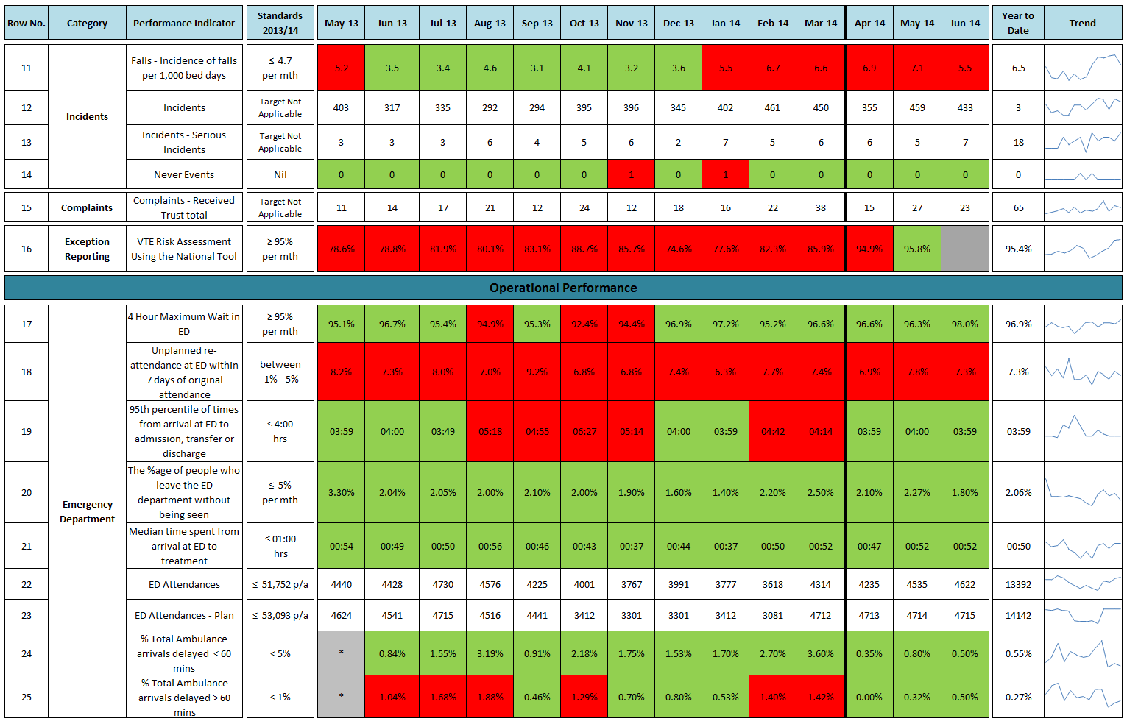

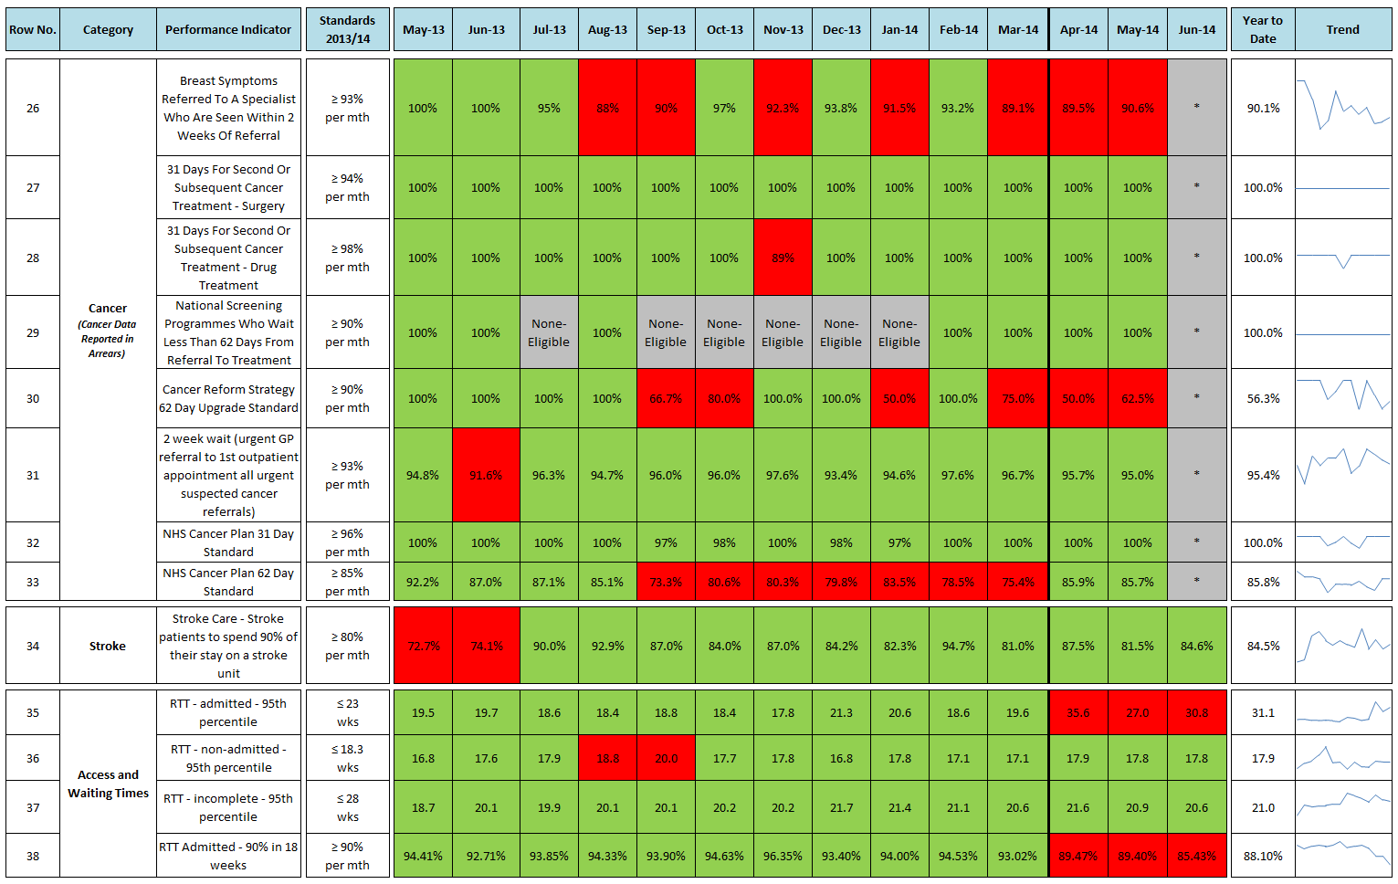

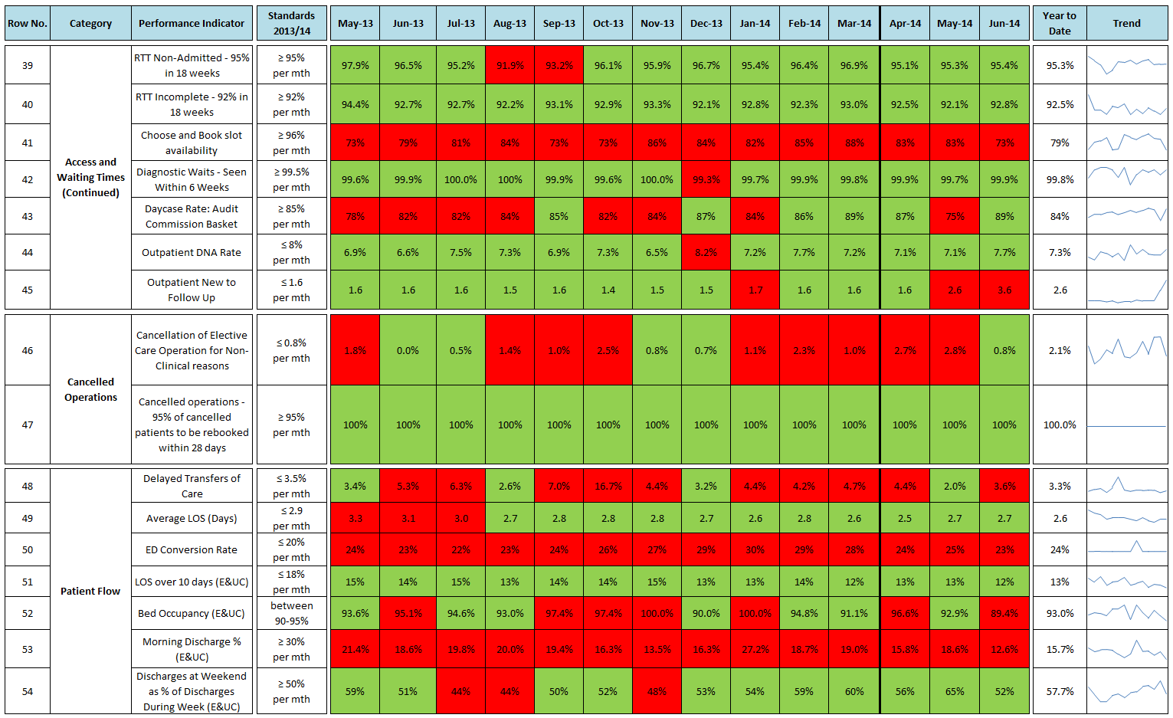

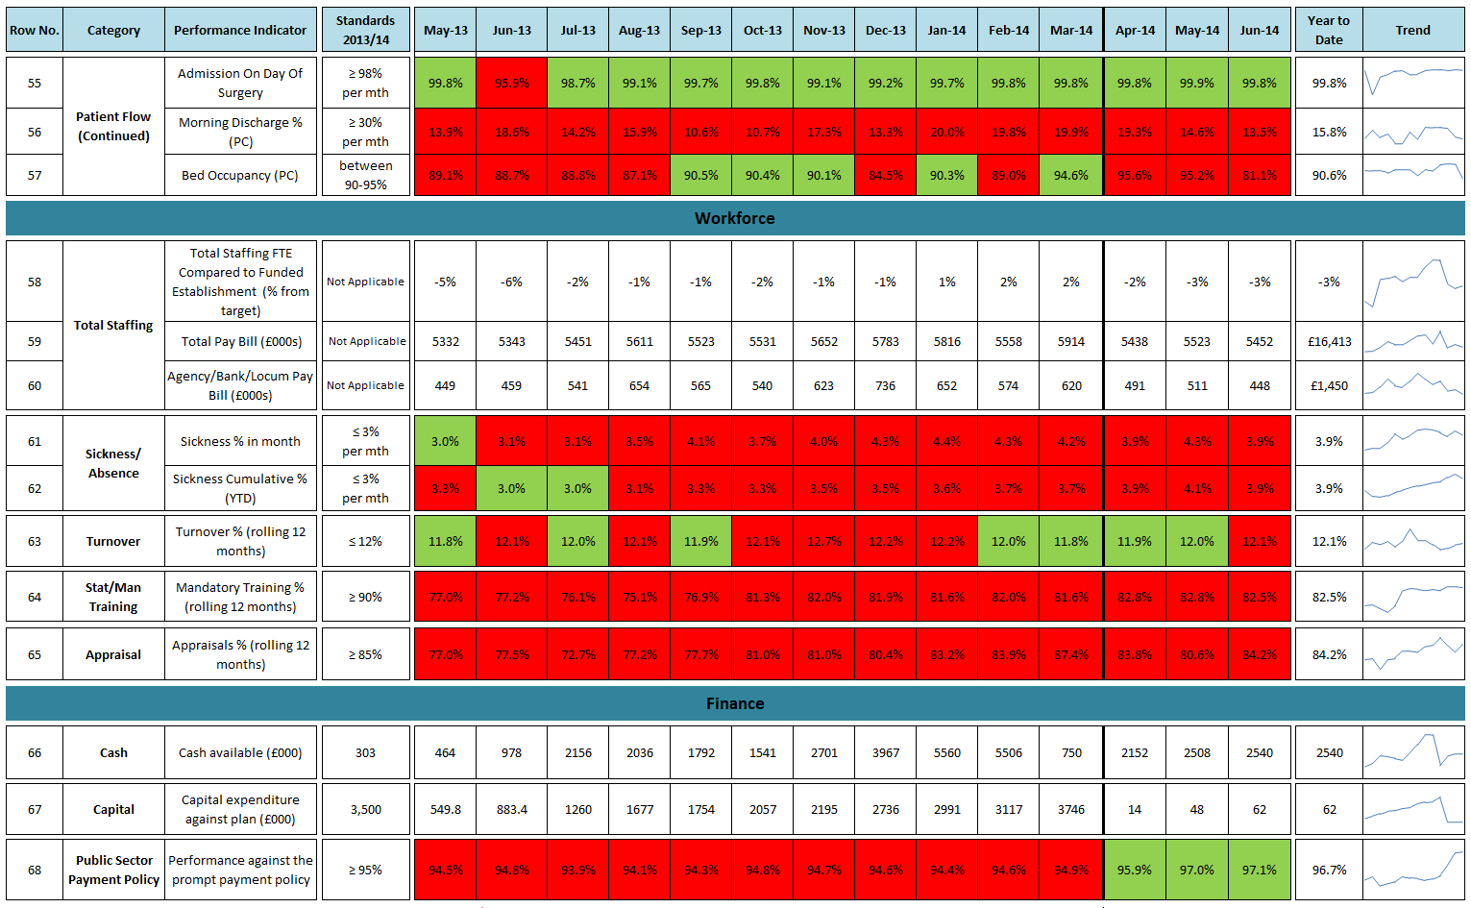

# 3. Nursing Metrics

