April 2015

**Weston Area Health NHS Trust**

**Integrated Performance Report**

# Section 1 Executive Summary

Executive Lead – Mr Nick Wood

Despite some challenges, at the year end we are pleased to report improved or sustained performance on a number of clinical & performance indicators.

Overall mortality rates (measured by the Summary Hospital-level Mortality Indicator (SHMI) have fallen from 83 in April 2014 to 66 in March 2015; and a Trust-wide initiative by the Trust Medical Director has driven consistent compliance throughout the year for assessment of patients for **venous thromboembolism** (VTE) where achievement against the 95% has been consistent.

The Referral to Treatment 18 week target was achieved in line with our trajectory, for 2014/15 this included a planned failure of the target to ensure a backlog of patients were treated in priority order, the recovered position was maintained from September as was planned.

Cancer performance has remained consistent with delivery of the two week waiting time standard throughout the year.

Patient flow has remained a challenge since the summer 2014 with the Trust having failed to achieve the Emergency Department four hour performance standard for the ninth month in succession at the end of March 2015. This has been in the main due to prolonged periods of norovirus affecting inpatient wards from September through until March coupled with high numbers of patients awaiting care in alternative care or social settings. The Trust continues to work closely with partners across the health community and in social care to ensure all patients requiring either social placement or continuing healthcare are discharged in a timely way.

Financially, the Trust has overachieved on its original plan which outlined a projected £4.95m deficit; this has been improved in year with the actual confirmed as an £3.902m deficit, an improvement of £1.048m on the Plan.

Focus on efficiency plans throughout the year have resulted in the Trust Savings Plan of £4.5m for the year being delivered, achieving £4.504m.

The Trust also achieved the Better Payment Practice Code meeting 96.7% for the year against a target of 95%.

# Monitor Scorecard

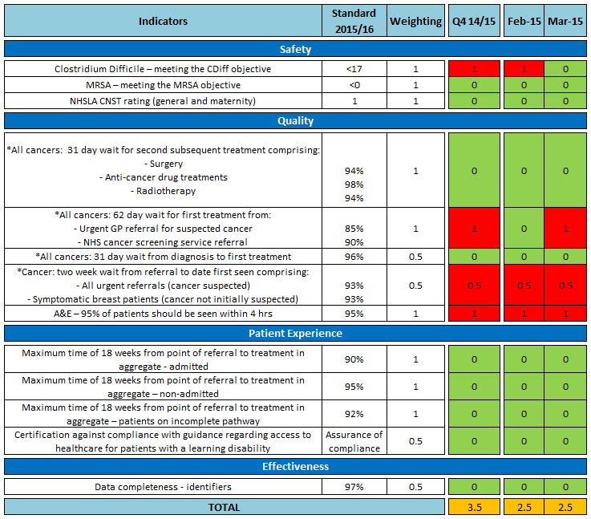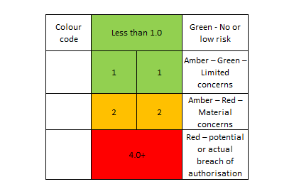

* 2. Summary Scorecard

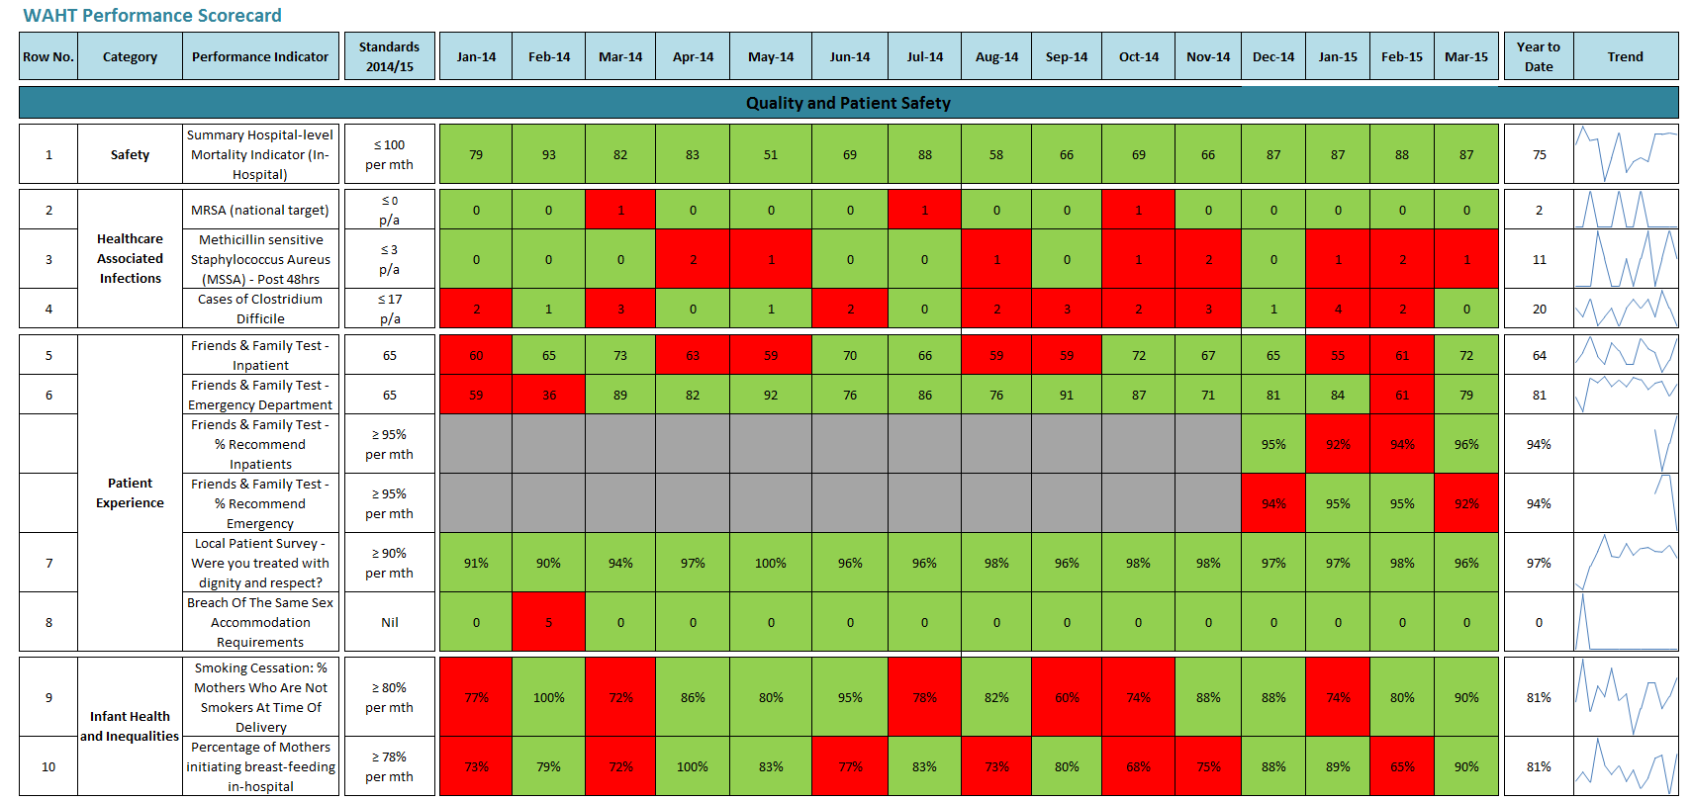

* Data Reported in arrears

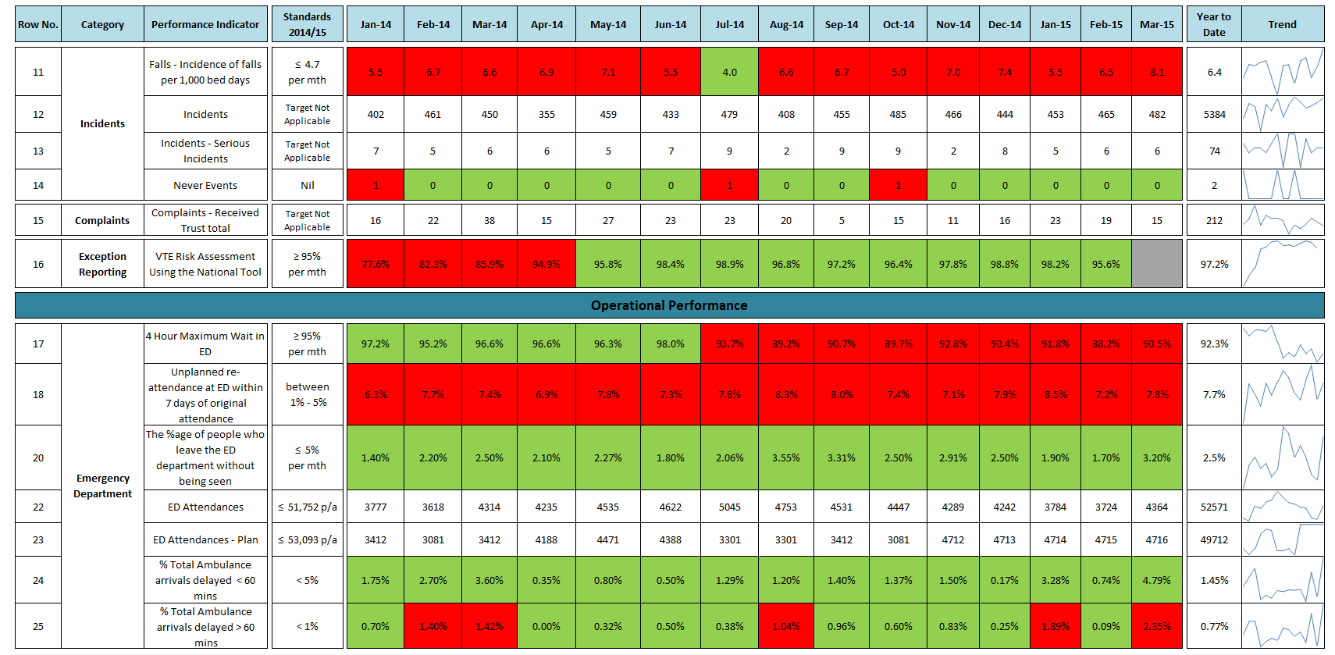

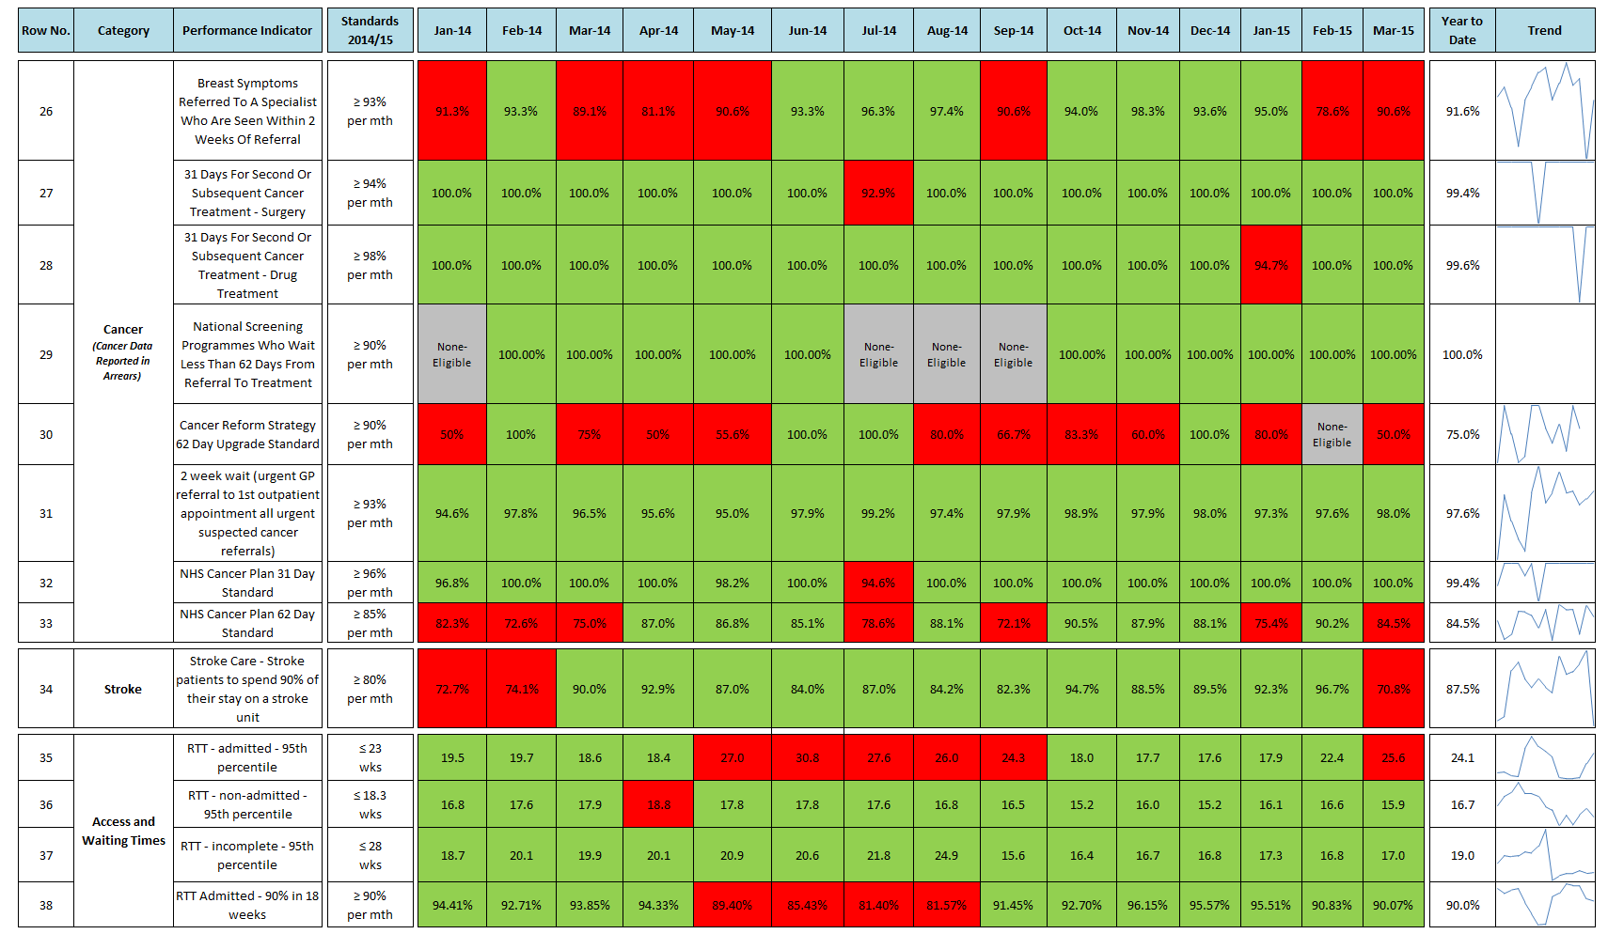

*\*Cancer figures updated following final validation & uploads to Open Exeter, they will be reported one month in arrears from April 2015.*

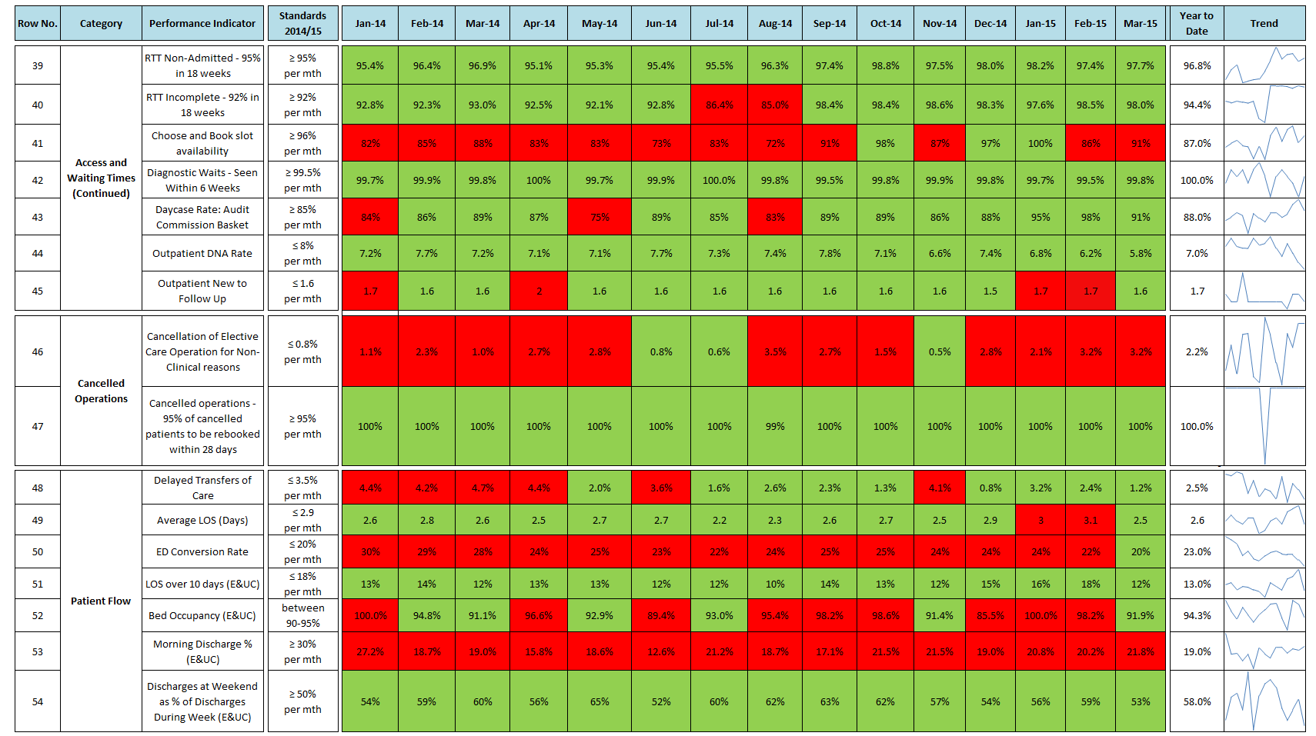

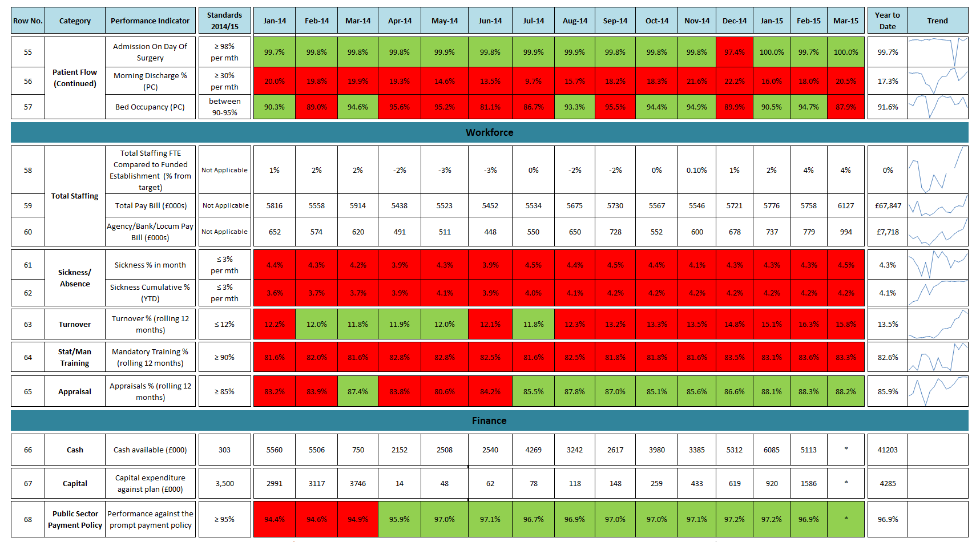

# Section 2 Quality & Patient Safety

Executive Lead – Mrs Chris Perry

* The Trust did not achieve the threshold of 17 hospital attributable cases of Clostridium *difficile* for the financial year 2014/15, reporting a total of 20. All twenty cases have been reviewed to determine whether a lapse of care has occurred which could have contributed to the patient developing Clostridium *diffficile* infection
* With regards to the Friends and Family test the National CQUIN standard for the response rate was achieved for the year having met each milestone agreed.  Many areas should be praised for achieving 100% of people that would recommend their service in March. However some areas did not achieve the locally set target of 95% and work will be undertaken with these wards to understand the reasons
* Falls incidents remain high for February and March.  The Associate Director of Nursing (Corporate) has established a working group to drive the work forward in making improvements in falls management within the trust.

## continues on falls prevention with an increase noted in August and September. Staff education regarding falls prevention remains an ongoing commitment and all nursing staff on wards where significant harm is a result of a fall will receive a letter of recommendations to follow. SWARM has been reinvigorated on Kewstoke ward, and the outcome is reflected in the reduction of patient falls in that area. As a result, Hutton and Uphill wards have been invited to complete SWARM documents

In September the Trust improved performance and achieved the national target of 95% with 97.2% of appropriate patients receiving a VTE risk assessment.

The management of complaints across the Trust has recently undergone a period of change brought into effect by the Director of Nursing to improve patient experience. The Trust is currently trialling a process where concerns are sent to the relevant area with a 48 hour resolution time.

## 2.1. Patient Story

Patient Story relating to Post-operative care on Steepholm.

This story related to the care my wife received following a short notice operation which was further complicated due to the fact that she had a severe infection. The operation took three times longer than normal to complete. I feel that the post-operative care that my wife received was woefully below the standard we expected. She was left writhing in agony for in excess of two hours following her return to the ward. Furthermore, pain management in the following days was not correctly followed as prescribed causing anxiety and discomfort as well as prolonging her recovery.

On review of the case there was a delay in the patient receiving pain relief when she returned to the ward after her operation. This was as a result of the drug chart not being properly completed and therefore it did not give the appropriate legal authority to the nurse to administer the prescribed drugs. This is particularly serious in the case of a controlled drug such as morphine which is subject to stringent regulation, to protect patients. Attempts to contact the prescribing doctor were unsuccessful. The doctor did not communicate back to the ward staff that he was unable to attend which would have enabled the issue to be escalated so that another doctor could prescribe the dose of medication required. The doctor was eventually located on another ward and attended due to the level of distress and pain the patient was experiencing.

The patient was not given her pain relief routinely every 2 hours, resulting in breakthrough pain.

**Actions**

In the event of the doctor being unable to attend immediately, the doctor should communicate this back to the ward staff and the issue escalated if necessary so that another doctor can prescribe the dose required. This has been fed back to all relevant staff for learning and to avoid any such reoccurrence.

The Trust is reviewing how drug rounds are carried out to ensure, even at busy times, pain relief medication is prioritised where appropriate and provided in a timely manner to avoid breakthrough pain. The ward Sister has also spoken to the team in the recovery area to remind them to check that drug charts are correctly filled out prior to returning patients to the ward.

Nursing staff have weekly training sessions and the Sister programmed a session on pain control to refresh staff on their knowledge based practice whilst considering pain from the patient’s perspective, to further develop enhanced standards of post-operative nursing care.

## 2.2 Registration with Care Quality Commission (CQC)

The Trust is compliant with all five of the CQC’s essential core standards of:

1. Treating people with respect and involving them in their care
2. Providing care, treatment and support the meets people’s needs
3. Caring for people safely and protecting them from harm
4. Staffing
5. Quality & suitability of management

The essential standards of quality and safety set by the CQC government body are central to our work as a Trust.

Quarterly monitoring of Trust compliance with CQC standards occurs via reporting to our Quality & Governance Committee.

The CQC will undertake an inspection of the Trust commencing May 19th 2015.

**2.3 Nursing Metrics**

The use of agency nurses continues to be high in February and March 2015 due to vacancies, opening of Cheddar Ward (as part of Winter planning) and the use of additional escalation beds   on the Stroke Unit and Ashcombe Birthing Centre for female adult patients.

The Registered Nurse and overall nursing numbers for Hutton and Berrow wards in February were less than the planned establishment to reflect lower nursing numbers required for a reduced number of patients on these wards due to Norovirus outbreaks.

Uphill ward is struggling to meet mandatory training due to high levels of sickness.

There were a total of thirteen Nurse staffing incidents reported through Datix in February, five of these were from MAU which related to staff being moved from their ward at night to cover other wards. The staff were moved as a result of shifts not being filled by agency and MAU having the higher number of registered nurse. They all relate to last minute staffing shortages

During this period the ward sisters and matrons met three times a daily to ensure staffing was appropriately managed and shared according to dependency.  At weekends  a Matron or senior Sister worked to support safe staffing extra to established staffing.

**Figure 1:** 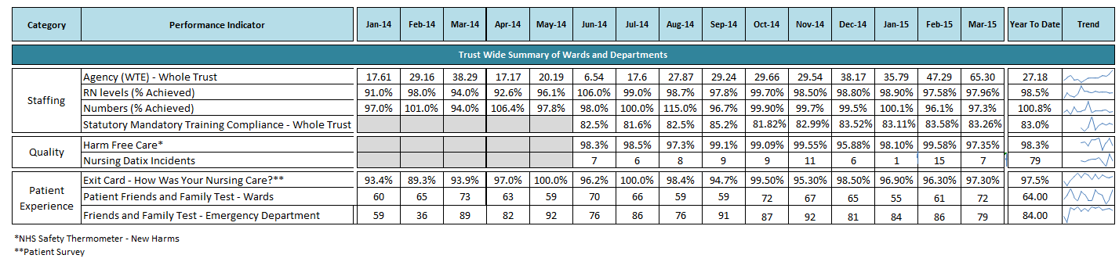

NB. Agency (WTE) and Statutory Mandatory Training Compliance as above encompass nurse staffing Trust-wide

**Figure 2:** February 2015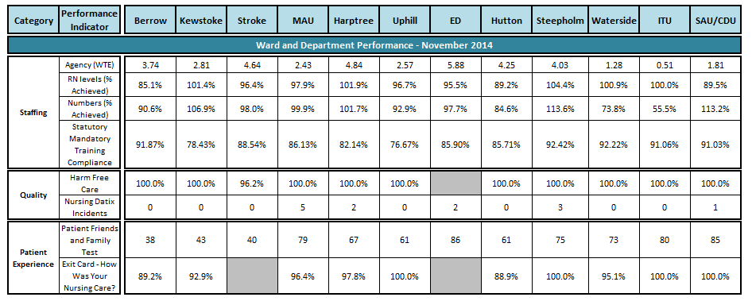

**Figure 3:** March 2015

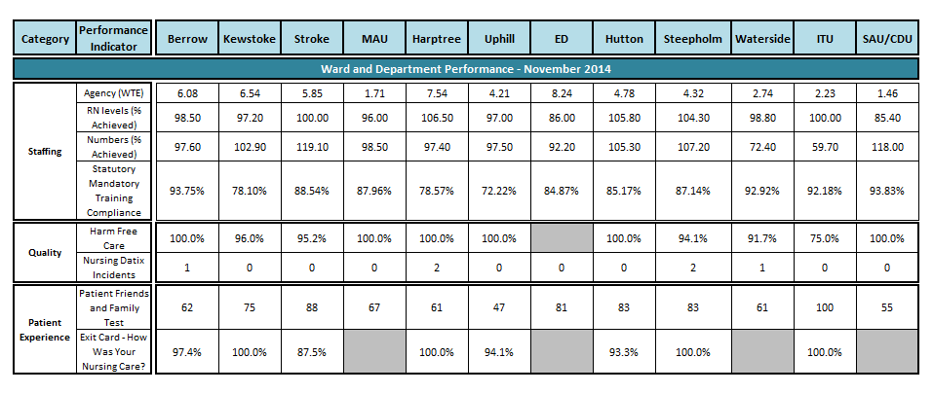

## 2.4 Incident Reporting

Incident reporting systems and policies are integral to patient safety and enable the Trust to analyse the type, frequency and severity of incidents that occur. The Trust’s open and honest reporting demonstrates a commitment to our patients and their safety. The information arising from these reports is used to make active changes to improve our provision of quality care and to safeguard the wellbeing of our staff and patients.

*Figure 1* depicts the number of patient incidents reported each month, compared to previous years.

**Figure 1:**

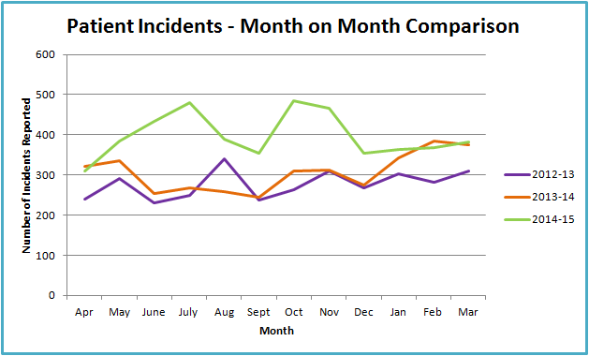

Since September2014 the reporting of incidents within the Trust has remained fairly stable, with the number of reported incidents fluctuating between 350 to 400 per month. There were a total of 750 patient incidents reported in February/March, 369 in February and 381 in March and the top 3 themes of incidents were pressure ulcers, falls and medication. On closer inspection there is an increase in incidents reported under a) Access/Admission/Transfer incidents, 18 compared to 2 for December/January and b) Documentation incidents, 23 compared to 12 for December/January and c) Slip from a height/chair or bed incidents, 23 compared to 13 for December/January.

On closer inspection:

* Access/Admission - Further review of incidents revealed no identified theme
* Documentation - Further review of incidents revealed no identified theme
* With regards to incidents reported around slips from a height/chair or bed. There is no underlying trend however it has been noted that 8 of these incidents were reported on one ward (Harptree) and 3 included the same patient on different occasions. This has been highlighted to the relevant ward staff

A total of 200 pressure ulcers were reported in February and March (total number of community and hospital acquired), accounting for 27% of all patient incidents. The Trust reported 39 hospital acquired pressure sores, which is a decrease of 8 from December/January. The Trust reported 4 hospital reported grade 3 and 4 pressure ulcers. All relevant external organisations were notified in February/March and a full investigation was commenced.

118 slips, trips, falls & collisions were reported in February and March, which is slightly up on the numbers reported in December and January (115). Kewstoke (21), Harptree (17), Uphill (12) and Cheddar (11) reported the highest number of falls incidents. 3 fall’s were escalated as requiring a Serious Incident Requiring Investigation, 2 due to the patient sustaining a fractured neck of femur one of these being a visitor) and 1 due to the patient sustaining a subdural haematoma following the fall.

103 medication incidents were reported in February/March, slightly up from 87 in December/January. These errors included administration (meaning medication administered orally or intravenously) from a clinical area (such as ward areas), medication error during the prescription process and preparation of medicines/dispensing in pharmacy.

### 2.3.1 Daily Situation Report

The daily situation report (SitRep) continues to be circulated by the Quality Improvement Team on a daily basis. Data is presented to help operational leads focus on any areas of concern.

**2.3.2 Staff Incidents**

The Trust Health and Safety Committee reviews incident trends and receives reports on incidents reported under the Reporting of Injuries, Diseases and Dangerous Occurrences Regulations (RIDDOR) 1995. *Figure 2* depicts the number of staff incidents reported each month, compared to previous years.

**Figure 2:**

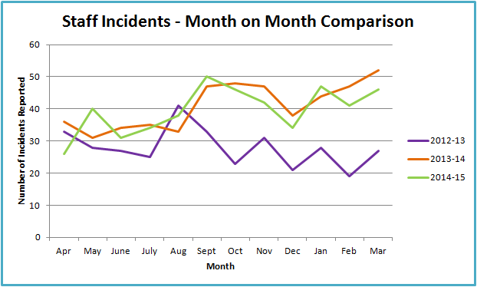

There were 41 staff incidents reported in February and 46 incidents reported in March, a total of 87. Incidents reported involving abuse of staff has decreased again with 18 incidents reported in February/March.

### 2.3.3 Serious Incidents (SIRIs)

A Serious Incident is defined in the <http://www.england.nhs.uk/ourwork/patientsafety/> (2013) as an incident that occurred in relation to NHS-funded services and care resulting in:

* Unexpected or avoidable death of one or more patients, staff, visitors, or members of the public.
* Serious harm to one or more patients, staff, visitors, or members of the public or when the outcome requires life saving intervention, major surgical/medical intervention, permanent harm or will shorten life expectancy or result in prolonged pain or psychological harm (this includes incidents graded under the NPSA definition of severe harm)
* A scenario that prevents or threatens to prevent a provider organisations ability to continue to deliver healthcare services, for example, acute or potential loss of personal/organisational information, damage to property, reputation or the environment, IT failure or incidents in population programmes like screening and immunisation where harm potentially may extend to a large population.
* Allegations of abuse
* Adverse media coverage or public concern about the organisation or the wider NHS.
* One of the core set of Never Events

*Figure 3* depicts the number of serious incidents reported to the Trust

**Figure 3:**

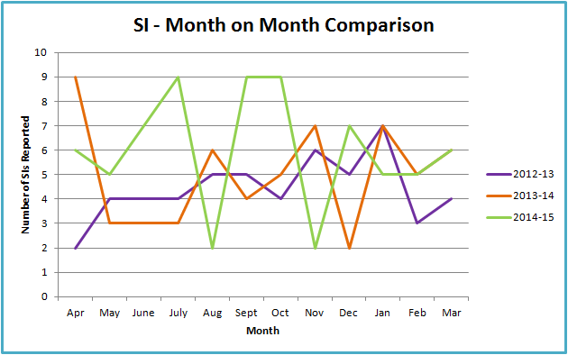

Resultant investigation reports are reviewed by the local Clinical Commissioning Group and, for the most serious cases, also reviewed by the NHS Trust Development Authority. Between the 1st February and 31st March 11 serious incidents were recorded.

The 11 investigations are classified as follows:

|  |  |  |
| --- | --- | --- |
| **Category** | **Grade 1** | **Grade 2** |
| Operational (e.g. unit closure) | 0 | 0 |
| Adverse media attention | 0 | 0 |
| Information Governance (e.g. loss of data) | 0 | 0 |
| Clinical Care of patient (e.g. pressure ulcer, delayed diagnosis, avoidable severe harm) | 11 | 0 |
| Safeguarding (e.g. allegation of abuse) | 0 | 0 |
| Avoidable severe harm to staff | 0 | 0 |

**2.5 Patient Feedback**

### 2.5.1 Complaints

Complaints management is critical to ensuring the Trust not only responds to the complainant in a timely manner, but to ensure the learning from complaints is translated into action. Complaints data enables the Trust to determine if there are any trends in subject matter, location or personnel. Figure *5* portrays that the total number of complaints received in February 2015 and March 2015 as 34.

There was one complaint linked to safety incidents.

**Figure 4:**

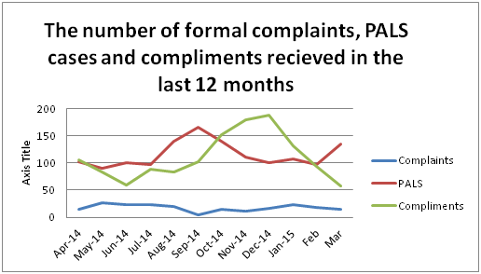

**Figure 5:**

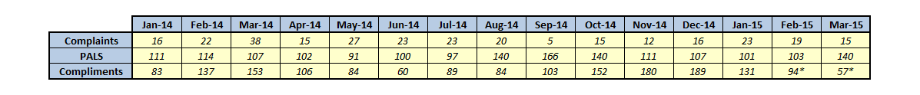

*At the time of writing this report, there have been 151 compliments logged for February and March. The full figure will be available in next report.

**Figure 6:**

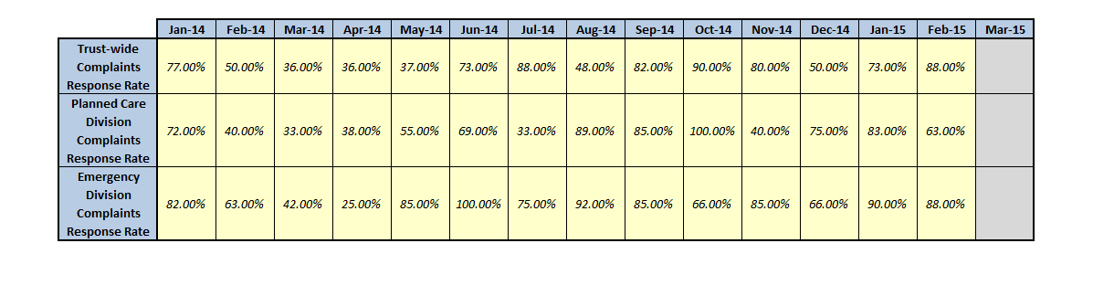

**Figure 7:**

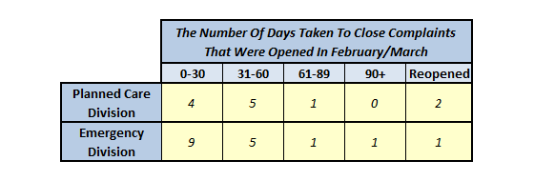

The Trust aims to provide a full response to all complainants within 30 working days. The response time for complaints as shown in *Figure 6* demonstrates the commitment of the Trust to resolve complaints in a timely manner.

The Head of Nursing regularly meets with the Team to discuss target dates. This enables the complaints team to keep complainants up to date and provided reasons should there be a delay to their response. There have been 11 cases that have taken longer than the Trust target of 30 days. In each case the complainant was kept informed of the delay.

There were 3 complaints linked to safety incidents in February and March. During this period the Trust has received 5 requests of further information relating to complaints already raised.

All complainants are offered the opportunity to meet with relevant staff should they wish. 4 complaint resolution meetings were held during February and March resulting in satisfactory resolution for the complainant. Should complainants remain unsatisfied with the final response from the Trust, and all options for internal resolution have been exhausted, complainants are advised of the option to refer their complaint to the Complaints Ombudsman. One new complaint was referred to the Complaints Ombudsman in March.

**2.4.2 Complaint themes**

**Figure 8**

a) Medical treatment - was a significant theme for complaints in February and March. However the number for each month was significantly lower than for January. 15 out of a total of 34 complaints mentioned medical treatment. Concerns raised include:

* Complaints relating to the DNAR instruction in 2 instances.
* Delays in assessment.
* Lack of consistency in diagnosis mentioned in 3 cases.

The Executive Medical Director takes a proactive role in the management of complaints. A monthly report is provided the Medical Director detailing the complaints linked specifically to clinicians. Further detailed information is being provided to Lead Clinicians when requested by the Complaints Team to facilitate a further review where appropriate.

b) Communication - The number of concerns raised linked to communication through February and March is lower than the previous 2 months and remains high. 11 out of a total of 34 complaints mentioned communication. In March communication was only raised in one complaint for the Emergency Department this reflects the positive feedback received from patients linked to communication.

c) Medication - There has been an emerging theme for medication 11 out of a total of 34 complaints mentioned medication. Concerns raised identify that pain relief is not always being administered in a timely way and ineffective monitoring and management of medication including pain relief. Questions have also been raised concerning the appropriateness of the medications prescribed two of these related to dementia patients. This theme was mirrored in the number of patient safety incidents being reported during the same period. A new Green Bag system has been introduced across the hospital which will facilitate staff using a patient’s own medication whilst the patient is in hospital. One of the aims of this new initiative is to reduce the number of delays in administering and ensure the continuation of regular patient medication.

An action plan has been developed by the Complaints Manager in partnership with Heads of Nursing to focus learning on the main themes identified from complaints and concerns; Medical Treatment, Communication and Communication linked to Medication. This action plan will be monitored by Heads of Nursing through the Divisional Governance process. The action plan is being updated and shared with the Quality and Governance Committee every three months.

**2.4.2 PALS**

The total number of cases dealt with by the team in February and March was 243. The top 4 themes were Information, Appointments, Communication and Care.

Information was the highest theme across the Divisions with 80 out of 243 cases requiring information. There were 52 cases linked to appointments; this was the highest theme within the Planned Care Division with 41 cases. Cancelled appointment is a new highest sub theme; 15 cases, along lengthy wait 14 cases as in previous months.

The care of patients was another main theme for the Trust; 36 out of 243 cases. The subthemes for Care were split Medical Care and Nursing Care with 26 and 13 respectively. There has been a noticeable shift to medical care which mirrors the theme for complaints.

As with formal complaints, communication has been a significant theme over the past two months there were 42 out of 243 cases. The cases highlighted communication concerns across varied areas with the Secretaries and ED receiving the highest number of PALS related to Communication. A risk related to the administrative process within the Trust has been recognised and is included on the Trust Risk Register.

**2.4.3 Compliments**

The number of compliments received in February and March was 153. At the time of writing this report however the recording is incomplete.

Wards are continuing to focus on gathering patient feedback and it is hoped that reviewing the exit cards weekly will encourage staff to make sure patients are given the opportunity to provide feedback before leaving the hospital. The Compliments formally recorded are received via email or letter. *Figure 9* depicts three examples of compliments received by the Trust in February and March. Where appropriate each compliment receives a letter to thank the individual for taking time to comment.

**Figure 9:**

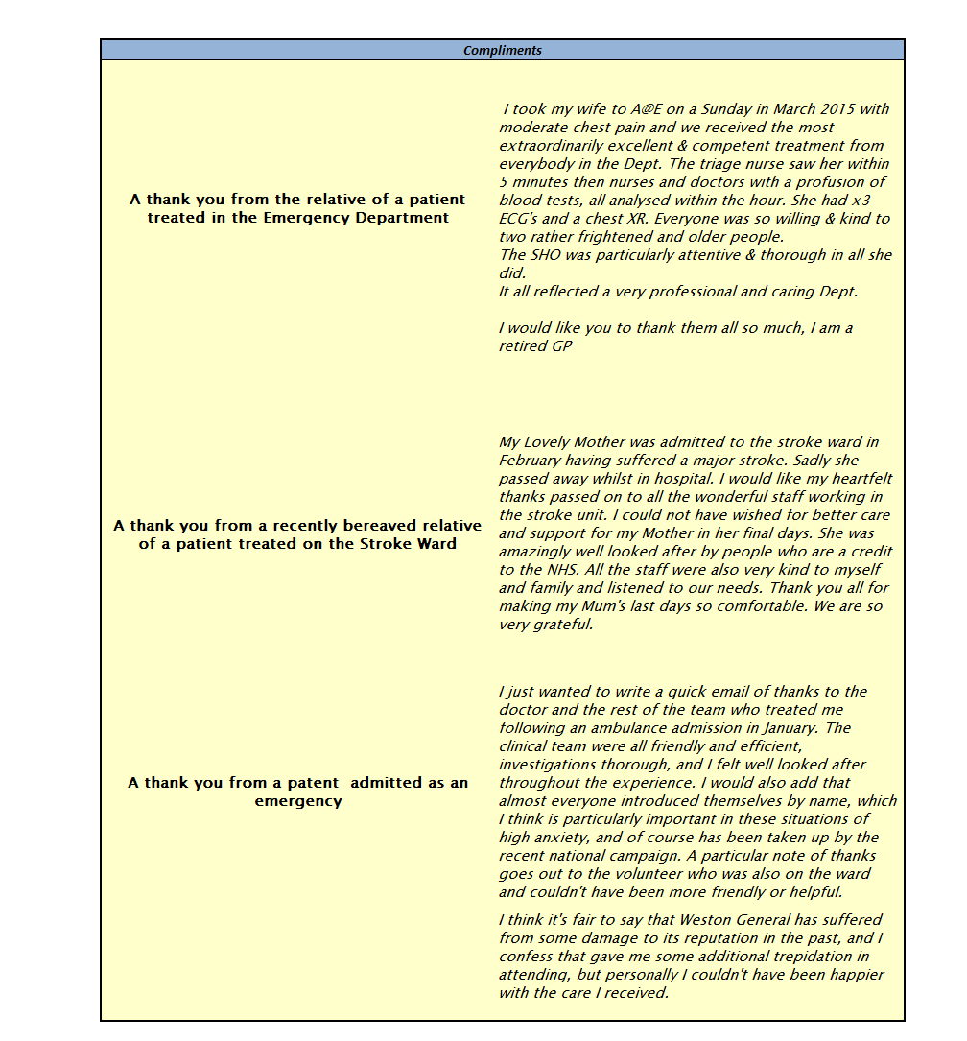

## 2.6 Patient Feedback

As a national requirement Weston Area Health NHS Trust is engaging in the delivery of the Friends and Family Test (FFT). This test has been implemented successfully across all areas. The Friends and Family Test is a single question survey which asks patients whether they would recommend the NHS service they have received to friends and family who need similar treatment or care.

The FFT is offered to all patients at the point of discharge and when patients attend the Emergency Department.

Each Directorate and all wards receive a breakdown of the outcome of their survey results to ensure they can take relevant action to sustain improvements already made and proactively develop actions to deliver further improvement. *Figure 10* provides a detailed report of February Friends & Family Test results, whilst *Figure 11* shows March’s breakdown.

Many areas should be praised for achieving 100% of people that would recommend in March. However some areas did not achieve the locally set target of 95%.

The National CQUIN standard for the response rate was achieved for the year having met each milestone agreed and also for the last quarter.

Update sessions for all department and ward leads along with Matrons have been held in April to ensure that everyone understands the targets for Friends and Family and to promote consistency in publishing the data for the public and staff to see. It is anticipated that by the end of April each area will be using a standardised report.

Children’s Services this month have begun to collect Friends and Family data and will be reporting from next month.

**Figure 10:** 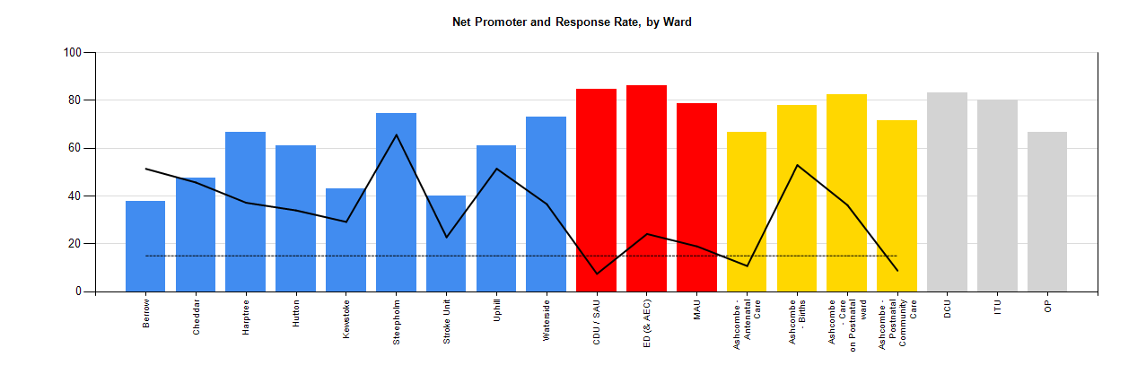



**Figure 11:**

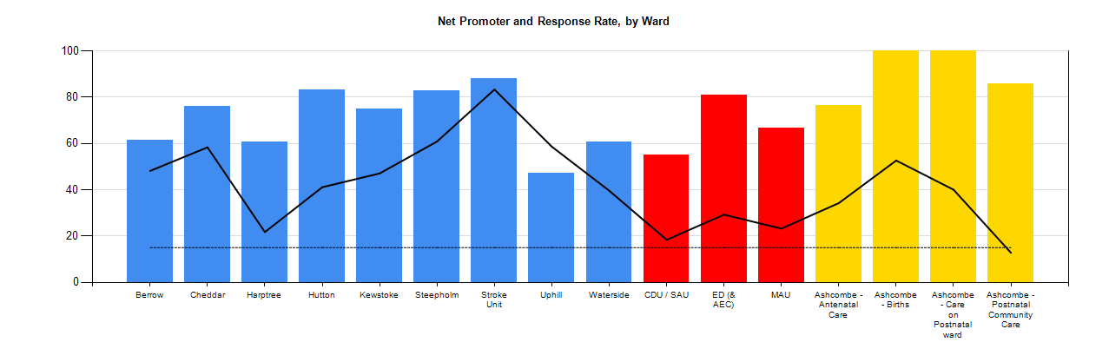



**2.7 Mortality Data**

Mortality data remains overall within expected limits. Further details on mortality review and actions is included in the Harm Free Care report.

**2.8 Infection Prevention and Control Performance**

***Clostridium* *difficile***

Prevention of avoidable hospital attributed cases remains high on the agenda for the Infection Prevention and Control Team. Weston Area Health NHS Trust had a threshold of 17 hospital attributable cases of Clostridium *difficile* for the financial year 2014/15. We did not achieve this threshold and reported 20 cases in total for this financial year. All twenty cases have been reviewed to determine whether a lapse of care has occurred which could have contributed to the patient developing Clostridium *diffficile* infection. Seven of those twenty cases have been associated with a lapse in care, for example, inappropriate antibiotic prescribing. The remaining thirteen cases have been scrutinised and assessed as unavoidable, which equates to 65% of the total cases.

The antimicrobial stewardship programme continues and levels of compliance with antibiotic prescribing have been steadily increasing. During March the Trust achieved its highest compliance percentage of 92% which is an exceptional achievement.

**MSSA Bacteraemia (bloodstream infection)**

Two cases of MSSA bacteraemia were reported in February and one in March 2015. The Trust has reported a total of eleven cases for 2014/2015 against our trajectory of three cases. A rapid improvement plan is currently being implemented to improve compliance with device related care, standard infection control precautions and isolation practice. Ward based training and competency assessment in Aseptic Non-Touch Technique (ANTT) for all medical and nursing staff will commence once the ANTT policy has been ratified next month.

**Outbreaks**

Outbreaks of Norovirus have continued to have a major operational impact on the Trust throughout both February and March. There have been 21 separate Norovirus outbreaks during this financial year, compared to 11 in 2013/14. Levels of gastroenteritis in the local health community have been higher than the national average since December 2014 and this has contributed to the outbreaks that have developed here.

There were seven confirmed outbreaks of Norovirus in February and March. The outbreaks were located in Hutton, Kewstoke, Uphill (x2), Berrow and Stroke (x2). Detailed analysis of these outbreaks is still ongoing. There is, however, evidence to suggest that both staff and visitors are coming into the hospital with symptoms suggestive of Norovirus and two of the seven outbreaks could have been introduced this way. There is still some improvement required with outbreak documentation and communication. Work is ongoing to understand the air flows within the ward environments and the level of ventilation in the side rooms. Deep cleaning of all affected wards occurred at the end of each outbreak in line with national guidance and Trust policy.

**Ebola Virus Disease (EVD)**

The EVD working group now meets on a monthly basis as the threat of an EVD case continues to decline; the group is responsible for ensuring that the Trust is as prepared as possible for a case of EVD. The Viral Haemorrhagic Fever policy will be updated as any changes to guidance are released by Public Health England. A further exercise to test our preparedness is planned for June 2015.The Emergency Department staff are all being retrained in the donning and doffing of Personal Protective Equipment (PPE) as a refresher.

**2.9 Maternity**

The maternity team achieved variable results in both its national targets for initiating breastfeeding in-hospital and mothers not smoking at the time of delivery in February and March. The Matron would highlight again that the data does not give a true picture of the achievements of the service, and has suggested that additional data including all women booked for antenatal care be considered in addition to just those who give birth at Ashcombe Birth Centre.

Referrals to Stop Smoking Service continue to be good, and we have implemented Carbon Monoxide (CO) monitoring at all antenatal contacts, with referrals for women whose reading is above 4 parts per million on the monitor.

Births for 2014-15 are 233, this is 5 fewer than last year, but a much smaller reduction than over the last few years. It is known that at least 3 women were redirected in labour when the inpatient maternity services were suspended for 3 days in January 2015 when the ABC was used as an escalation ward for inpatients.

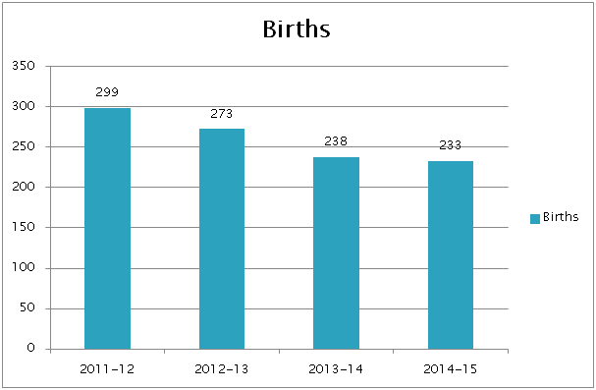

**Figure 12**

The Matron is very hopeful that continuing the work on the 36 week clinic, and ensuring information regarding partners staying the first night will mean that over the next 12 months there will be an increase in births. Additionally, she plans to produce some patient information illustrating visually the statistics from the Birthplace Study (2011) which supports the safety of freestanding midwifery-led units, and which NICE has included in the recently updated Intrapartum guidance (December 2014).

The Matron sits on the Maternity Group of the South West Strategic Clinical Network, and is delighted that the South West Maternity Dashboard has been rolled out, and that Weston Area Health Trust are contributing to it. Sadly, as WAHT is the only Midwife-led Unit in a discrete Trust it is not possible to benchmark against a similar unit.

The joint Local Supervising Authority Midwifery Officer audit of Supervision of Midwives took place on the 12th March at St Michael’s Hospital. The report is not yet available, and the Matron is awaiting a date from the audit team for their visit to review the environmental changes at Ashcombe Birth Centre following the audit in 2014.

## 2.10 Venous Thrombo-Embolism (VTE)

VTE risk assessment compliance is achieving the required standard. Further information on VTE prevention and management is outlined in the Harm Free Care report.

# Section 3 Operational Performance

Executive Lead – Mrs Karen Croker

## 

## 3.1 Executive Summary Headlines

* The Trust did not achieve the Emergency Department four hour standard of 95% for the year with a year end position of 92.55%. March performance standing at 90.5%.
* Trust-wide delivery against all three Referral To Treatment targets was achieved during March. Despite a planned recovery phase during summer 2014 our overall consistently high performance has achieved the overall year end position.
* The year end position for cancer shows achievement against 5 of the 8 cancer access standards; as was the position for March with a failure against three of the eight.
* Patient flow challenges throughout the month of March has resulted in an increase in cancelled operations and hampered our ability to achieve the stroke target.

## 3.2 Operational Performance

The following sections detail the Trust performance against a number of key indicators. The report is divided into:

* *Clinical Indicators*
* *Clinical Pathways*
* *Emergency Access*
* *Elective Access*
* *Patient Flow*

## 3.3 Clinical Indicators

## 3.3.1 Emergency Readmissions

An emergency readmission is defined as an unplanned readmission within an identified time of leaving the hospital. The ideal readmission rate is zero however this is not always possible as patients can have multiple co-morbidities or long-term conditions which require frequent medical attention.

Monitoring emergency readmission rates is important to the Trust as it can help to prevent or reduce unplanned readmissions to hospital.

The Trust monitors emergency readmissions within 14 days and 30 days. As illustrated in *Figure 13,* performance of readmissions within 14 and 30 days continued to improve in February and although rose slightly in March, was still the low for the year to date. The Trust has noted the lowest readmission percentages in twelve months, over the last quarter.

**Figure 13:**

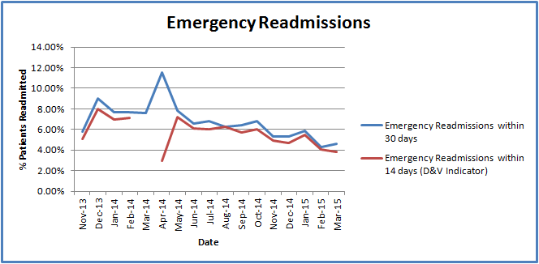

**Trust Action:**

To provide additional assurance that emergency readmissions are not related to the original episode of care, the Emergency & Urgent Care Division are undertaking regular audits of the readmissions to provide assurance that patients are not being readmitted as a result of the Trusts treatment and care.

### 3.3.2 Average Length of Stay

The average length of stay (ALOS) refers to the average number of days that patients spend in hospital. The Trust strives to have a length of stay below the Trust target as it demonstrates proactive planning of the whole process of care, as well as active discharge planning. In February the average LOS increased to 3.1 days which in the main is a result of delayed discharges due to a high number of beds closed due to norovirus. This has dropped in March to 2.5 days which is encouraging and reflective of appropriate care planning and the focus on discharge throughout inpatient areas.

**Figure 14:**

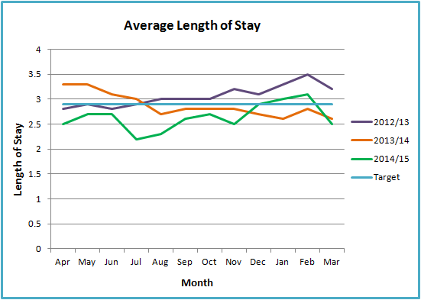

The Trust also monitors the percentage of patients with a length of stay (LOS) over 10 days. The programme of work to improve patient pathways and the level of care alongside the focus on the Green to Go list has enabled the Trust to work to a reduction plan in the percentage of patients with a LOS over 10 days, although recent delays due to ward closures will be reflected in the higher figures for February and March. With reduced mortality rates and the local population percentage over 80 years of age rising and therefore likely to require ongoing health or social care this increase in length of stay is a potential risk.

**Figure 15:**

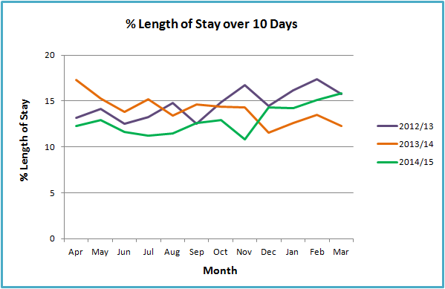

**Trust Action:**

In addition to the work streams already underway as part of the Trust’s business plan, the operational teams are focussing on optimising the ward board rounds. A ward board round takes place twice during the day and is where the multi-disciplinary clinical teams review each of the patient in detail using the rounding tool. This will ensure that throughout the patients stay all necessary actions are undertaken on time and in line with the clinical pathway for the patient. Each ward has also been allocated a senior manager to support the teams to deliver and unblock any difficulties that arise.

Daily monitoring of delays to discharge takes place at ward level with any barriers to a timely discharge being escalated through the divisions. It is important that work to reduce length of stay is linked with feedback from patient complaints and surveys; therefore a discharge work stream is being established which will be responsible for both progressing timeliness and quality of discharge.

## 3.4 Clinical Pathways

*This section sets out performance indicators related to key clinical pathways, including cancer and stroke.*

## 3.4.1 Cancer Services

The Trust strives to achieve the national cancer waiting times as they are important to patients clinical outcomes, are a measure of how the Trust is responding to demands for services, and highlights where there are delays in the system. In February the Trust achieved seven of the eight national cancer targets and five of the eight in March.

#### 3.4.2 Cancer Two Week Wait

The two week wait target was achieved in both February and March with a score of 97.6% and 98.0% respectively. This was not matched by the Breast Symptomatic two week wait target, which achieved below 93% for February and March.

#### 3.4.3 31 Day Target

The Trust achieved all three of the 31 day targets in February and March, demonstrating the Trust’s ability to effectively treat patients once diagnosed with cancer.

3.4.4 62 Day Target

The Trust achieved the 62 days standard for February but not March. The Trust sees very small numbers within this standard, and one patient can show the Trust as below 85% each month.

**Trust Action:**

Daily monitoring of performance by the MDT Coordinator and cancer team leader.

Weekly monitoring at the Waiting List Forward Planning meeting.

Close liaison with tertiary centres to streamline patient pathways to ensure timely referral and treatment.

Work with primary care to develop information to be provided to patients to improve the availability of patients for appointment.

Active participation in the BNSSG Cancer Strategy Group to help gain better awareness of likely peaks in demand to assist with capacity planning, this group is also leading on pathway work between Trusts.

## 3.4.5 Stroke

The Trust achieved the stroke target of patients diagnosed with a stroke spending 90% of their time on the Stroke Unit in February but missed this target in March (*Figure 16)*.

The Stroke Unit was closed to new admissions during March following an outbreak of Norovirus. The Stroke specialist nurse and team supported stroke patients in other designated areas of the hospital. The unit has since been deep cleaned and is fully operational again.

The Trust continues to focus on patient flow and bedding patients in the most appropriate place.

**Figure 16:**

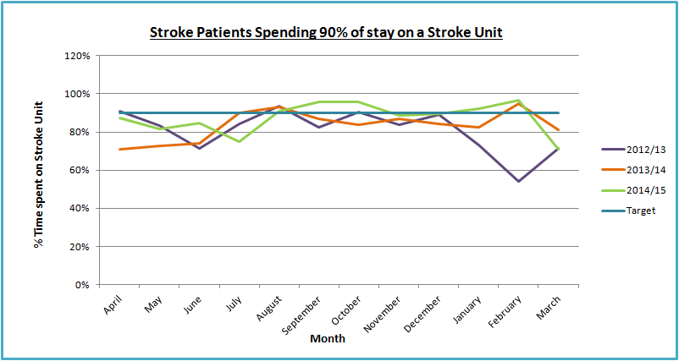

**Trust Action:**

The patient flow team have been instructed to create and keep a stroke hot bed for both sexes available at all times. This will ensure that patients diagnosed with a Stroke or TIA in the Emergency Department can be transferred straight to the unit to start their care and treatment.

Use of the hot bed during times of escalation and/or outbreak must be with Executive approval only.

In instances of outbreak on the Stroke Unit, beds on the High Care Unit are allocated with medical teams providing specialist care and support to diagnosed stroke patients.

Throughout February there was an elevated number of Stroke patients admitted. In order to best care for these patients, six additional beds were opened on the Stroke Unit.

## 3.5 Emergency Access

### 3.5.1 Emergency Department (ED) Performance

The NHS constitution set the national standard wherein 95% of all patients attending NHS Emergency Department’s spend a maximum of four hours in the department before being discharged, referred/transferred to other services or admitted to the hospital and transferred to an inpatient bed. The target was not achieved in February (88.24%) or in March (90.51%) as illustrated in *Figure 17*. This as a result of two key factors:

1. Outbreaks of Norovirus and increased length of stays for patients over 80 years old causing issues with patient flow throughout the Trust.
2. Throughout February and March the Trust has been experiencing not only an increase in activity out of hours but a pattern of activity arriving together causing peaks, which put significant pressure on the Emergency Department. This activity is a mixture of both walk-in patients and ambulance arrivals.

**Figure 17:**

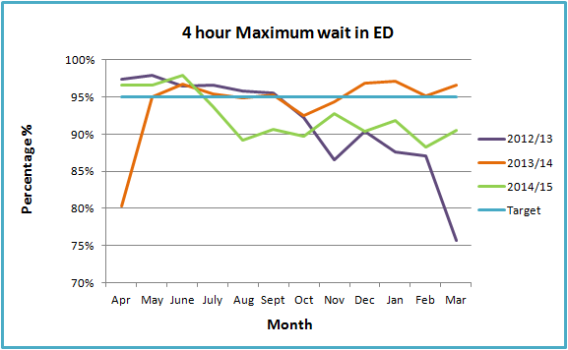

**Trust Action:**

* A detailed review of internal and external performance and activity data has been completed to understand the causes behind the sudden drop in performance, this has been shared with key staff to support the development and implementation of an action plan.
* Transformation event planned for week commencing 06th May 2015 – “Bouncing Back to Green”; a focus on patient flow and unblocking bottlenecks by the whole Trust – introduction of Ward Liaison Officers as part of the week.
* Daily North Somerset System Escalation calls to ensure that performance across the health and social care system is reviewed in detail to ensure all capacity is maximised to manage patients the most effective and caring manner.
* A programme of work within the Emergency Department to bring about closer working with colleagues in Acute Medicine to support the department together with the introduction of Rapid Assessment and Treatment.
* Opening hours of the Ambulatory Emergency Centre have been extended to help assist with peaks in demand.
* Daily Leadership Briefings take place within the Department daily, this provides an overview of the previous 24 hours, progressing any actions to resolve problems encountered together with a forward view on staffing and potential risks. Participants include medical, nursing and management leads to ensure ownership within the department.

A number of quality metrics are reviewed at this meeting, including time to triage and time to assessment to assure of clinical safety of patients within the department at all times of pressure.

**3.6 Elective Access**

*This section reviews the key elective access targets to understand the effectiveness and the quality of care throughout the elective care pathways.*

### 3.6.1 Referral to Treatment (RTT)

The NHS constitution states that patients have the legal right to start their NHS consultant-led treatment within a maximum of 18 weeks from referral, unless the patient chooses to wait longer or it is clinically appropriate to wait longer. For the months of February and March the following sub-sections will review the Trust performance against the three national 18 week targets.

### 3.6.2 Referral to Treatment (RTT) Admitted

The Trust achieved the admitted 18 week target in February and March at 90.83% and 90.07%.

**Figure 18:**

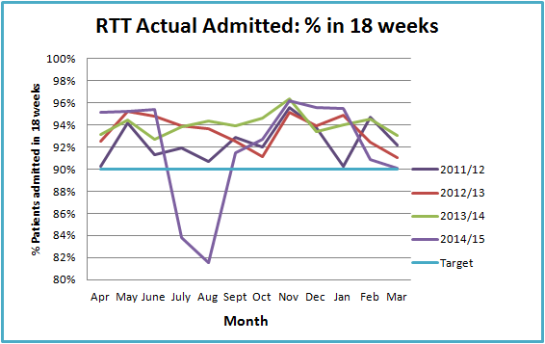

**Trust Action:**

The Trust continues to undertake weekly waiting list forward planning meetings where the waiting list for each specialty and the theatre timetable is reviewed by the Directorate Manager for Surgery, Access Manager and Theatre Manager with the Director of Operations in attendance.

### 3.6.3 Referral to Treatment (RTT) Non-Admitted

The Trust continued to achieve the non-admitted target in February and March as illustrated in *Figure 19.*

**Figure 19:**

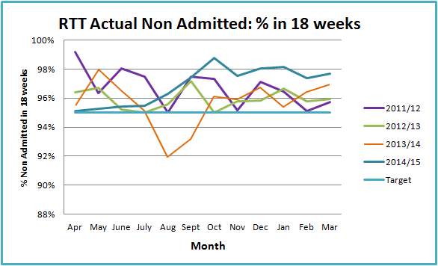

**Trust Action:**

The Trust will continue to undertake waiting list forward planning meetings where the waiting list for each specialty and the theatre timetable is reviewed on a weekly basis.

### 3.6.4 Referral to Treatment (RTT) Incomplete

The 92% target was achieved for February and March as illustrated in *Figure 20*. This was expected according to plan. The Trust has undertaken a rigorous validation of its waiting list supported by a team from the Trust Development Authority, this has driven new algorithms to be put in place to ensure the current validated waiting list position maintains at a manageable level on an ongoing basis.

**Figure 20:**

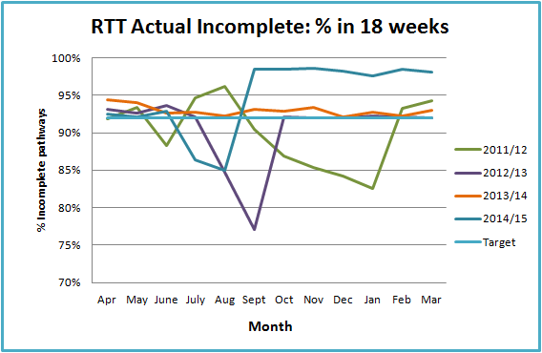

**Trust Action:**

The Trust will continue to undertake waiting list forward planning meetings where the waiting list for each specialty and the theatre timetable is reviewed on a weekly basis.

**3.6.5 Choose and Book**

The Trust missed the 96% National target for Choose and Book slots in February and March, this is disappointing given the considerable improvement seen earlier in the year and is a result of absence of consultants within a small number of specialities. This is depicted in *Figure 21.*

**Figure 21:**

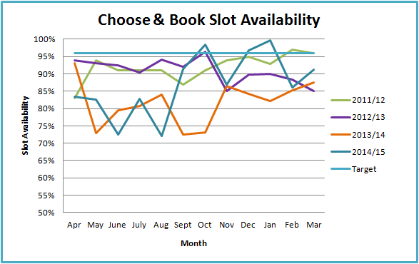

**Trust Action:**

This Work is ongoing to improve and meet the 96% requirement by:

Review of capacity and demand required, particularly as we have experienced a continued increase in two week wait referrals resulting in choose and book slots being used to provide additional urgent appointments

Work with neighbouring Trusts who provide some visiting services where capacity fails to match demand leading to no slots being available for patients.

Seeking locums or permanent appointments to fill vacant posts or long term absences.

## 3.7 Patient Flow

*To support the delivery of key operational targets, it is vital that the Trust has good patient flow. An important aspect of ensuring good patient flow is the level of discharges throughout the day and at the weekend.*

### 3.7.1 Delayed Transfer of Care

A delayed transfer of care is defined as when a patient is ready for transfer from acute care, but is still occupying an acute bed. Patients can be delayed for the following reasons:

* Further assessment required before their discharge destination can be decided
* Lack of capacity in local nursing/residential homes
* They may require a specialist placement
* Patient or their family/carer needs more time to make a decision about a long-term placement

The Trust monitors performance daily against delayed transfers of care as high levels can have a big impact on the daily numbers of discharges, causing delays in allocating beds for emergency admissions or planned operations. Performance in February and March improved following a spike in January (*Figure 22*). There is still considerable work to undertaken with partner organisations and the use of the **‘Green to Go’** list.

**Figure 22:**

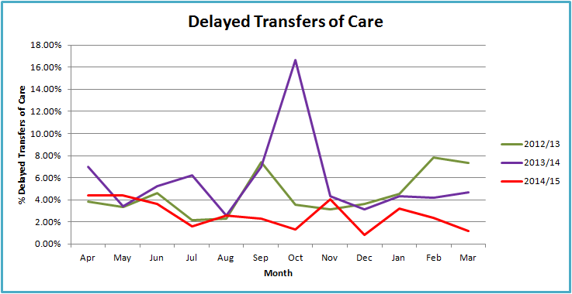

**Trust Action:**

The Trust continues to work with health and social care partners in North Somerset to manage the **‘Green to Go’** list, and where gaps in services are discovered, work with the Clinical Commissioning Group to identify how future commissioning can be organised to close these gaps, providing higher quality joined up care between all partners.

Agencies and other care providers are invited in regularly to assess patients, particularly those who may have complex needs with a view to discharging as soon as possible.

Daily Green to Go meetings held internally.

Daily Alamac calls, which includes senior representatives from across the health community, addresses the performance indicators on a daily basis with escalation of particularly challenging areas as necessary.

A short life working group has been established by the Directorate Manager for Emergency, this group to review the monitoring of the list and ensuring actions and owners are clear for every patient delayed.

**3.7.2 Bed Stock**

The Trust has a usual funded bed base of 234. As part of the winter ORCP, this funded base was increased from October 2014 to March 2015 and allows a further 20 inpatient beds, currently located on Cheddar ward. A decision was made to keep the additional 20 beds in use over the Easter period until the end of April 2015. There have been six unfunded beds in use consistently on the Stroke Unit during February and March

Section 4 Workforce

Executive Lead – Mrs Sheridan Flavin

## 4.1 Executive Summary Headlines

* The temporary staffing costs were 13.52% in February and 16.22% in March of the total pay bill.
* Sickness rates were 4.31% in February and 4.46% in March.
* The appraisal rate increased to 88.30% in February and was 88.24% in March.
* The training compliance rate increased to 83.53% in February and slightly decreased to 83.26% in March.

## 4.2 Workforce

*Figure 23* below shows the pay expenditure for contracted staff, for agency staff.

## Figure 23:

*Figure 24*, shows the temporary staffing usage as a month on month comparator. Cost of temporary staff continues to be high. The temporary staffing usage for March is higher when compared to last March, whilst much of this is attributed to additional capacity, the additional temporary staff does have an overall impact on the Trust skills mix, with a greater percentage of temporary staff.

In January the Trust held an open evening, specifically targeting newly qualified nurses and the Trust had a very successful evening by appointing students from University of the West of England (UWE) who will complete their Nursing Degree’s in June and will receive the NMC PINS in September. It is anticipated that these staff will commence employment in July whilst awaiting their NMC registration.

Some progress has been made with medical recruitment with NHS appointments being made to two Consultant posts in Orthopaedics, NHS locum appointments having been made in Community paediatrics, Gastroenterology and Histopathology and Speciality Doctor appointments being made in Community Paediatrics and the Emergency Department.

In addition to the appointments made amongst medical staff, during May there are Consultant interviews scheduled in Radiology, Anaesthetics, and Histopathology.

### 

### 4.2.1 Sickness

Sickness remains high in February and March, however the Trust sickness has fallen below the national average for sickness. As recently reported through the Trust Quality and Governance, the Trust has in place an action plan to reduce sickness absence through effective but supportive management of sickness absence and employee health issues.

### Figure 25:

* Trust target ≤ 3.0%

### 4.2.2 Statutory/Mandatory Training

The Trust statutory training compliance was 83.26% in March. As previously reported the Trust is taking formal action against staff that are a year or more out of date with one or more of their core training requirements. Of the 127 staff that this applied to, 109 are now fully compliant and disciplinary action is being taken against the remaining 18 staff members.

### Appraisal

The appraisal compliance rate was 88.24% in March, and the Trust has consistently achieved above the 85% target for the past 10 months.

### 4.2.4 National Pay Deal

As reported in the last Board Report, the Trade Unions representing employees within the NHS accepted a pay proposal by the Secretary of State, as outlined below:

* Abolition of the bottom point of AfC and increasing pay point 2 to £15,100. This means an increase of 5.6% for staff on point 1 and 3.1% for staff on pay point 2
* 1% consolidated pay rise for all staff up to point 42 from April 2015.
* A further consolidated pay rise of an additional £200 for staff on pay points 3-8. This means staff on these pay points will receive an increase between 2.1% and 2.3%
* Staff on pay points 34 to 54 will not be eligible for incremental pay progression from 1 April 2015 – 31 March 2016.

These changes have now come into effect from 1st April 2015 and have l been paid to staff in April.

### Overseas Recruitment (Nursing)

The following chart outlines the various overseas recruitment activities in the last couple of years and clearly demonstrates a higher dropout rate of candidates in more recent campaigns when compared to our successful recruitment campaign in Spain in 2013.

This shows that the market is becoming more competitive, and that therefore the challenge to recruit from the European market is increasingly difficult.

**Figure 27:**

|  |  |  |  |  |  |
| --- | --- | --- | --- | --- | --- |
| Year | Interview location | Number of candidates booked for interview | Number of candidates interviewed | Number of candidates offered | Number of candidates started |
| 2013 | Spain | 105 | 98 | 44 | 39 |
| 2014 | Italy | 35 | 21 | 12 | 3 |
| 2014 | Skype | 53 | 41 | 34 | 14 |
| 2015 | Spain/Italy | 20 | 10 | 6 | 2 |

Recognising the competitiveness of the recruitment market both nationally and internationally, the Trust is working on a partnership arrangement with another Hospital in Europe. It is therefore scheduled for a recruitment event to take place in May.

**Section 5 - Finance Report**

Executive Lead – Mr Rob Little

## 

## 5.1 Executive Summary Headlines

* The financial position at Month 12 is that the Trust is reporting a deficit of £3,902k which is an improvement of £1,048k compared to the plan.
* Overall income is £1,367k over plan at the end of March.
* Overall expenditure is £433k over plan at the end of March.
* The Trust has achieved and/or improved on all of the planned financial duties as shown in the financial dashboard for 2014/15.
* The accounts were submitted by the deadline to the Trust Development Authority and the Trusts External Auditors on Thursday 23th April 2015.

## 

## 5.1.1 Statement of Comprehensive Income Position to Date

The financial position at the year end is that the Trust reported a £3,902k deficit which is an improvement of £1,048k on the plan.

Revenue from patient activity is £460k over plan for the 12 months to the end of March 2015. Other sources of income are £907k over plan.

Overall expenditure for pay, non pay, reserves and depreciation is £429k over plan for the 12 months to the end of March. Pay and non pay expenditure is £1,506k over plan and this is partially offset by £1,073k of reserves.

The Trust’s Service Improvement Programme (SIP) is above target by £4k with a full year achievement of £4,504k against the target of £4,500k.

The adjusted run rate for expenditure has increased by £83k in March when compared with the February level.

### 5.1.2 Statement of Comprehensive Income Position In Month

Income from patient care activity is £57k less than plan whilst other sources of income generated £43k more than plan.

Pay and non pay expenditure, including savings delivery, is £127k over plan for the month of March.

The Trust’s Service Improvement Programme (SIP) delivered £930k in March against a plan of £423k and has now reached the target for the year.

### 5.1.3 Cash

The revised cash plan for 2014/15 was to hold a balance of £1,482k at 31st March 2015. The cash held of £2,898k, as at 31st March, which is £1,507k higher than the planned position. The increase in cash is matched primarily by an increase in revenue and capital payables at the year end.

### 5.1.4 External Financing Limit

The Trust’s External Financing Limit (EFL) has been met through the management of cash and working balances along with the planned level of Public Dividend Capital.

The Trust had a higher than forecast cash balance at the 31st March 2015 recording an undershoot against the EFL of £2,498k.

### 5.1.5 Capital Resource Limit

The capital resource limit is £3,858k and in addition to this the Trust has received £124k matched funding from the NHS Safer Hospital, Safer Wards Technology Fund for the implementation of a new Order Communications system. Therefore the Trust’s capital resource for capital projects is £3,982k.

As at the yearend the programme has delivered capital expenditure of £3,796k which was £186k under the available capital resources.  Due to the slippage on the Theatres project in year not all of the approved schemes were able to be delivered by 31st March 2015.

### 5.1.6 Capital Cost Absorption rate

The Trust’s Capital Cost Absorption (CCA) rate is fixed at 3.5% and this is calculated based on 3.5% of actual balance sheet values at the end of the financial year.

### 5.1.7 Better Payment Practice Code (BPPC)

The Trust’s overall performance for the financial year 2014/15 is 96.7% on the BPPC.

Financial Dashboards 2014/15: Month 12



## 5.2 The Income and Expenditure Position of the Trust

**5.2.1** The financial position at Month 12 is a deficit of £3,902k, which is an improvement on the plan which was a deficit of £4,950k.

## 5.3 Expenditure

**5.3.1** The main points are:

* The position is that overall the Trust has overspent the expenditure budgets by £1,506k which includes delivery of the Savings (SIP) plan. This has been offset with £1,073k from reserves.
* Pay expenditure is higher than budgeted with an overspend of £942k. The staff category with the highest overspend at the end of March was Nursing (£829k), followed by Medical Staff (£352k). These overspends were offset by underspends in the AHP’s (£274k), Admin and Clerical (£260k) and Biomedical Scientists (£167k) categories.
* Non pay expenditure is £564k over budget at the end of March. There are overspends on Linen & Laundry (£143k), Medical & Surgical Equipment (£121k), Internal recharges (£129k), and Office Expenditure £60k), offset by underspends on Drugs (£406k), Blood Products (£157k), Travel and Subsistence (£89k), Utilities (£54k) and Training (£46k).
* Bank and agency expenditure on Nursing increased overall in March by £114k. Agency expenditure increased from £240k in February to £361k in March, which included £104k expenditure on winter resilience projects. Bank expenditure reduced from £186k in February to £179k in March, £70k of the expenditure was for winter projects.
* In recent months the Trust has had a significant number of Medical staff vacancies which has led to an increase in the use of Agency locums to cover the Trusts services; however some of these vacancies have now been filled. In November the Trust also increased its medical cover as part of the Operational Resilience and Capacity Planning (ORCP) Programme which has resulted in further Locum Medical Staffing being requested. In March £277k was spent, a decrease of £31k compared with February. In March £125k of the expenditure was attributable to the ORCP project work. Some of this locum expenditure is offset by the medical staff vacancy savings of £90k.

**5.3.2**

At Month 12 the main points for the Divisional and Corporate performance are as follows:

* The Emergency Division has overspent by £497k in the year, with an overspend of £78k in month 12. Of this, Pay expenditure is overspent by £632k whilst Non Pay is underspent by £5k. There is SIP over delivery of £138k. The Pay overspend is mainly due to Medical Staffing (£479k), Uphill (£205k), ED (£194k), and Kewstoke (£111k), offset by underspends on Pathology (£155k), Physiotherapy (£59k) and AEC (£59k). The Non Pay underspend is due to a saving on drugs (£67k), Blood (£40k) & Pharmacy (£52k) offset by an overspend on Pathology (£173k).
* The Planned care Division has overspent by £1,239k for the year, an increase of £132k in March. The pay overspend is £347k whilst non pay is overspent by a further £155k. The divisional income is £29k above the planned level. The SIP underachievement is £766k. The pay overspend is in Theatres (£307k), Hutton (£193k) and SAU (£111k), offset by underspends in Planned Care Management (£115k), Hospital at Night (£43k), Access Team (£43k) ,Medical Secretaries (£34k) and Radiography (£34k). The non pay overspend is mainly on Theatres (£222k) with additional overspends in ITU (£64k), Radiology (£62k) and Endoscopy (£22k) offset by underspends on Radiography (£128k), PPU (£87k), Drugs (£125k), Blood (£28k) and GUM (£20k).
* The Estates and Facilities Division has underspent by £29k at the end of month 12. The non pay is overspent by £101k which includes overspends against Property Services (£82k), HSSU (£15k), Housekeeping (£13k), Telecoms (£13k) and Linen & Laundry (£11k), offset by underspends on Utilities (£30k), Catering (£18k) and Residences (£7k).
* The Corporate Departments have underspent by £442k for the year.

Reserves have been deployed to cover spend where there are agreed allocations such as the cover of Medical agency premiums and agreed waiting list initiatives. Further monies have been made available to support the additional capacity for the Operational Resilience and Capacity Planning (ORCP) Programme.

**5.3.3**

The Trusts expenditure run-rate information has been rebased to neutralise the effect on both expenditure and budgets for variations in monthly NICE funded drugs expenditure which has no overall impact on the Trusts net financial position. There have also been some amendments for one-off exceptional items which include the impact of any work undertaken as part of the RTT project and the Operational Resilience and Capacity Planning Programme. The Trust’s expenditure run rate is shown in the table below compared to the adjusted expenditure level for each month.



The budgeted adjusted run rate for March is £7.390m. The adjusted expenditure run rate has increased in February by £83k, from £7.358m in February to £7.441m in March 2015.

## 5. 4 Savings Plans (SIP)

**5.4.1** The Trusthad a savings requirement of £4.5m for the year which represents 4.45% of expenditure budgets. Savings plans have delivered £4,504k against the profiled plan of £4,500k for the twelve months. Of the SIP savings delivered £2,542k is from recurrent schemes and £1,962k from non-recurrent schemes. In month the Trust delivered £930k against the £423k required, an overachievement of £507k in month. The Trusts performance against its monthly SIP savings requirement is shown below along with the monthly phased plan.

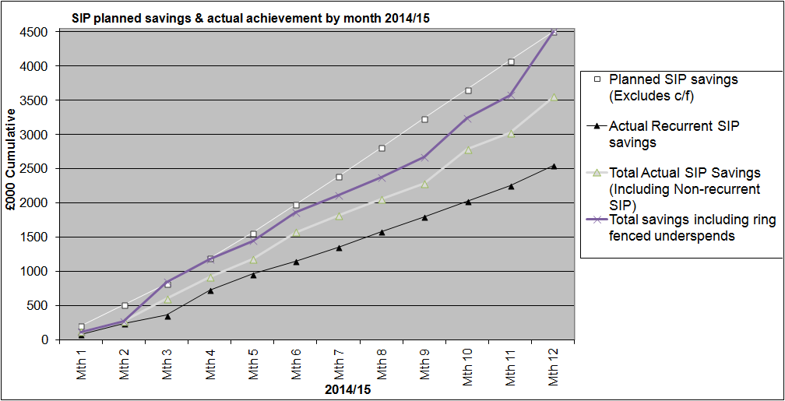

## 5. 5 Activity and Income

* + 1. Overall patient activity income is assessed at £460k over plan at the end of March 2015.
* Income related to North Somerset CCG contract is £5k under plan.
* Income related to the NHS Somerset contract is £15k under plan
* Other CCG patient care activities is £159k over plan
* The Specialist services contract is £428k over plan
* Local authorities is £26k over plan
* Private patients’ income is £138k under plan.



Significant volume variations in performance are shown in the table below:



**5.5.2** The following table shows the overall activity for the period ended 31st March 2015:



## 5.6 CQUINS

**5.6.1**

The Trust received £1501k out of potential income of £1540k; all schemes were achieved except for the Dementia (Find Assess Investigate and Refer) scheme.

## 5.7 Penalties

**5.7.1**

Penalties for the period ending 31st March 2015 amounted to £277k for Referral to Treatment, Cancer access, waits and Ambulance handovers. The detailed assessment is shown in the table below. It is agreed that there will be no RTT penalties for July, August and September and that the Emergency Department 4 & 12 hour penalty will be reinvested to help resolve the underlying performance issues.



**Referral to Treatment penalty by specialty**



## 5.8 Other operating revenue

**5.8.1** The Trusts Other sources of income over delivered against plan by a total of £907k for the year to 31st March.

Education and Training income was £193k over plan due to the Trust delivering more weeks of Medical trainee and student placements and also supporting more Pharmacist and Biomedical scientist trainee in placements than originally anticipated.

The Income received from Insurance companies via the Compensation recover unit for the treatment of patients who received injuries in Road Traffic Accidents was £117k over plan due to a higher overall number of claims and a small number of very high value incidents.

Other income is the Trusts income generated by the Divisions for non patient treatment activies. In total this was £597k over plan, the largest favourable variances were against R&D income, Consultant recharges to other providers and Somerset Surgical Services income.

## 5.9 Statement of Financial Position

**5.9.1** The Trust’s main accounting statements are shown in the appendices of this report and see Appendix B for the Statement of Financial Position as at 31st March 2015.

#### Cash

**5.9.2** The External Financing Limit has been achieved by in year management of cash and working balances. The yearend cash balance of £2,989k, as at 31st March, is £1,507k higher than the revised planned position of £1,482k. The increase in cash is matched primarily by an increase in revenue and capital payables at the year end.

The difference between actual cash balance held £3,030k and the reported £2,989k on the Statement of Financial position relates to un-presented payments and cash in transit as at 31st March 2015.

The Trust met its requirement to remain within its External Financing Limit.

#### Debtors

**5.9.3**. The figures from the debtors system represent invoices raised for which cash has yet to be received. The total outstanding invoiced debt as at 31th March is £1,922k, which is divided between NHS £1,613k, Private Patients £96k and non NHS £213k. Debts over 250 days represent £97k which is 5.0% of the total debt.

#### Creditors

**5.9.4** The measure for the better payment practice code is to pay all NHS and non-NHS trade creditors within 30 calendar days of receipt of goods or a valid invoice (whichever is later), unless other payment terms have been agreed. The compliance is for at least 95% of invoices to be paid (by the bank automated credit system or date and issue of a cheque) within thirty days, or within agreed contract terms. The yearend performance against the target is below and this target was met.



## 5.10 Capital Programme and Performance against Capital Resource Limit

**5.10.1** The Trust operated within its Capital Resource Limit and detailed capital programme management enabled the capital expenditure to be delivered within resources.

**5.10.2** As at 31st March 2015 there has been £3,796k of capital expenditure. See appendix D for the final year end position.

## 5.11 Foundation Trust Indicative Risk Rating

**5.11.1** The Financial risk rating for the Trust, if operating as a Foundation Trust, as at the 31st March 2015 is a level 1, and the liquidity ratio is 16.6 days which achieves a level 3.

**5.11.2** The Continuity of Services risk metrics, if operating as a Foundation Trust, as at the 31st March 2015 is a level 1.5.

**5.11.3** The calculation for the Financial risk rating, after applying the over-riding rules, and for the Continuity of Services risk metrics, for the annual plan, and year end outturn for the Trust is a 1, which is a result of the Trust’s overall financial sustainability issues.



## 5.12 Recommendation

The Board is asked to note the Trust’s yearend financial performance for 2014/15 regarding the revenue, capital and cash positions.

**5.13 Reference costs plan**

**5.13.1** The Reference costs guidance for 2014/15 was published by the Department of Health in February 2015. This guidance provides detailed information to enable providers to prepare reference costs and it must be followed when preparing and submitting mandatory reference cost returns. It contains high level costing principles, and there are clinical costing standards for acute services published by HFMA and Monitor.

Reference costs are the average unit cost used to set prices for the NHS-funded services in England and are collected and published annually. In 2014/15, in line with 2013/14, there is the requirement for Provider Trust Boards to approve the costing process that supports the reference costs preparation. The submission is due on the 31st July 2015.

The Trust Board is required to confirm that:

* Costs will be prepared with due regard to the principles and standards set out in the Monitor’s “Approved Costing Guidance”.
* Appropriate costing and information capture systems are in operation.
* Costing teams are appropriately resourced to complete the reference cost returns accurately within the timescales set out in the reference cost guidance.

Procedures are in place such that the self-assessment quality checklist will be completed at the time of the reference costs return.

**5.13.2** Monitor’s “Approved Costing Guidance”, updated in February 2015, sets out the approach to costing that Monitor encourages providers to adopt. It incorporates Costing principles for this year’s Patient Level Information and Costing Systems (PLICS) voluntary collection, together with the HFMA Acute Health Clinical Costing Standards and the Department of Health’s Reference Costs Guidance for 2014/15. The Trust will be using and complying with all three documents to prepare the submission.

Reference costs need to be:

* Calculated on a full absorption basis to identify the full cost of all included services.
* Ensure all costs are allocated and apportioned accurately by maximising direct charging, and where this is not possible the Trust uses standard methods of apportionment as recommended in the HFMA Clinical Costing Standards publication.
* Matched to the services generating them to avoid cross subsidisation.
* Reconciled to the quantum of costs from the audited accounts for 2014/15
* Emphasise the cost of delivering the service and not the funding streams.

**5.13.3** The approved costing guidance includes the six costing principles to be followed:

1. Stakeholder engagement – effective costing requires input from a wide range of stakeholders, including non finance staff.
2. Consistency – for some costing purposes, a consistent approach is required across or within organisations.
3. Data accuracy – accurate costing relies on the quality of the underlying input data.
4. Materiality – costing effort should be focussed on material costs and activities.
5. Causality and objectivity – costing should be based on an understanding of causality to minimise its subjectivity.
6. Transparency – costing should be transparent and auditable.

**5.13.4** The six steps are with reference to specific guidance from HFMA clinical costing standards, Reference costs guidance and PLICS collection guidance.

1. Define the cost object. A cost object is a product or service for which costs are accumulated or measured.
2. Identify the activities.
3. Identify the relevant costs.
4. Analyse costs. Costs should be categorised based on the following classifications: direct, indirect and overhead costs; fixed, semi-fixed and variable.
5. Assign costs. Costs can be attributed to a cost object via: direct tracing, cause and effect assignment, or allocation.
6. Validate the outputs. Undertake basic checks to the costs are accurate.

**5.13.5** The Trusts reference costs will be calculated on a full absorption basis to identify the full cost of all services provided from the list in the Reference Costs Guidance for 2014/15. The Trust uses Patient level costing to identify as much cost to an individual patient’s pathway and then the patients with the same Point of Delivery i.e. Day case or Outpatient, Specialty and HRG (inpatient only) are aggregated to provide an average unit cost. The Trust finance team includes a senior post holder who has been mostly dedicated to developing and improving the Trust’s costing regime, production of the Reference costs, Service line reporting and to engage with Directors, Managers and Clinicians. This has led to:

* Data and information improvements
* Apportionment review and agreement of apportionment of indirect costs.
* Benchmarking against National average costs.
* Reconciliation with HES and SUS.
* Refinement of the Costing System.
* Use of Patient level costing.

The Trust finance team will ensure that the Board requirements are achieved with costs prepared with due regard to the principles and standards set out in the Monitor’s “Approved Costing Guidance”; appropriate costing and information capture systems are in operation; Costing team is appropriately resourced to complete the reference cost returns accurately, although there has been a loss of the experienced Costing accountant in April 2015, within the timescales set out in the reference cost guidance; procedures are in place such that the self-assessment quality checklist will be completed at the time of the reference costs return.

## 5.14 Recommendation

The Trust Board is recommended to approve the Reference costs plan.

### Appendix A – Statement of Comprehensive Income – Accumulated Variances as at Month 12 – March 2015



### Appendix B – Statement of Financial Position as at 31st March 2015



### Appendix C - 12 Month statement of rolling cash flow

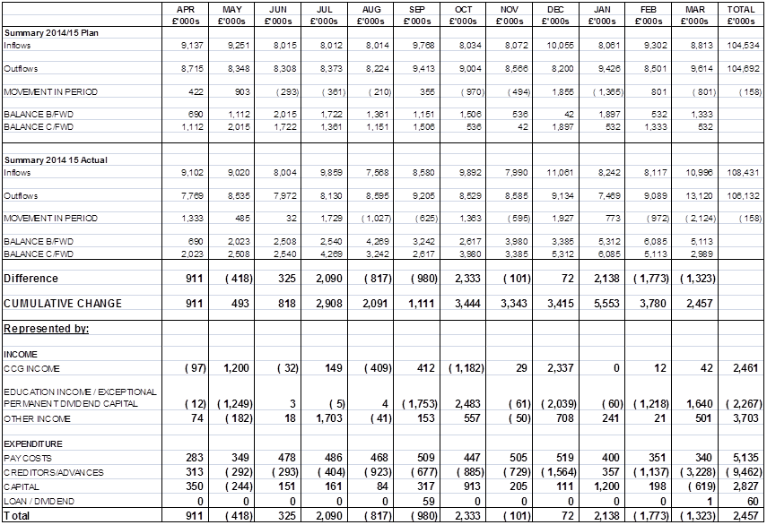

### Appendix D - Capital Programme 31st March 2015

